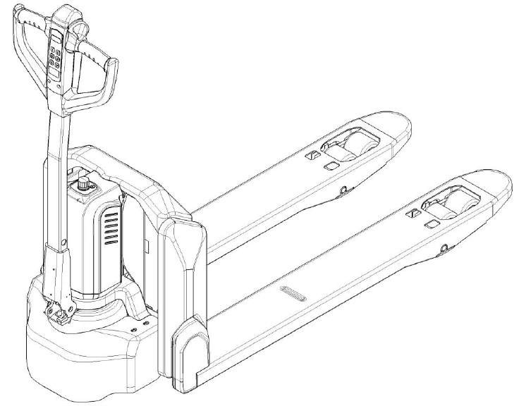

Service & Maintenance Manual Electric Pallet Truck
PTE33N

Version 12/2018
WARNING
Do not use the pallet truck before reading and understanding these operating
instructions. NOTE:
- Please check the designation of your present type at the last page of this document as well as on the ID-plate.

TABLE OF CONTENTS
- REGULAR MAINTENANCE 2
  - Maintenance checklist 2
  - Lubricating points 3
  - Check and refill hydraulic oil 4
  - Checking electrical fuses 4
- TROUBLE SHOOTING 5
  - Common trouble shooting 5
  - Fault code 5
- WIRING/ CIRCUIT DIAGRAM 9
  - Electrical circuit diagram 9
  - Hydraulic circuit 12
- MAINTENANCE OF MAIN COMPONENTS 13
  - Battery replacement 13
  - Outer-appearance parts 13
  - Tiller 14
  - Cylinder 16
  - Pump 17
  - Drivng unit 20
  - Brake 21
  - Driving wheel 21
  - Emergencvcy button 22
  - Controller 23
  - Contactor 23
  - Chassis 24
  - Pump motor 25
  - Micro switch 25
  - Side roller and adjustment 26
- SCREW TORQUE 27
- BUSHING SPECIFICATION 27

1

- REGULAR MAINTENANCE
  - Maintenance checklist
Table 1: Maintenance checklist
 |  |  | Interval(Month)
 |  |  | 1 | 3 | 6 | 12
 | Hydraulic
 | 1 | Check the hydraulic cylinder(s), piston for damage noise and leakage |  | •
 | 2 | Check the hydraulic joints for damage and leakage |  | •
 | 3 | Inspect the hydraulic oil level, refill if necessary |  | •
 | 4 | Refill the hydraulic oil ( 12 month or 1500 working hours ) |  |  |  | •
 | 5 | Check and adjust function of the pressure valve (1500kg+0/+10%) |  |  |  | •
 | Mechanical system
 | 6 | Inspect the forks for deformation and cracks |  | •
 | 7 | Check the chassis for deformation and cracks |  | •
 | 8 | Check if all screws are fixed |  | •
 | 9 | Check the push rods for deformation and damages |  | •
 | 10 | Check the gearbox for noise and leakage |  | •
 | 11 | Inspect the wheels for deformation and damages |  | •
 | 12 | Inspect and lubricate the steering bearing |  |  |  | •
 | 13 | Inspect and lubricate the pivot points |  | •
 | 14 | Lubricate the grease nipples | •
 | Electrical system
 | 15 | Inspect the electric wiring for damage |  | •
 | 16 | Check the electric connections and terminals |  | •
 | 17 | Test the Emergency switch function |  | •
 | 18 | Check the electric drive motor for noise and damages |  | •
 | 19 | Test the display |  | •
 | 20 | Check, if correct fuses are used |  | •
 | 21 | Test the warning signal |  | •
 | 22 | Check the contactor(s) |  | •
 | 23 | Check the frame leakage (insulation test) |  | •
 | 24 | Check function and mechanical wear of the accelerator |  | •
 | 25 | Check the electrical system of the drive motor |  | •
 | Braking system
 | 26 | Check brake performance, if necessary replace the brake disc or adjust the air gap |  | •
 | Battery
 | 27 | Check the battery voltage |  | •
 | 28 | Clean and grease the terminals and check for corrosion and damage |  | •
 | 29 | Check the battery housing for damages |  | •
 | Charger
 | 30 | Check the main power cable for damages |  |  | •
 | 31 | Check the start-up protection during charging |  |  | •
 | Function
2

 | 32 | Check the horn function | •
 | 33 | Check the air gap of the electromagnetic brake | •
 | 34 | Test the emergency braking | •
 | 35 | Test the reverse and regenerative braking | •
 | 36 | Test the safety (belly) button function | •
 | 37 | Check the steering function | •
 | 38 | Check the lifting and lowering function | •
 | 39 | Check the tiller arm switch function | •
 | General
 | 40 | Check if all decals are legible and complete | •
 | 41 | Inspect the castors, adjust the height or replace these if worn out. |  | •
 | 42 | Carry out a test run | •
- Lubricating points
Lubricate the marked points according to the maintenance checklist. The required grease specification is: DIN 51825, standard grease.

  - Load roller bearing
  - Cylinder
  - Axle
  - Bearing
  - Gear box
  - Side roller bearing
  - Connection point

Fig. 1: Lubricating points

3
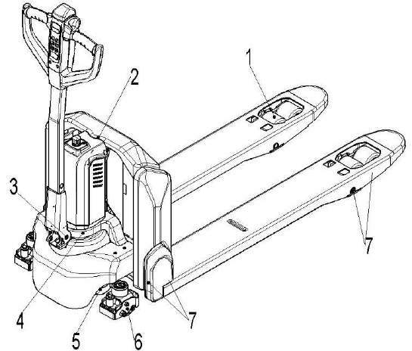

Check and refill hydraulic oil
It is recommended to use hydraulic oil in connection with average temperature:

Environment temperature | –5℃~25℃ | >25℃
Type | HVLP 32， DIN 51524 | HLP 46， DIN 51524
Viscosity | 28.8-35.2 | 41.4 - 47
Amount | 0.4L

Waste material like oil, used batteries or other must be probably disposed and recycled according to the national regulations and if necessary brought to a recycling company.
The oil level height shall be in the not lifted position min. 0.3L to 0.5L. If necessary add oil at the filling point.

Checking electrical fuses

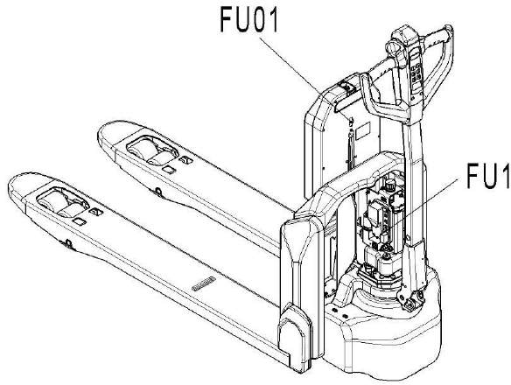
Fig. 2: Location of fuses

Table 2: Size of the fuses
 | Rate
FU 1 | 10A
FU 01 | 70A

TROUBLE SHOOTING

Common trouble shooting
If the truck has malfunctions follow the instructions, mentioned in chapter 6.

Table 3: Trouble shooting
TROUBLE | CAUSE | REPAIR
Load can’t be lifted | Load weight too high | Lift only the max. capacity, mentioned on the ID-plate
 | Battery discharged | Charge the battery
 | Lifting fuse faulty | Check and eventually replace the lifting fuse
 | Hydraulic oil level too  low | Check and eventually refill hydraulic oil
 | Oil leakage | Repair the sealing of the cylinder
Oil leakage from air  breathing | Excessive quantity of oil. | Reduce oil quantity.
Truck not starts operating | Battery is charging | Charge the battery completely and then remove the  main power plug form the electrical socket.
 | Battery not connected | Connect the battery correctly
 | Fuse faulty | Check and eventually replace fuses
 | Low battery | Charge the battery
 | Emergency switch is  activated | Turn the emergency clockwise
 | Tiller in the operating | Move the tiller firstly to the braking zone.

If the truck has malfunctions and can’t be operated out of the working zone, jack the truck up and go with a load handler under the truck and safe the truck securely. Then move truck out of the aisle.

Fault code
When is on, means there is fault of the truck, you can remove the code on LCD with the help of following table.
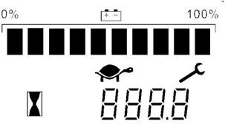

Table 4: Fault code list
Fault  code | Description | Possible reasons | Source of  failure
0 | LOW BDI | Low battery power | Controller
1 | PUMP SRO FAULT | Lifting or lowering switch is activated earlier  than key switch | Controller
2 | SRO FAULT | Operation sequence of direction, inter-lock and  key switch is not correct. | Controller
3 | HPD FAULT | Operation sequence of inter-lock and accelerator is not correct; or accelerator is not returned to neutral position after emergency  button is activated. | Controller
4 | WAITING FAULT | Accelerator:  - Misadjusted throttle.  - Broken throttle pot or throttle mechanism. | Controller
5 | THROTTLE FAULT | Accelerator wiring:  - Throttle input wire open or shorted.  - Throttle pot defective. | Controller
6 | PRECHARGE FAULT | Controller doesn’t work | Controller
7 | MAIN DRIVER FAULT | Internal relay coil is broken, replace controller. | Controller
8 | MAIN RELAY WELDED | - Internal relay welded.  - Controller defective. | Controller
9 | MAIN RELAY DNC | - Internal relay was commanded to be close and it did not.  - Internal relay tips are oxidized. | Controller
10 | BRAKE OFF FAULT | - Electromagnetic brake driver open.  - Electromagnetic brake coil shorted. | Controller
11 | MOTOR OVER TEMPERATURE | Motor overheating | Controller
12 | BATTERY DISCONNECT FAULT | - Battery not connected.  - Poor connection to battery terminals. | Controller
13 | BRAKE ON FAULT | - Electromagnetic brake driver shorted.  - Electromagnetic brake coil open. | Controller
14 | CURRENT SENSE FAULT | Controller doesn’t work | Controller
15 | HARDWARE FAULT | - Motor voltage does not correspond to throttle request.  - Controller failure. | Controller
16 | SOFTWARE FAULT | - Software defective.  - Controller defective. | Controller
17 | PARAMETER CHANGE FAULT | - One parameter value is changed that requires a power cycle (such as Throttle Type, Interlock Type, Driver Type, EMR Type, Pump SRO Type, AUX Switch Input Type)  - Parameters are restored  to the default settings | Controller
18 | MOTOR SHORT | Motor short circuit | Controller

19 | MOTOR OPEN | - Motor wires open.  - Faulty motor cable wiring.  - Controller defective. | Controller
20 | CONTROLLER OVERCURRENT | Controller defective. | Controller
21 | MOTOR TEMP HOT CUTBACK | - Excessive load on vehicle.  - Controller is operating in extreme high temperature. | Controller
22 | CONTROLLER OVERTEMP  CUTBACK | - Excessive load on vehicle.  - Controller is operating in high temperature. | Controller
23 | CONTROLLER UNDERTEMP | - Controller is operating in extreme low temperature.  - The temperature sensor is broken. | Controller
24 | CONTROLLER SEVERE  OVERTEMP | - Excessive load on vehicle.  - Controller is operating in high temperature. | Controller
25 | OVERVOLTAGE CUTBACK | - Battery voltage >Overvoltage Cutback point.  - Vehicle operating with charger attached.  - Intermittent battery connection. | Controller
26 | SEVERE OVERVOLTAGE | - Battery voltage >34.0V  - Vehicle operating with charger attached.  - Intermittent battery connection. | Controller
27 | UNDERVOLTAGE CUTBACK | - Battery voltage <16.8V  - Bad connection at battery or controller. | Controller
28 | SEVERE UNDERVOLTAGE | Battery voltage <13.8V | Controller
29 | PARAMETER FAULT | - The CRC of the parameters does not calculate correctly.  - Controller defective. | Controller
32 | PDO TIMEOUT | Communication between the 1212C and the  CAN tiller has halted. | Controller
33 | LIFT DRIVER FAULT | Lifting contactor is open or shorted. | Controller
34 | LOWER DRIVER FAULT | Lowering electromagnetic is open or shorted. | Controller
36 | BMS PDO TIMEOUT | Communication between the 1212C and the  BMS has halted. | Controller
37 | EMR SEQUENCING FAULT | - Emergency button is activated before truck is turned on.  - Micro switch inside the emergency button is defective.  - Cable from micro switch to controller is  broken. | Controller
39 | COAST SRO FAULT | Vertical driving is activated earlier than key switch or when vertical driving is closed, inter-  lock switch from ON to OFF | Controller
80 | Mode fault | Turtle button doesn’t work | Tiller
81 | Lift fault | Lifting button doesn’t work | Tiller
82 | Lower fault | Lowering button doesn’t work | Tiller
83 | BMS Communication Outage | Lithium battery communication has halted: | Tiller

- BMS failure.
- Cable from lithium battery to tiller is broken.
- Communication module of tiller is defective.
90 | Over Voltage | High battery voltage:  - Overcharging.  - BMS failure.  - Big current from motor during driving down from ramp. | Lithium battery
91 | Over Discharge | Battery over discharged.  - Battery is not used for long time.  - Overused. | Lithium battery
92 | Communication Outage | Battery communication has halted. | Lithium  battery
93 | Under Voltage | Battery low voltage:  - Discharged.  - Battery cell defective. | Lithium battery
94 | Over Current | Overcorrect:  - Unapproved adjustment of default parameters.  - Wrong parameter after replacement of controller.  - Current detection failure of lithium battery. | Lithium battery
95 | Over Temperature Protect | Extremely high battery temperature | Lithium  battery
96 | Temperature Protect | High battery temperature | Lithium  battery

WIRING/ CIRCUIT DIAGRAM

Electrical circuit diagram

Without speed reduction on curves

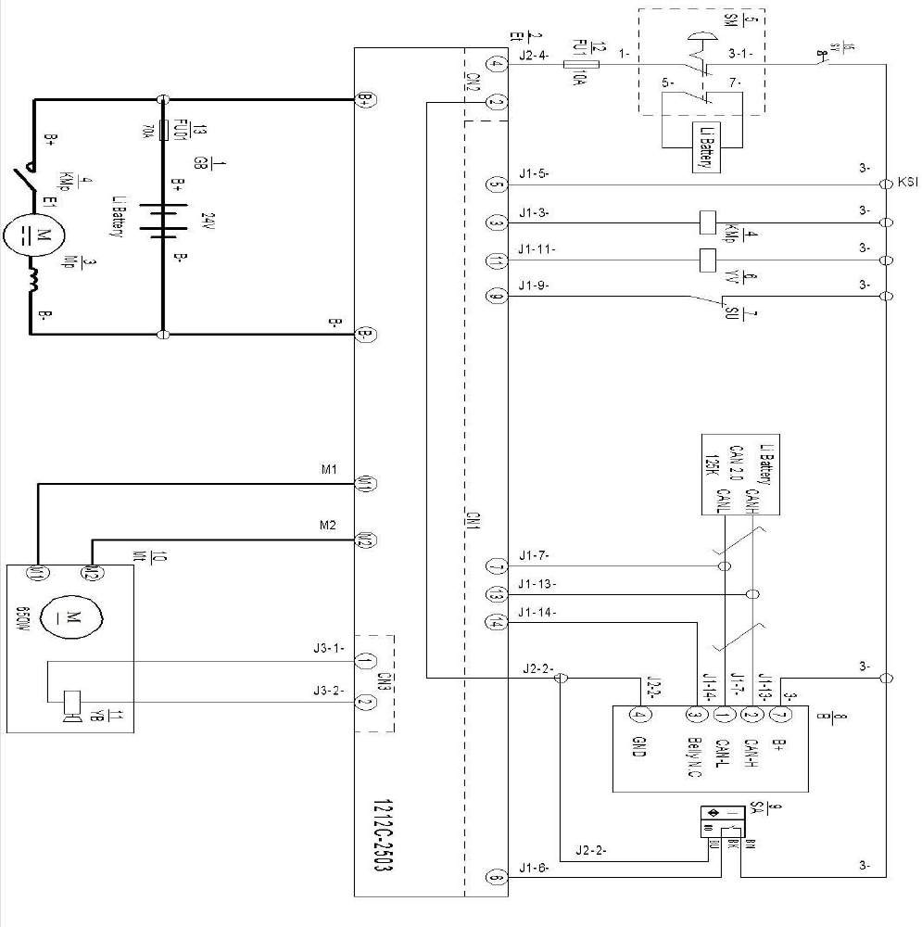
FU 1 : 10A FU 01 : 70A
Fig. 3: Electric diagram

Table 5: Description of electrical diagram

Code | Item | Code | Item
GB | Battery | B | CAN tiller
Et | Controller | SA | Proximity switch
Mp | Pump motor | Mt | Traction motor
KMp | Pump contactor | YB | Electromagnetic brake
SM | Emergency button | FU1 | 10A fuse
YV | Electromagnetic valve | FU01 | 70A fuse
SU | Micro switch

With speed reduction on curves
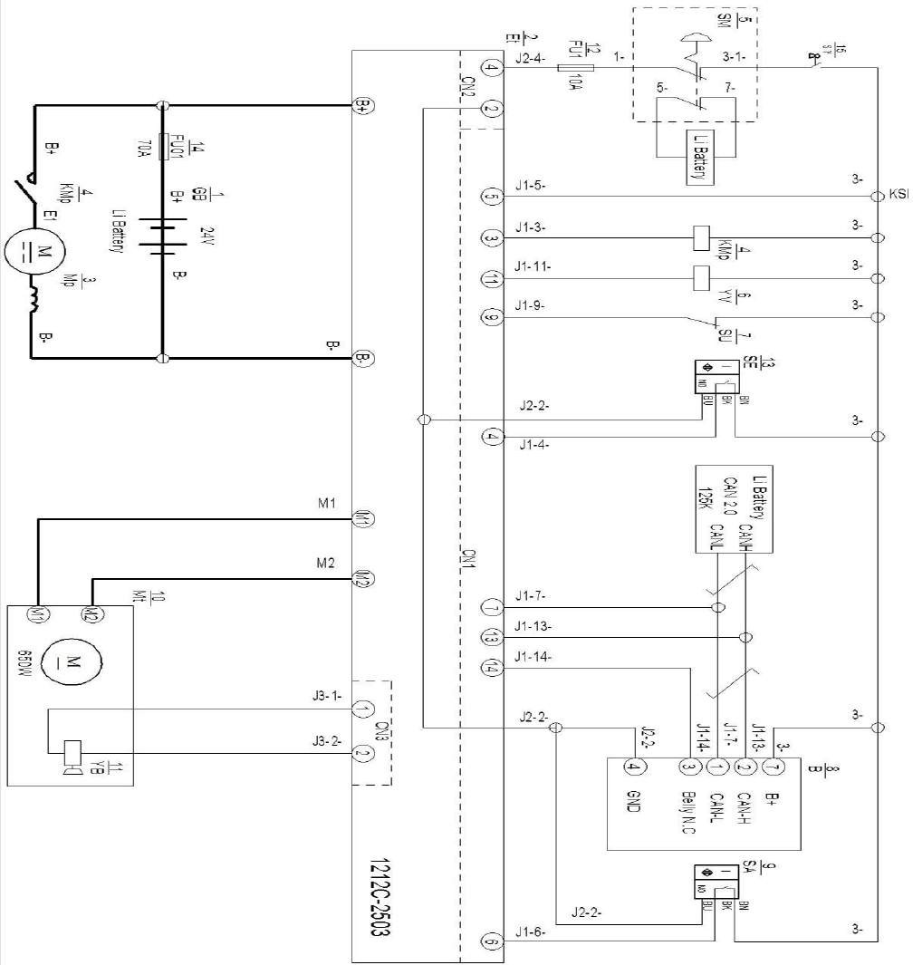

Fig.4: Electric diagram
FU1 : 10A FU01 : 70A

Table 6: Description of electrical diagram

Code | Item | Code | Item
GB | Battery | B | CAN tiller
Et | Controller | SA | Proximity switch
Mp | Pump motor | Mt | Traction motor
KMp | Pump contactor | YB | Electromagnetic brake
SM | Emergency button | FU1 | 10A fuse
YV | Electromagnetic valve | SE | Proximity switch
SU | Micro switch | FU01 | 70A fuse

Hydraulic circuit

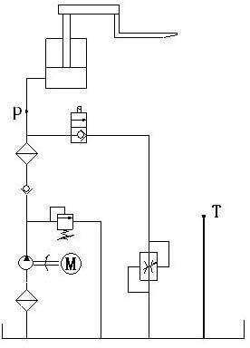Lifting cylinder Lowering valve

Pressure control valve

Throttle valve

Hydraulic power unit

Oil tank

Fig. 5 : Hydraulic circuit

Hydraulic oil inspection
Degree of purity | Smell | Status | Result
Clear and same color as before | Good | Good | Can be used
Transparent | Good | Mixed with other oil | Can be used if viscosity is fine
Milky | Good | Mixed with water and air | Separate water or replace  hydraulic oil
Brown | Bad | Oxidation | Replace hydraulic oil
Transparent but with particles | Good | Mixed with other particles | Can be used after filtering

MAINTENANCE OF MAIN COMPONENTS

Battery replacement
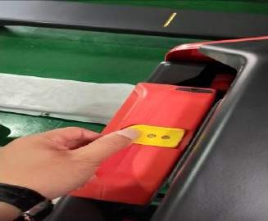
Oulock the battery and pull out from the top.

  - Outer-appearance parts

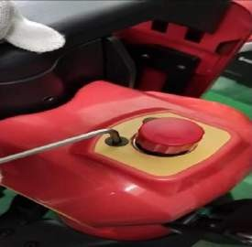 | 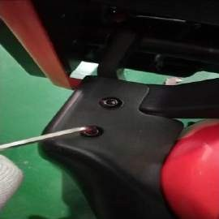 | 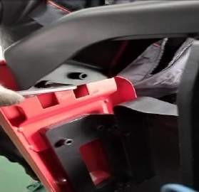
Remove two screws with 4mm Allen wrench, take out the cover from top. | Remove each side two screws with 6mm Allen wrench to take out the  apron. | Remove each side two screws with 6mm Allen wrench to take out the  top metal part.
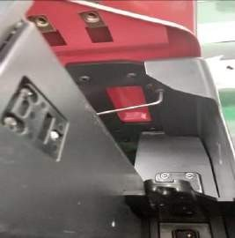 | 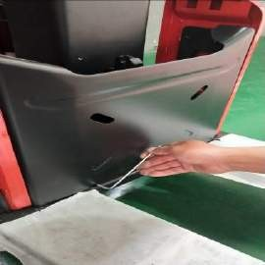 | 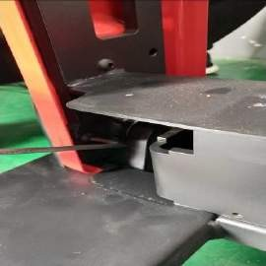
Remove each side one screw with 6mm Allen  wrench. | Remove two screws with 6mm Allen wrench. | Remove three screws with 6mm Allen wrench.

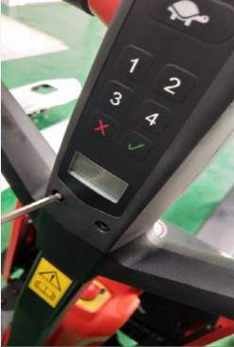 | 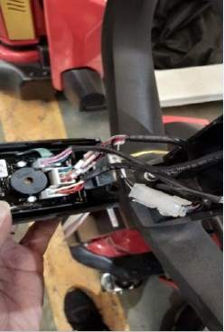 | 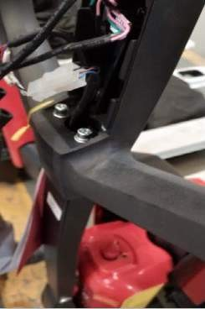
Remove two screws with 5mm Allen wrench. | Disconnect plugs to remove tiller assembly. | Remove four screws with 5mm Allen wrench to  disassemble the tiller head

  - Tiller

Tiller assembly

- Tiller

- Disassembly of air spring

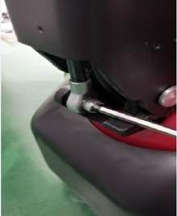 | 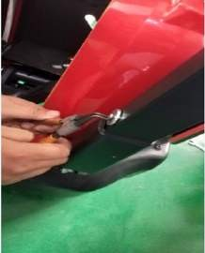 | 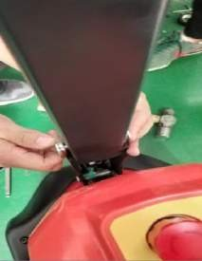 | 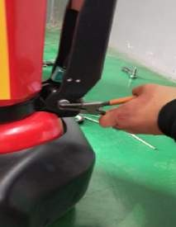
Remove the screw with 5mm Allen  wrench | Remove the circlip with circlip plier. | Remove the axle. | Remove circlip and axle.

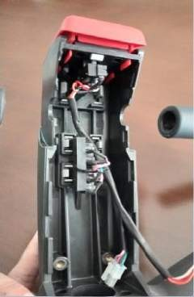 | 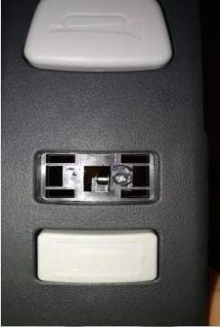 | 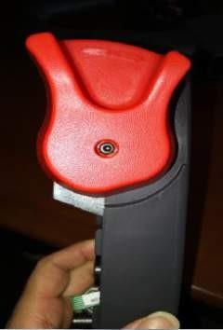 | 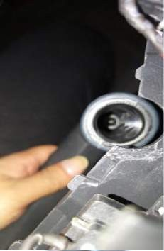
Push two sides of the plastic clamp to the middle to remove the button. | After button is disassembled, remove the screw with screwdriver to take out the micro switch. | Remove the screw with 3mm Allen wrench to disassemble the accelerator. | Remove the screw inside with 4mm Allen wrench to take out the grip.

- Assembly of air spring

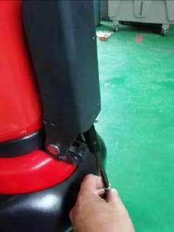 | 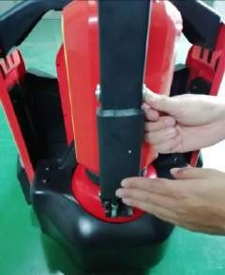 | 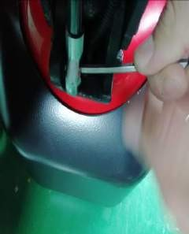 | 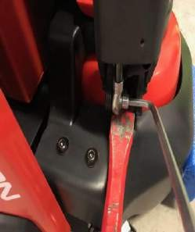
Put the air spring into tiller arm. | Insert the axle. | Make hole of axle and hole of screw on the same level  with Allen wrench. | Support the air  spring with flat metal tool to fix the screw.

  - Cylinder

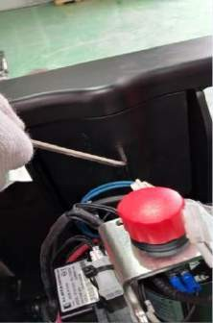 | 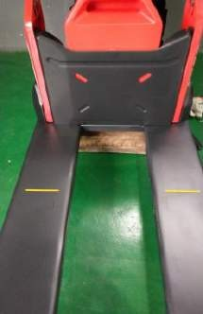 | 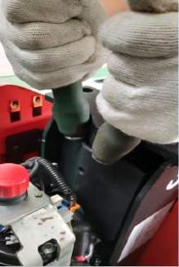 | 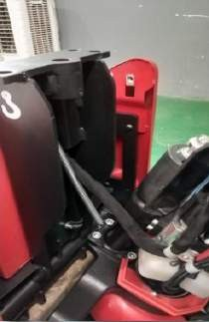
Remove the screw  with 5mm Allen | Put a wooden  block under the | Power on the  truck, activate the | Turn over the  cylinder.

wrench. | chassis. | lowering button and apply some force on top of the cylinder to retract  the piston rod.
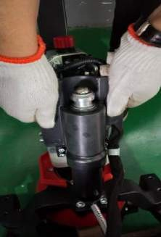 | 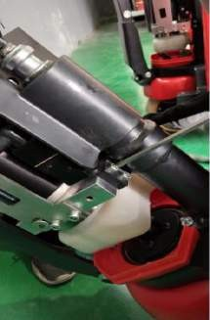 | 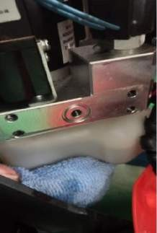 | 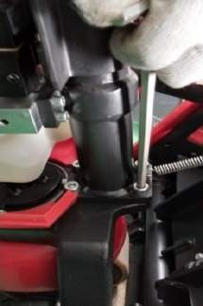
Pull out the  protective cover from top. | Disconnect the cylinder from  pump with 5mm Allen wrench.  During assembly, it’s required to apply thread  locker with 1243  model. | After disconnection, there is an O ring on the valve; the specification is 13.5*1.8. | Remove four screws with 6mm Allen wrench.  During assembly, it’s required to apply thread  locker with 1222 model.

  - Pump

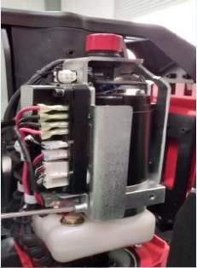 | 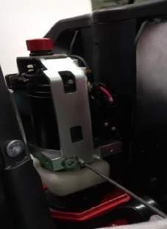
Remove the screw with 5mm Allen  wrench. | Remove the screw with 5mm Allen  wrench. | Remove the screw with 5mm Allen  wrench. | Put a wooden  block under the chassis.
Power on the truck, activate the  lowering button and apply some force on top of the cylinder to retract the piston rod. | Turn over the cylinder. | Disconnect the cylinder from  pump with 5mm Allen wrench.  During assembly, it’s required to apply thread  locker with 1243  model. | After disconnection, there is an O ring on the valve; the specification is 13.5*1.8.

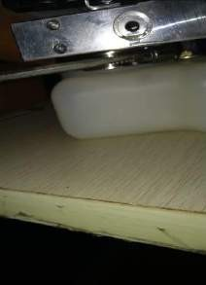 | 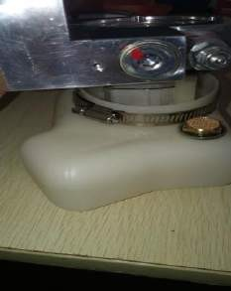 | 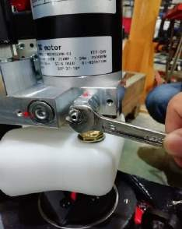 | 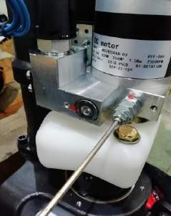
Loosen the clamp with screwdriver. | Disconnect the oil tank from pump; during assembly ensure O ring is  inside the groove. | Loosen the screw with 10mm wrench (anti-clockwise)  before adjusting the pressure of pump. | Tighten screw with 3mm Allen wrench to increase the  pressure or loosen the screw to  release the  pressure.

  - Drivng unit

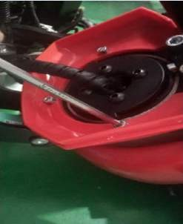 | 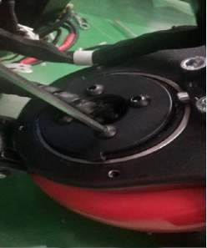 | 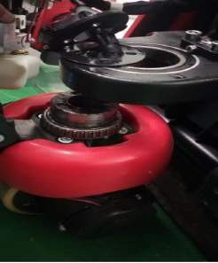
Remove three screws  with 5mm Allen wrench. | Remove four screws with 6mm Allen wrench. It’s required to apply thread  locker with 1243 model. | Remove the driving unit from the chassis.  Note：Bearing  specification is GB276-  6013-2RS.
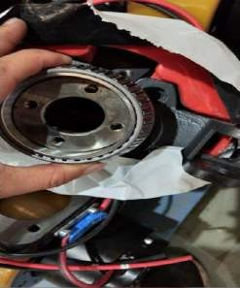 | 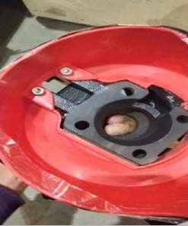
First remove the | Remove the screw with
bearing, then remove | 5mm Allen wrench to
four screws under the | take out the plastic
bearing with 6mm Allen | cover.
wrench to take out the
flange. It’s required to
apply thread locker with
1243 model.
Note：Bearing
specification is GB297-
32913.

  - Brake
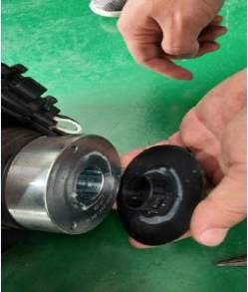 | 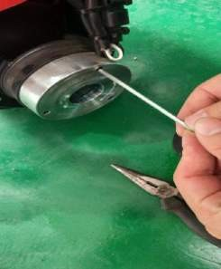
Remove the plastic | Remove three screws
cover before | with 4mm Allen
replacement of brake, | wrench to take out the
it’s connected with | brake.
glue.

  - Driving wheel

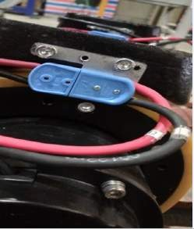 | 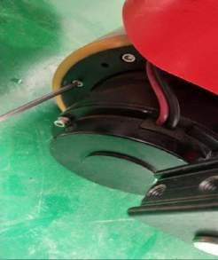
Remove the screws | Remove 10 screws with
with 5mm Allen wrench | 5mm Allen wrench, take
to take out the plug | out the wheel ring.
holder, then disconnect
the plug.

  - Emergencvcy button

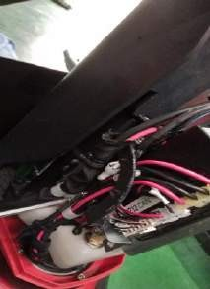 | 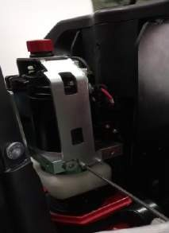 | 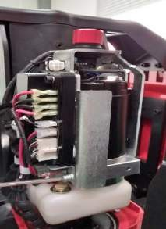 | 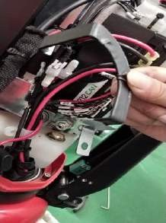
Remove the cable clamp with  screwdriver. | Remove two screws on the right side of the frame with 5mm Allen wrench. | Remove screw on the left side of the frame with 5mm Allen wrench. | Remove the cable clamp; make sure during assembly of the clamp,  hook must be fixed with mounting frame rather than  controller.
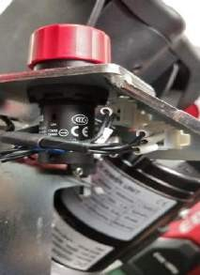 | 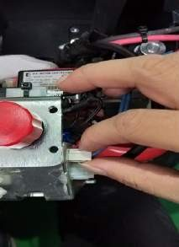 | 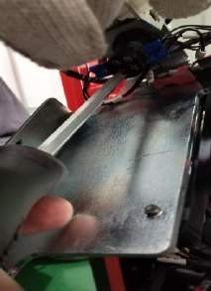 | 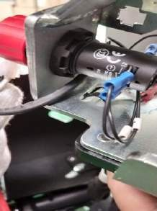
Disconnect two plugs. | Hole the plug to disconnect from the frame. | Remove the cable under emergency button with  screwdriver. | Loosen the screw to remove the emergency  button.

  - Controller

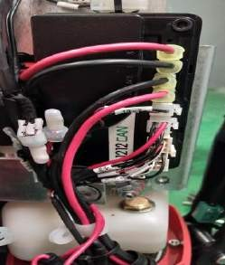 | 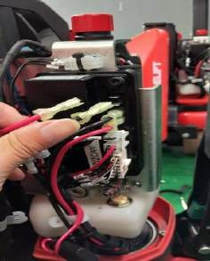 | 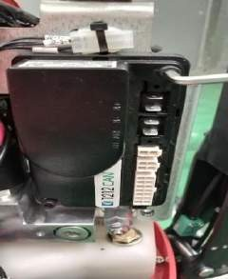
It’s recommended to make picture for the routing and  connection before controller is  disconnected. Four plugs here from top to bottom are battery positive pole, battery negative pole, motor negative pole and  motor positive pole. | Disconnect plugs. | Remove two screws with 5mm Allen  wrench to take out the controller.

  - Contactor

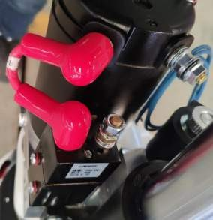 | 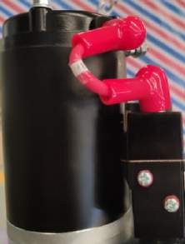
Disconnect cable  terminals with 10mm | Remove cables on  side.

wrench, and then remove one screw on mounting frame with screwdriver to take out the contactor
together with frame.

  - Chassis

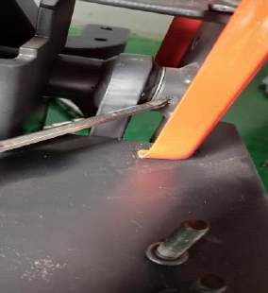 | 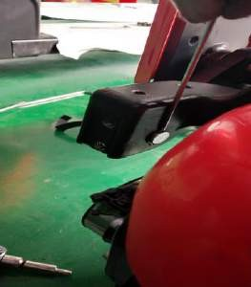 | 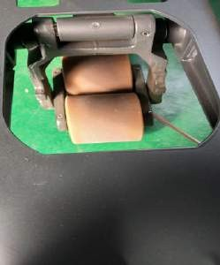
Remove the elastic pin to take out the axle, then disconnect rock arm from chassis.  Note: elastic pin  specification is 6*40. | Remove circlip to  disconnect rock arm from body. | First remove four elastic pins.  Note: elastic pin specification is 6*40.5*30.
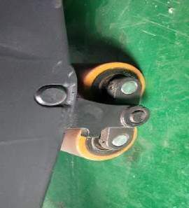 | 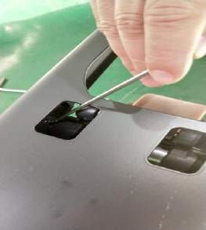 | 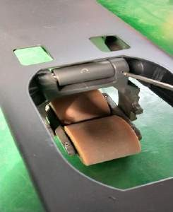
Then remove the axle to replace the roller. | Remove elastic pin to disconnect frame of roller from chassis.  Note: elastic pin  specification is 5*30. | Remove elastic pin to disconnect frame of roller from push rod.  Note: elastic pin  specification is 5*28.

  - Pump motor

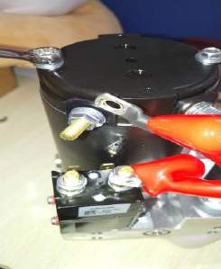 | 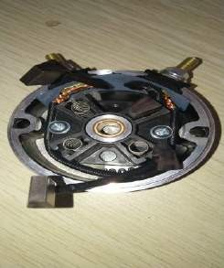
Remove cable | There are four
terminals from motor | carbon brushes after
with 10mm wrench, | motor cover is
and then remove two | removed.
screws on top of the
motor with 10mm
wrench to take out
the motor.

  - Micro switch

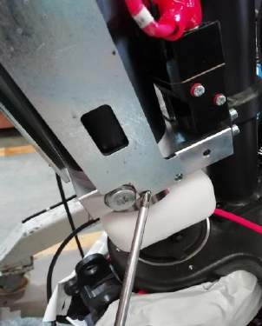 | 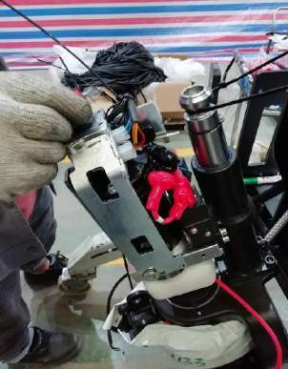 | 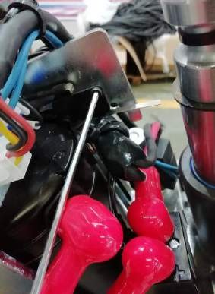
Remover three screws on the mounting frame with 5mm Allen wrench. | Pull out a little the mountign frame. | Remove screws with 3mm Allen wrench to take out the sensor.

  - Side roller and adjustment

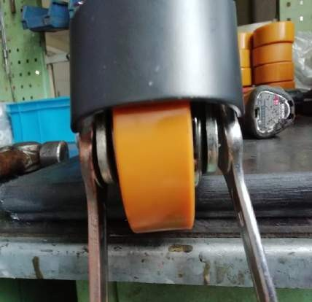 | 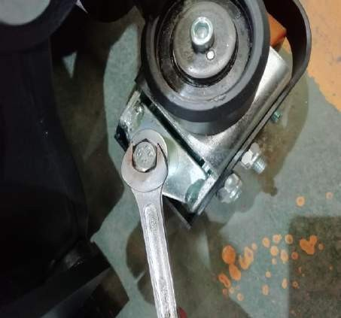
Remove the nut with 17mm wrench to take out the bolt. | Tighten screw clockwise with  13mm wrench to increase the pressure or anti-clockwise to release the pressure.

SCREW TORQUE

Picture | Position | Screw | Torque
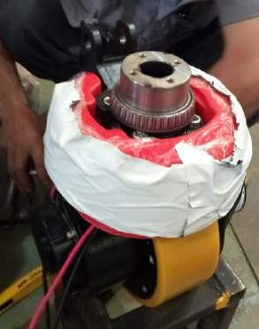 | Connection  between flange and driving unit. | GB70.1-M10x25-8.8 | 50N.m
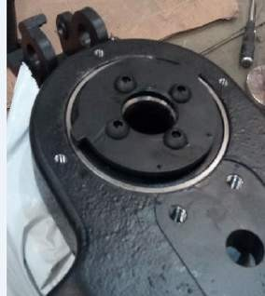 | Connection  between bearing cap and flange | GB70.2-M8x16-10.9 | 30N.m

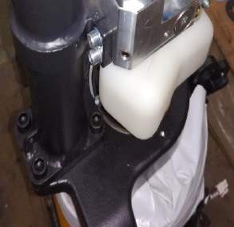 | Connection  between cylinder and driving wheel seat | GB70.1-M10x30-8.8 | 50N.m
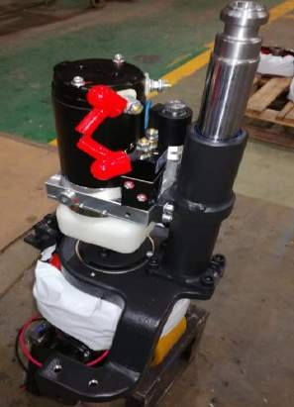 | Connection  between pump and cylinder | Screw GB70.1- M6x16-8.8;  Washer GB97.1-6- 200HV | 8 N.m
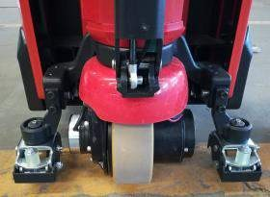 | Connection between side  roller and driving wheel seat | Screw GB70.1- M10x25-8.8;  Washer GB97.1-10- 200HV | 50N.m

BUSHING SPECIFICATION

