

Version 05/2021

NR530-SMS-001-EN  
xyz

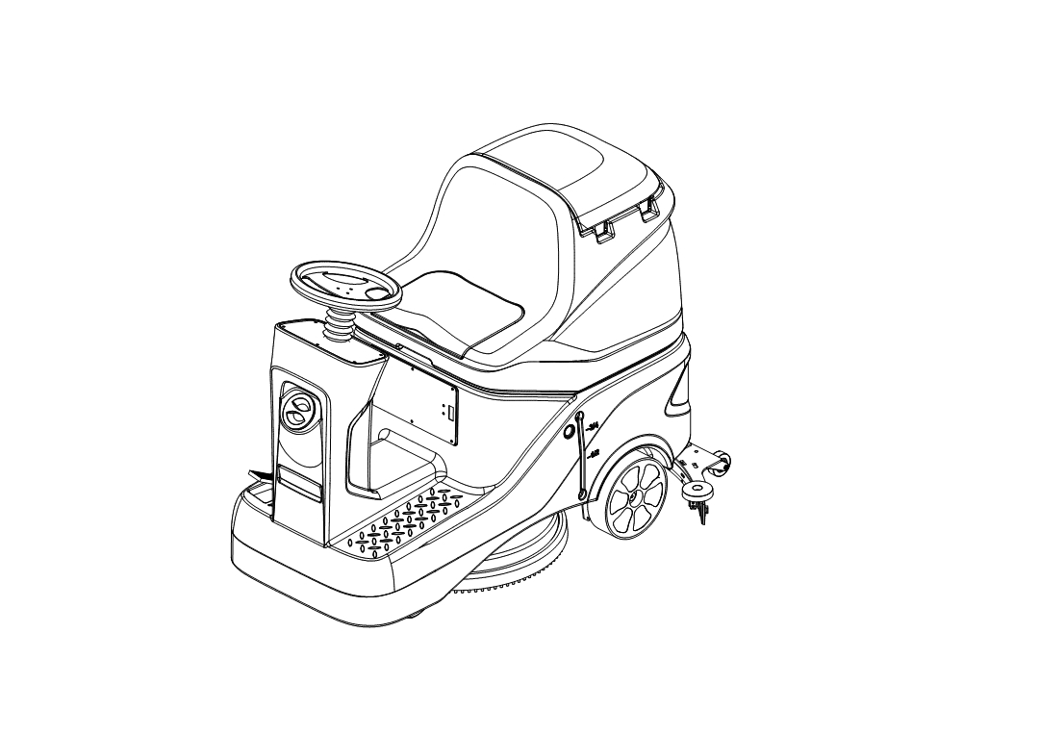MCj04113200000[1]

**WARNING**

**Do not operate the rider scrubber before reading and understanding the operator manual.**

**NOTE:**

* **Please check product type and**

**parameters of your scrubber in**

**this manual as well as on the ID-plate.**

* **Keep this operator manual for future reference.**

**Operator Manual  
NR530 Rider Scrubber**

CONTENTS

INTRODUCTION 1

MANUAL PURPOSE AND CONTENT 1

HOW TO KEEP THE MANUAL 1

DECLARATION OF CONFORMITY 1

ACCESSORIES AND MAINTENANCE 1

CHANGE AND IMPROVEMENT 2

INTENDED USE 2

MACHINE IDENTIFICATION 2

TRANSPORTING AND UNCRATING 2

SAFETY 2

SAFETY SYMBOLS 2

GENERAL SAFETY INSTRUCTIONS 3

MACHINE SETUP 5

MAIN COMPONENTS 5

CONTROL PANEL 6

TECHNICAL DATA 7

ELECTRICAL WIRING DIAGRAM 8

OPERATION INSTRUCTIONS 9

INSTALLING BATTERIES 9

EMERGENCY STOP 9

INSTALLING AND REMOVING DISK BRUSHES/PADS 10

ATTACHING SQUEEGEE ASSEMBLY 10

SOLUTION TANK FILLING 11

START AND STOP OF MACHINE 11

DRAINING TANKS 12

DRAINING SOLUTION TANK 12

AFTER USE 12

AFTER LONG-TERM INACTIVITY 12

INITIAL USE 13

MAINTENANCE 14

REGULAR MAINTENANCE CHECKLIST 14

CHARGING BATTERY 14

CLEANING DISK BRUSH/ PAD 15

CLEANING SOLUTION FILTER 15

SQUEEGEE CLEANING AND STORAGE 15

SQUEEGEE BLADE CHECK AND REPLACEMENT 16

RECOVERY TANK CLEANING AND CHECK 16

READ RUNNING DATA 17

TROUBLE SHOOTING 18

LCD DISPLAY FAULT CODE 19

SCRAPING AND DISPOSE 21

HAZARDOUS SUBSTANCE AND CONTENT 21

# INTRODUCTION

**NOTE**

**The code of related components in ( ) can be found in the chapter of machine description.**

## MANUAL PURPOSE AND CONTENT

* This manual is to provide the operator with the necessary information for the correct and safe use of the machine, which includes the technical data, safety, operation, storage, maintenance, accessories and dispose of the machine.
* Before performing any operation or maintenance on this machine, the operator and the qualified technicians must read this manual carefully.
* If you have any questions about the explanation of this manual or want more related information, please contact our after-sales or agency.
* The operator is not allowed to perform the steps that must be completed by the technicians. All instructions in this manual should be seriously followed, otherwise our company shall not be liable for any losses arising therefrom.

## HOW TO KEEP THE MANUAL

* The Manual must be kept near the machine, inside an adequate case or bag, away from liquids and other substances that can cause any damage to it.

## DECLARATION OF CONFORMITY

* The declaration of conformity is provided with the machine to prove that the machine complies with relevant criteria and regulations.

**NOTE**

**The copy of the original declaration of conformity is provided together with the machine documentation.**

## ACCESSORIES AND MAINTENANCE

* All necessary operation, maintenance and repair procedures must be performed by qualified personnel or the maintenance center designated by our company. Only original spare parts and accessories are allowed to be used on the machine.
* If you need service or want to order spare parts or accessories, please contact our company's after-sales service department or the agent, and provide the model and serial number of the machine.

## CHANGE AND IMPROVEMENT

* Our company is committed to the continuous improvement of the products and reserves the right to notify the improvements and changes of the products that have been sold.

## INTENDED USE

* This floor scrubber can be used in commercial and industrial environments, and it is suitable for cleaning smooth and hard floors (washing and sewage collecting). It must be used in a safe environment by a qualified operator. This scrubber is not suitable for cleaning outdoors floors, carpets or rough floors.

## MACHINE IDENTIFICATION

* The model and serial number of this machine are marked on the identification label. The information on this label is very important, which is required to be provided when you order the accessories for the machine.

## TRANSPORTING AND UNCRATING

* Carefully check machine for signs of damage. Report damages at once to carrier. Record the damages on paper to reserve the right for compensation.

After uncrating, check if the machine is equipped with the following items:

1. Technical documents, including operation manual;
2. Battery connecting cable.

# SAFETY

* The following symbols indicate potential dangers. In any case, please read this information carefully and take necessary precautions to avoid possible injury and property loss.

## SAFETY SYMBOLS

**WARNING!**

**Read all the instructions carefully before performing any operation**

**on the machine.**

C:\Users\LGS\Desktop\图片1.png图片1**DANGER!**

**It indicates the danger that may cause death of the operator.**

**C:\Users\LGS\Desktop\图片1.png图片1WARNING!**

**It indicates a potential hazard that may cause people injury and objects**

**damage.**

**C:\Users\LGS\Desktop\图片1.png图片1CAUTION!**

**It indicates a caution related to important or useful functions.**

**Pay attention to the paragraphs marked by this symbol.**

**NOTE**

**It indicates notes on important matters and useful functions.**

**CONSULTATION**

**It indicates the necessity to refer to the instructions of this manual before**

**performing any procedures.**

## GENERAL SAFETY INSTRUCTIONS

Specific warnings and cautions for potential damages to personnel and machine are notified as follows:

C:\Users\LGS\Desktop\图片1.png图片1

**DANGER!**

* This machine must be operated by trained and authorized personnel according to the instructions of this manual.
* Before performing any procedures of cleaning, maintenance, repair or replacement, read all the instructions carefully, and ensure to turn off the machine and disconnect the battery connector.
* Do not operate the machine near toxic, dangerous, flammable and/or explosive powders, liquids or vapors. This machine is not suitable for collecting dangerous powders.
* Do not wear jewels when working near electrical components.
* Do not work under the lifted machine without safety support.
* Lead-acid battery may emit inflammable gas under normal use, must keep the battery away from sparks, flames, smokes and radiating, illuminating and burning objects.
* During charging, lead-acid battery may emit hydrogen gas which may cause explosion. Must keep the charging environment well-ventilated and away from naked flames.

C:\Users\LGS\Desktop\图片1.png图片1

**WARNING!**

* Check the machine carefully before each use to ensure that all parts of the machine are installed correctly, otherwise it may cause harm to people or property. 
* Please check if the values of voltage and frequency indicated on the serial number label match with the main power before using the charger.
* Do not move the machine by pulling the charger cable, do not let the cable pass through a closed door, or wind with sharp edges or angles, and do not let the machine run over the cord. Keep the battery charger cable away from heated surfaces.
* In order to avoid fire, electric shock or personnel injury, make sure that the machine is off before leaving.
* This machine is not intended for outdoor use, it is only suitable for indoor use, please store the machine in a dry indoor environment when not in use.
* The storage temperature and working ambient temperature of the machine must be between 0-40°C (32°F~104°F). The humidity must be between 30%-95%.
* Do not use the machine on a ramp that exceeds the specified slope. 
* When using and handling floor cleaning detergents, follow the instructions on the labels of the detergent container and wear suitable gloves for protection.
* Please use the brush disk and pad driver provided with the machine and the parts specified in the user manual. Other brush disk and pad driver use may reduce safety.
* In case of machine malfunctions, ensure that these are not due to lack of maintenance. If necessary, request assistance from the authorized personnel or from an authorized service center.
* Take all necessary precautions to avoid the dangers of hair, jewelry and loose clothes that may be caught by the moving parts of the machine.
* Do not use the machine in particularly dusty areas.
* Do not rinse the machine directly with water, pressured water jets or corrosive substances.
* Avoid collision with surrounding objects when using the machine, especially when the collision may cause the danger of falling objects.
* For stationary machine, stop the working brush/ pad driver to avoid damage to the ground.
* In case of fire, use a dry powder fire extinguisher. Do not use liquid fire extinguishers.
* Do not remove or modify the stickers on the machine.
* Do not tamper with the safety protection of the machine or disobey the maintenance instructions.
* Pay attention to the transportation when temperature is below 0°C (32°F). The water in the recovery tank and hoses may freeze and cause serious damage to the machine.
* If spare parts need be replaced, order ORIGINAL spare parts from an Authorized Dealer or Agency.
* Send the machine to the service center if it cannot work normally due to damage, being placed outdoors or being dropped into the water.
* To ensure proper and safe operation of the machine, the regular maintenance shown in the relevant chapter of this manual must be performed by the authorized personnel or an authorized service center.
* This machine must be properly disposed because of the toxic and hazardous materials (batteries, etc.) that must be disposed by a specific center in accordance with relevant regulations (see the chapter for disposal and scrapping).
* This machine can only be used as a cleaning tool, any other purpose use is not allowed.
* Keep the working area unobstructed and do not use the machine in blocked aisle. Remove dust, hair and any objects that may obstruct the air circulation from the aisles.
* Use the machine in a well-lit area.
* This machine can only be used by properly trained or authorized personnel. Children or unsuitable people cannot use this machine.

Close attention is necessary when operate the machine nearby children. Ensure that children do not play with the machine to avoid injury.

* When using the machine, please be careful not to injure people or objects around.
* Avoid damage to people or objects when using the machine.

# MACHINE SETUP

## MAIN COMPONENTS

1. Recovery tank lid
2. Seat
3. Steering wheel
4. Fill-port lid
5. Front lamp
6. Charging socket
7. Filter
8. Liquid level hose
9. Rear wheel
10. Solution tank level hose
11. Drain hose

12. Recovery tank

13. Control panel

14. Accelerator pedal

15. Drive unit

16. Solution tank drain valve

17. Brush deck

18. Brush disk/ Pad driver

19. Vacuum hose

20. Squeegee assembly

21. Warning lamp

## CONTROL PANEL

1

2

3

4

5

6

7

8

9

10

11

12

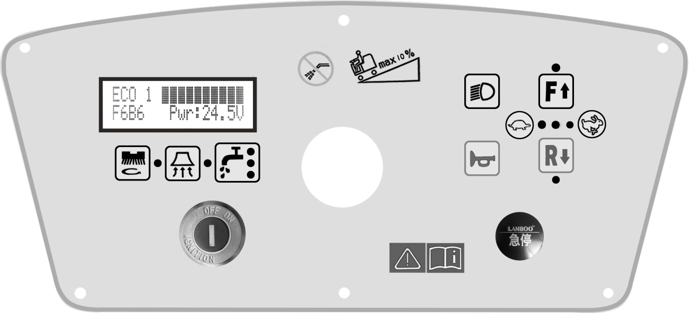

[键入文档的引述或关注点的摘要。您可将文本框放置在文档中的任何位置。请使用“绘图工具”选项卡更改引言文本框的格式。]

|  |  |  |
| --- | --- | --- |
| NO. | Description | Function |
| 1 | LCD display | Display the functional status of the machine. |
| 2 | Brush motor button | Short press the button, the brush disk push rod drops and the brush motor works. |
| Long press the button, perform automatic brush loading. |
| 3 | Vacuum motor button | Short press the button, lower the squeegee assembly, and vacuum motor works. |
| Long press the button to enter ECO energy-saving mode. |
| 4 | Key switch | Control the main power supply of the machine. Turn the key to "OFF" when charging. |
| 5 | Solution flow button | Short press the button to adjust the amount of liquid, the flow increases step by step. |
| Long press the button, perform automatic brush unloading. |
| 6 | Horn button | Press the horn button and a beep will be issued. |
| 7 | Emergency button | Press the emergency button, the machine stops working. |
| 8 | Backward button | Press the backward button, step the accelerator pedal, the machine will move backward. |
| 9 | Acceleration button | Press the button with rabbit symbol to increase the speed, 3 indicator lights on indicate the fastest speed. |
| 10 | Forward Button | Press the forward button, step the accelerator pedal, the machine will move forward. |
| 11 | Deceleration button | Short press the button with turtle symbol to reduce the speed, 1 indicator light on indicate the slowest speed. |
| 12 | Front lamp button | Short press the button to turn the front lamp on/off. |
| Long press the button to enter the LCD display interface and the working state of the machine can be read. |

## TECHNICAL DATA

|  |  |  |
| --- | --- | --- |
| Model | | NR530 |
| Rated power | W | 1500 |
| Brush motor rated power | W | 550 |
| Drive motor rated power | W | 550 |
| Vacuum motor rated power | W | 400 |
| Vacuum | kPa | >12 |
| Voltage (DC) | V | 24 |
| Sound pressure level at 1.5 m (ISO 3744) | dB (A) | 68±3 |
| Max. speed | km/h | 6 |
| Product dimensions (L*W*H) | mm | 1260*600*1010 |
| Brush speed | rpm | 180-200 |
| Solution/ Recovery tank capacity | L | 70/70 |
| Brush pressure | kg | 35 |
| Cleaning path | mm | 530 |
| Turning radius | mm | 1300 |
| Gradeability | % | 10 |
| Clean productivity (theoretical/ actual) | m²/h | 3180/ 2120 |
| Insulation class |  | III |
| Brush/ Pad diameter | mm | 500/ 500 |
| IP protection class |  | IP24 |
| Net weight (without batteries) | kg | 150 |
| Water flow | L/ min | 1.2 |
| Continuous working time (12V120AH*2) | H | 3-4h |
| Battery compartment size (L*W*H) | mm | 590*390*350 |
| Gross weight (with batteries) | kg | 220 |
| Brush disk quantity |  | 1 Disc |

## ELECTRICAL WIRING DIAGRAM

M1: Drive motor

M2: Vacuum motor

M3: Brush motor

M4: Motor for squeegee system

M5: Motor for brush system

# OPERATION INSTRUCTIONS

**C:\Users\LGS\Desktop\图片1.png图片1WARNING!**

**If the battery is installed or wired incorrectly, the electrical components of**

**the machine may be seriously damaged. The battery must be installed by**

**qualified personnel. Equip the machine with correct charger according to**

**the battery. Please check if the battery is damaged before assembling.**

**Disconnect the battery connector and charger plug. Handle the batteries**

**with great care.**



**NOTE**

**This machine requires two 12V batteries or one 24V lithium battery, please follow the drawing for wiring.**

## INSTALLING BATTERIES

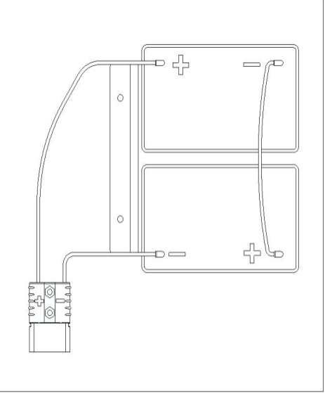

1. Open the recovery tank lid to check whether the recovery tank is empty, if not, drain it through the drain hose.
2. Hold the grip under the seat to open the the recovery tank till the tank rope is in tension.
3. Carefully and correctly place the battery into the battery compartment.
4. Complete the wiring as shown in the picture. Tighten the lock screw on the battery.
5. Connect the battery with machine though the connector.
6. Hold the grip under the seat to close the recovery tank carefully.

C:\Users\LGS\Desktop\图片1.png图片1

**CAUTION!**

**Ensure to hold the grip under the seat when close the recovery tank in case of hand-pinching.**

## EMERGENCY STOP

If there is any emergency during machine operating, press the emergency button on the control panel, then all functions of machine will stop, nothing will be displayed on the control panel. Push emergency button to restore the power supply.

## INSTALLING AND REMOVING DISK BRUSHES/PADS

**NOTE**

**According to the conditions of the floor to choose the appropriate brush disc or pad driver for cleaning.**

**C:\Users\LGS\Desktop\图片1.png图片1CAUTION!**

**Before manually installing or uninstalling the brush disc or pad driver, ensure that all switches of the machine are off. Protective gloves must be worn during operation to avoid injury by debris.**

**NOTE**

**The machine has the function of automatic loading and unloading of brush disc/ pad driver. It is not recommended to manually install/ remove the brush disc or pad driver. Specific steps are as follows:**

1. Turn the key switch to "ON" position (the brush disk and squeegee assembly will automatically return to the original position).

2. Put the brush disk/ pad driver under the brush deck and place it in the center.

3. Long press the "brush motor button", the brush motor indicator flashes, the brush deck is lowering and the brush motor rotates until the brush/pad is locked by the buckle. Release the "brush motor button", the brush loading is completed, the brush motor stops, and the front push rod is lifted.

4. Long press the "solution flow button" to enter the automatic brush unloading mode. When three indicator lights flash, you can release the button, and the controller will automatically complete the brush unloading process and the solution flow indicator lights stop flashing.

5. Manually loading/unloading the brush/pad. Align the brush/pad driver with the central axis, manually rotate the brush/pad counterclockwise for installing. Removing the brush/pad by rotating contrariwise.

C:\Users\LGS\Desktop\图片1.png图片1

**WARNING!**

**Do not operate the machine until the brush/pad is well-installed.**

## ATTACHING SQUEEGEE ASSEMBLY

1. Turn the key switch to "ON" position.

2. Press the "Vacuum motor button", the squeegee assembly will be automatically lowered to the ground.

3. Unscrew the two knobs on the squeegee assembly and lock it into the groove on the squeegee holder.

4. Tighten the knobs on the squeegee assembly and connect the vacuum hose to the squeegee.

## SOLUTION TANK FILLING

1. Open the fill-port lid in the front of the machine.

2. Fill the cleaning water or suitable detergent with hose. The solution tank water level can be checked by the indicator hose on the side. When the float ball reaches "F" position, the solution water tank is full. The temperature of the filling water or detergent shall not exceed +104F (+40°C).

**NOTE**

**When the float ball exceeds "F" position, excess water will be spilled from the top of the water level indicator hose. Avoid the float ball exceeding the "F" position when filling water.**

**C:\Users\LGS\Desktop\图片1.png图片1WARNING!**

**Use only low-foam and non-flammable detergent, which should be suitable for the scrubber.**

## START AND STOP OF MACHINE

1. Prepare the machine as shown in previous paragraph. Operator sits on the seat and turn the key switch to "ON" position. If the BDI display 100% of battery charge, it means the battery is fully charged and available for use. If the BDI displays 10%, the battery needs to be charged. Turn the key switch to "OFF" and charge the battery fully. (See Maintenance Chapter)
2. Press the "brush motor button" and "vacuum motor button", the indicator light will be on, the squeegee and the brush will be automatically lowered to the ground. Brush motor and vacuum motor start running.
3. According to the cleaning demand, the solution liquid flow can be adjusted through the "solution flow button" on the control panel, three different flows are available. Three indicator lights on indicates the maximum flow. Visually check the water level indicator hose on the side of the solution tank. When the float ball reaches the bottom, the water of the solution tank is going to be empty, fill the water accordingly.
4. The speed of the machine can be adjusted through the "tortoise/rabbit button" on the panel. Press the "tortoise button" to decelerate, and press the "rabbit button" to accelerate. Three levels of speed are available. Speed can be adjusted by operating the accelerator pedal, the more force on the pedal, the faster machine travels. Reduce the force on the accelerator pedal slowly, move the steering wheel and start scrubbing.
5. Press the "R" button to move the machine backwards. When the machine backward, the squeegee assembly and brush disc will be automatically lifted and the machine stops cleaning automatically.
6. In case of sudden crowd or crowded situation, operator can press the "horn button" for warning, the machine will issue a "beep" sound.
7. If work in the dark area, press "front lamp button" to turn on the front LED lamp.
8. Press “emergency button" to stop the machine immediately in case of emergency.
9. Release the accelerator pedal to stop the machine.
10. Press the "brush motor button" and "vacuum motor button" again, the indicator light will be off and the squeegee and the brush will be automatically lifted. The brush motor shuts down and the vacuum motor shuts down after a few seconds.
11. Make sure to park the machine and turn the key switch to "OFF" position.

**C:\Users\LGS\Desktop\图片1.png图片1CAUTION!**

**To avoid any damage to the floor surface, turn off the brush/pad driver when the machine stops in an area.**

**C:\Users\LGS\Desktop\图片1.png图片1CAUTION!**

**Do not use the machine when the battery charge is low, to avoid damaging the batteries and reducing the battery life.**

# DRAINING TANKS

1. The float shut-off screen will block the inspiratory path of vacuum motor when the recovery tank is full, and the vacuum motor can not suck the floor dry. Please stop working immediately.

2. Turn off the brush motor and vacuum motor to lift the brush disk and squeegee assembly.

3. Move the machine to the designated drainage area.

4. Drain the recovery tank through the drain hose, then rinse the recovery tank with clean water.

C:\Users\LGS\Desktop\图片1.png图片1**WARNING!**

**When the recovery tank is full, please stop working immediately to avoid**

**sewage entering the vacuum motor.**

## DRAINING SOLUTION TANK

Unscrew the solution tank tap cover under the accelerator pedal to drain the solution liquid.

## AFTER USE

After working, complete the following steps before leaving the machine:

1. Remove the brush disk/pad driver according to the procedures shown in previous chapter.
2. Drain the solution tank and recovery tank according to the procedures described above.
3. Perform the daily maintenance procedures (see the maintenance chapter).
4. Store the machine in a clean and dry place, with the brush disk/ pad driver and the squeegee lifted or removed.

## AFTER LONG-TERM INACTIVITY

If the machine is not going to be used for more than 30 days, proceed as follows:

1. Perform the procedures shown in chapter of After Use.
2. Disconnect the battery and the machine.

## INITIAL USE

After the first 8 hours of use, check if the fastening and connecting parts of the machine are loose, and check for visible damage and leakage.

## **MAINTENANCE**

**WARNING!**

**C:\Users\LGS\Desktop\图片1.png图片1The procedures must be carried out with the machine off and the battery disconnected. Moreover, read carefully the instructions in the Safety chapter before performing any maintenance procedures.**

## REGULAR MAINTENANCE CHECKLIST

MCj04113200000[1]**CAUTION!**

**The procedure marked with (1) must be performed when the machine is**

**used after 8 hours for the first time. The procedure marked with (2) must**

**be performed by an authorized service center.**

|  |  |  |  |  |
| --- | --- | --- | --- | --- |
| Check Item | Daily  (after use) | Weekly | Semi-  -annually | Yearly |
| Charge battery |  |  |  |  |
| Clean squeegee |  |  |  |  |
| Clean brush/pad |  |  |  |  |
| Clean solution tank and recovery tank |  |  |  |  |
| Check seal of tanks |  |  |  |  |
| Check squeegee, replace it if necessary |  |  |  |  |
| Clean solution tank filter |  |  |  |  |
| Clean vacuum motor filter |  |  |  |  |
| Check if all screws and nuts are tightened |  |  | 1 |  |
| Check brush/ pad driver, replace it if necessary |  |  |  | 2 |
| Check carbon brush of vacuum motor, replace it if necessary |  |  |  | 2 |
| Check carbon brush of drive motor, replace it if necessary |  |  |  | 2 |

## C:\Users\LGS\Desktop\图片1.png图片1CHARGING BATTERY

**NOTE**

**Charge the battery when BDI on the LCD display shows less than or equal to two notches, or charge the battery after every use.**

**C:\Users\LGS\Desktop\图片1.png图片1CAUTION!**

**Keep the battery fully charged to extend the service life of the battery.**

**C:\Users\LGS\Desktop\图片1.png图片1CAUTION!**

**Charge the battery as soon as possible when the battery is low, otherwise the service life of the battery will be shortened. Check the battery at least once a week.**

1. Move the machine to designated charging area.
2. According to the type of the battery, choose the appropriate charger for charging.
3. Connect the charger connector to the socket under the seat of the machine, and then connect the charger plug to the power supply.
4. After charging the battery, disconnect the charger plug from the power supply, and then disconnect the connector from the machine.

## CLEANING DISK BRUSH/ PAD

**C:\Users\LGS\Desktop\图片1.png图片1CAUTION!**

**Wear protective gloves when cleaning the brush/pad in case of the injury by the sharp debris.**

1. Remove the brush disk/ pad driver from the machine, as shown in the previous chapter.
2. Clean the brush disk (pad driver) and brush (pad) with cleaning solution and water.
3. Check the condition of the brush/pad for wear, and replace it if necessary.

## CLEANING SOLUTION FILTER

1. Turn off the water tap of the solution tank.
2. Remove the filter cover and clean the filter, then fit it back in place.
3. Turn on the water tap of the solution tank and check if the filter is properly installed without leakage.

## SQUEEGEE CLEANING AND STORAGE

**NOTE**

**The squeegee must be clean and its blades must be in good conditions in order to achieve better scrubbing.**

**C:\Users\LGS\Desktop\图片1.png图片1CAUTION!**

**It is advisable to wear protective gloves when cleaning the squeegee in case of the injury by the sharp debris.**

1. Loosen the knobs on the squeegee assembly and remove the vacuum hose from the squeegee.
2. Clean the aluminum bracket squeegee and the vacuum hose. Check the front blade and the rear blade for integrity, cuts and tears; replace them if necessary.
3. Assemble the squeegee in the reverse order of disassembly.

## SQUEEGEE BLADE CHECK AND REPLACEMENT

1. Check the edges of front blade and rear blade for integrity, cuts and tears; if the bottom edge of the blade is worn, turn it upside down (the top edge is intact). If the top edge is worn, replace the blade according to the following procedures:
2. Loosen the buckle, release pressure strip from the retainers and remove the retaining strip. Replace the worn blade and assemble the new rear blade in the reverse order of removal.
3. Unscrew the knob and remove the retaining strip, then replace the front blade. Assemble the front blade in the reverse order of removal.

## RECOVERY TANK CLEANING AND CHECK

1. Drain the recovery tank by drain hose.
2. Open the recovery tank and remove the recovery tank lid, then rinse the recovery tank lid and recovery tank with clean water.
3. Check whether the bearing surface of the sealing of the recovery tank is intact and sealed, remove the sealing from the tank and replace it if necessary.
4. Fit the recovery tank lid in place.

## READ RUNNING DATA

Long press the "front lamp button" to enter the LCD interface, working data of the machine can be read. There are four interfaces in total.



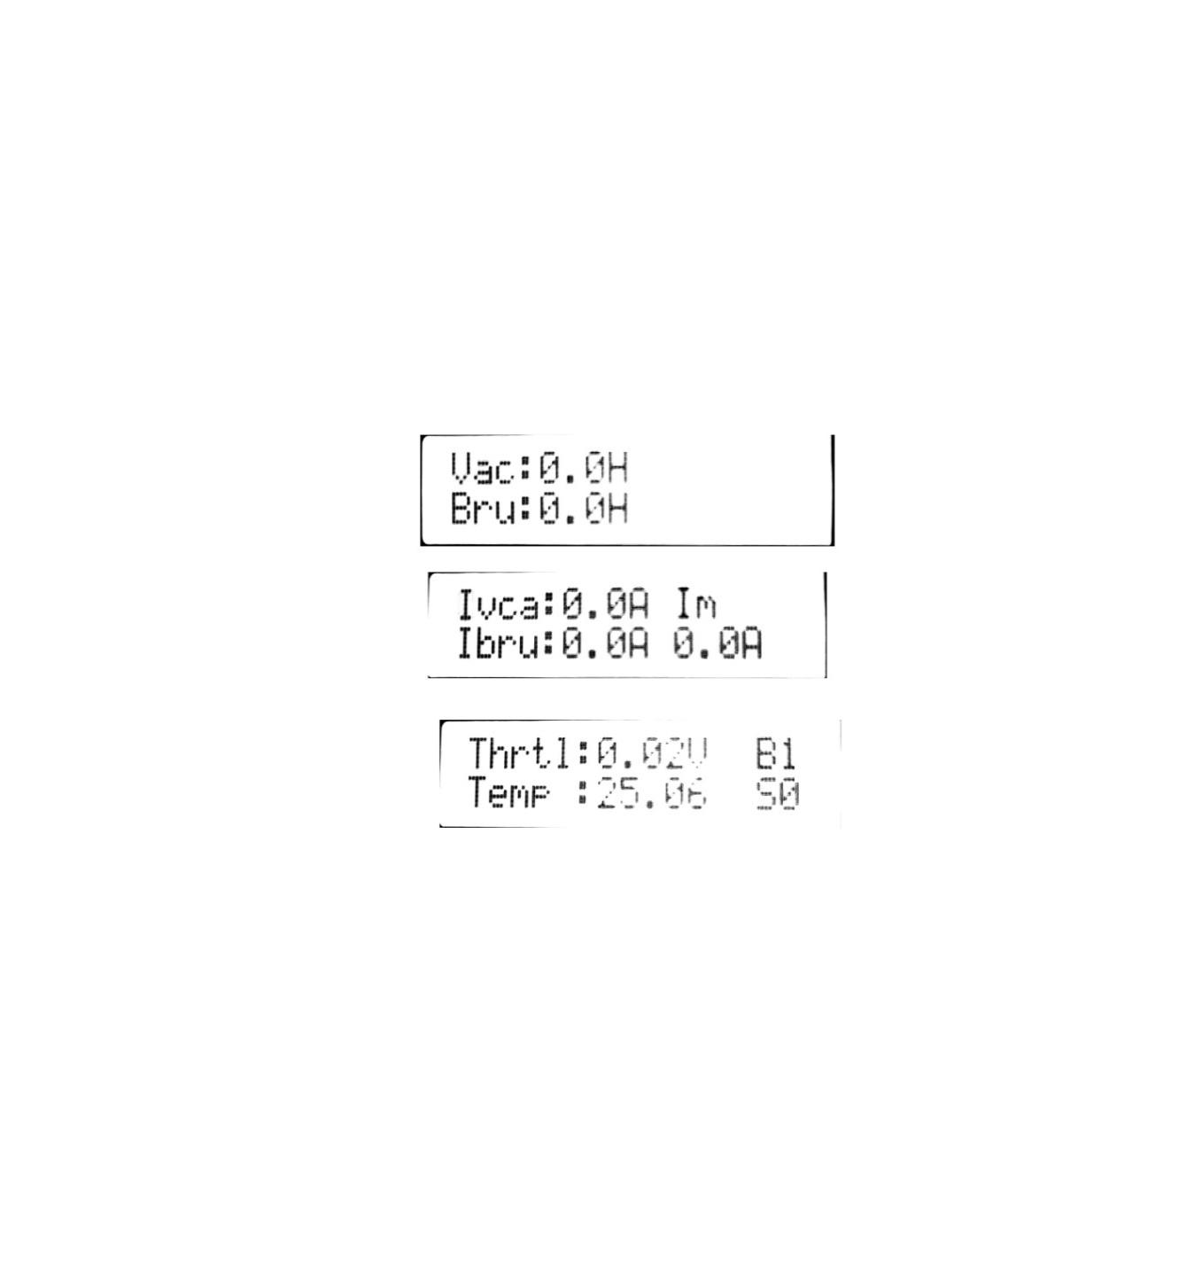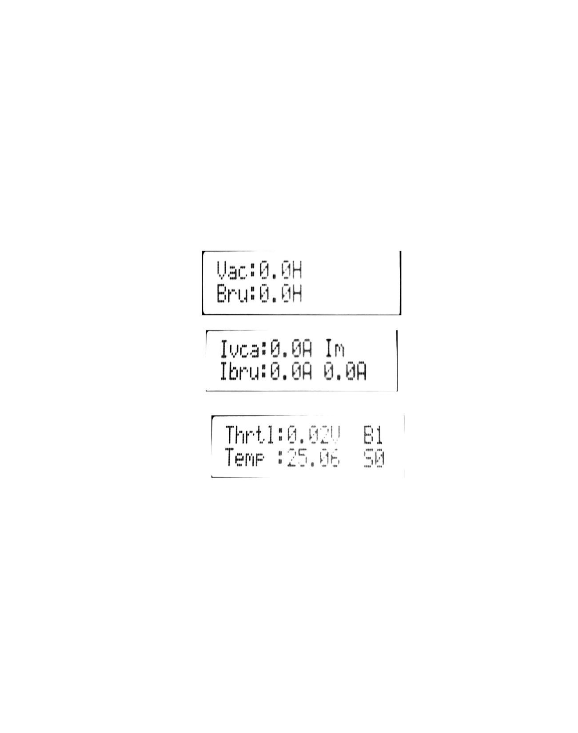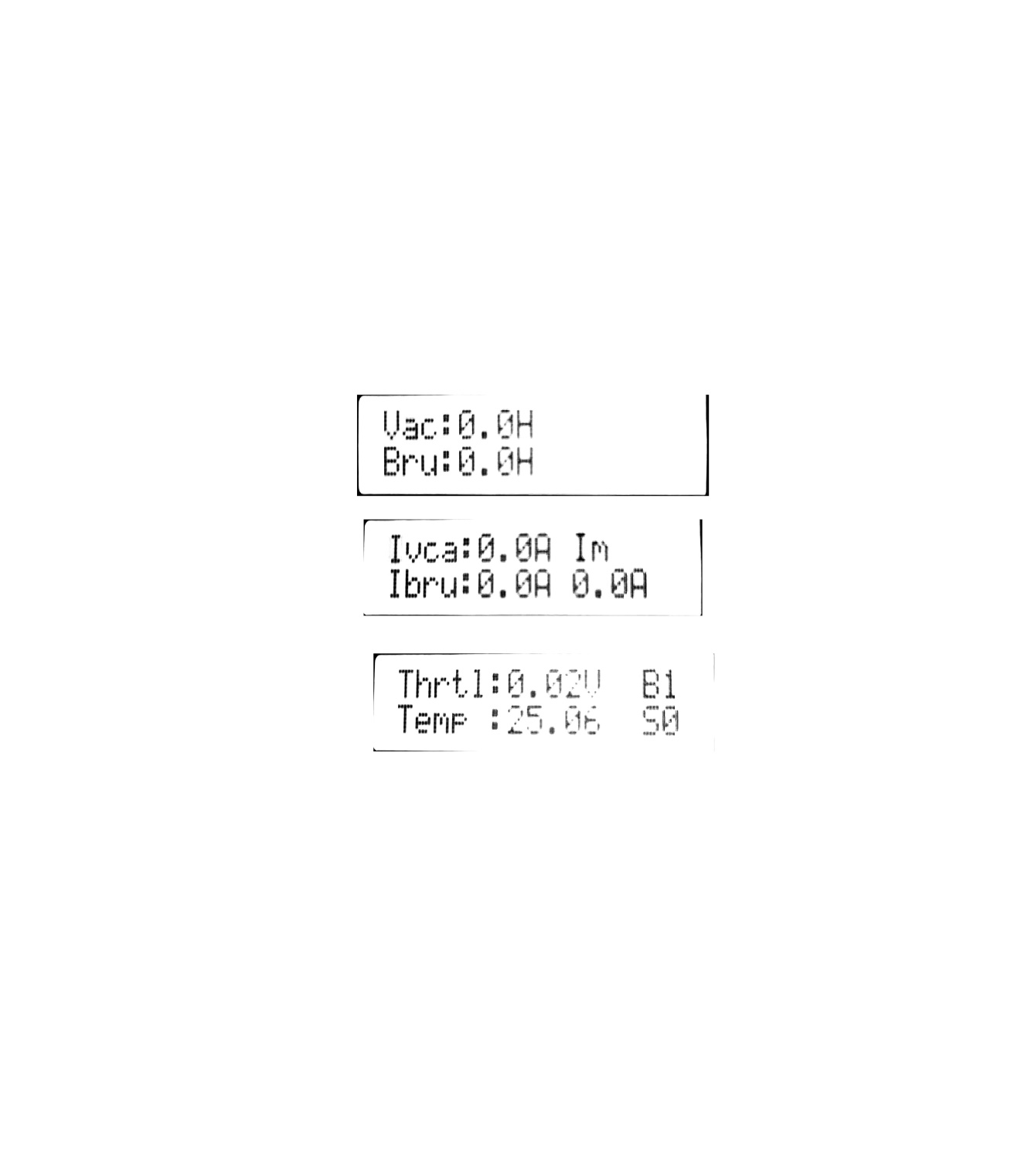

P1

P2

P3

P4

# TROUBLE SHOOTING

|  |  |  |
| --- | --- | --- |
| **Trouble** | **Possible Cause** | **Remedy** |
| The machine doesn't work and the LCD display doesn't light up | The battery connector is disconnected | Connect the battery connector |
| The batteries are completely discharged | Charge the batteries |
| 10% The machine don’t work, and the battery is displayed at 10% | Low battery | Charge the batteries |
| The machine do not go-forward/backward | Control circuit board failure | Replace the control circuit board |
| Operator is not on the seat or seat switch failure | Sit on the seat or replace seat switch |
| Accelerator pedal is unconnected or damaged | Check the cable or replace the accelerator pedal |
| The brush motor does not work | Control circuit board failure | Replace the control circuit board |
| Brush motor overload | Use soft bristle brush that is suitable for cleaning, and reset the brush motor overload protector |
|
| Brush motor carbon brush wearing | Contact after-sales service |
| Obstacles prevent the brush rotating | Clean the brush |
| The vacuum motor does not work | Vacuum motor damage | Check and replace vacuum motor |
| Control circuit board failure | Replace the control circuit board |
| Insufficient suction, the floor cannot be dried | Recovery tank is full | Empty the recovery tank |
| Drain hose and squeegee poor connection | Connect the drain hose and squeegee correctly |
| Squeegee is dirty or wearing | Check and clean the squeegee |
| Recovery tank cover is not closed properly, or the seal is damaged, or the hose is clogged | Close the cover correctly, or replace the gasket or clean the Bend tube. |
| Recovery tank is dirty | Clean the recovery tank |
| Insufficient solution supply to brush plate | Solution filter is dirty | Clean the filter |
| Dirty solution tank or a clogged pipeline | Clean the solution tank and piping |
| Squeegee leaves scratch on the floor | There are debris under the squeegee blade | Remove the debris |
| Squeegee blade wear, crack, aged | Replace the squeegee blades |

## LCD DISPLAY FAULT CODE

|  |  |  |
| --- | --- | --- |
| LED Display | **Possible Cause** | **Remedy** |
| Low battery | Low voltage | 1. Charge the battery. 2. Check the voltage detection circuit of the controller. |
| Traction error | Drive motor wire connection open | Check if the drive motor and electromagnetic brake are normal. |
| High temperature | Controller temperature is too high. | 1. Whether the machine has been overloaded and climbing continuously for a long time. 2. Whether the motor is overloaded because the machine has cleaned the extremely rough roads for a long time. 3. Whether the controller installation position is well ventilated or other heat sources are there. 4. Check the temperature detection circuit of the controller. |
| Brush overcurr | Brush motor current is too high. | 1. Check if the machine has been working on extremely rough roads for a long time. 2. Check the brush motor. |
| Vacuum overcurr | Vacuum motor current is too high. | Check the vacuum motor. |
| Vacuum open | Vacuum motor wire connection open | The vacuum motor is faulty or the connection is disconnected. |
| Brush open | Drive motor wire connection open | The brush motor is faulty or the connection is disconnected. |
| Fjmk overcurr | Brush deck push rod motor over current | 1. Check whether the machine is blocked 2. Check the brush deck push rod motor. |
| Bjmk overcurr | Squeegee assembly push rod motor over current | 1. Check whether the machine is blocked . 2. Check the squeegee lifting push rod motor. |
| Prechange error | Charge failure | 1. The battery voltage is low. 2. Check the controller. |
| Pedal error | Accelerator pedal release issue | 1. Step on the accelerator pedal when the key switch is turned on. 2. Check whether the input voltage of the pedal is normal, check the wiring of the J2 of pedal. 3. Check the wiring of J3 to J8. |
| Drive open | Drive motor wire connection open | Check the drive motor and related wiring. |
| Drive overcurr | Drive motor current is too high. | Check the drive motor and electromagnetic brake. |
| Brake open | Electromagnetic brake open circuit | Check the electromagnetic brake position and coil resistance. |
| No LCD display | LCD display is broken. | Replace the panel. |
| No battery charge notches and F6B6 on LCD display, and voltage displays 0 after booting | 1. The controller is not powered on. | 1. Check if there is voltage on the 5th pin of J2 of the controller; |
| 2. The signal cable between the controller and the panel is not connected. | 2. Check whether the connection cable between J3 of controller and J8 of panel is connected. |
| LCD display voltage is 0 after booting | Communication between the drive circuit of the controller and control panel is not established. | Check whether the 5th and 6th pins of the controller J3 are connected to the J8 of panel. |
| The LCD does not display the battery charge notches after power on | Communication between the vacuum circuit of the controller and control panel is not established. | 1. Check if the 3rd and 4th pins of controller J3 are connected to the panel.  2. Turn off the machine and restart. |

**C:\Users\LGS\Desktop\图片1.png图片1CAUTION!**

**When there is a fault alarm, please turn off the power and wait 5 seconds before restarting.**

# SCRAPING AND DISPOSE

1. Have the machine scrapped by a qualified scrapper.
2. Before scrapping the machine, remove and separate the following materials, which must be properly

disposed of according to relevant laws and regulations:

– Battery

– Brush disk/pad driver

– Plastic hoses and components

– Electrical and electronic components (*)

## HAZARDOUS SUBSTANCE AND CONTENT

|  |  |  |  |  |  |  |
| --- | --- | --- | --- | --- | --- | --- |
| Item | Hazardous substance | | | | | |
| Pb | Hg | Cd | Cr (VI) | PBB | PBDE |
| Battery | X | o | o | o | X | X |
| Charger | X | o | X | o | o | o |
| Chassis | X | o | o | o | o | o |
| Electronic accessories | X | o | X | o | X | X |
| Hose | X | o | o | X | X | o |
| Motor | X | o | o | o | X | X |
| Cable | X | o | X | X | o | o |
| Basic parts | o | o | o | X | o | o |
| Controller | X | o | o | o | o | o |
| Treatment/sewage | o | o | o | o | X | X |
| Brush/broom | o | o | o | o | X | X |
| This table compiles in accordance with SJ/T 11364. | | | | | | |
| O: Indicates that the content of the hazardous substance in all homogeneous materials of the part is below the limit requirement specified in GB/T 26572. | | | | | | |
| X: Indicates that the content of the hazardous substance in at least one of the homogeneous materials of the part exceeds the limit requirement of GB/T 26572. | | | | | | |