

Version 05/2021

NB530-SMS-001-EN  
xyz

MCj04113200000[1]

**Operator Manual  
NB530 Walk-Behind Floor Scrubber**

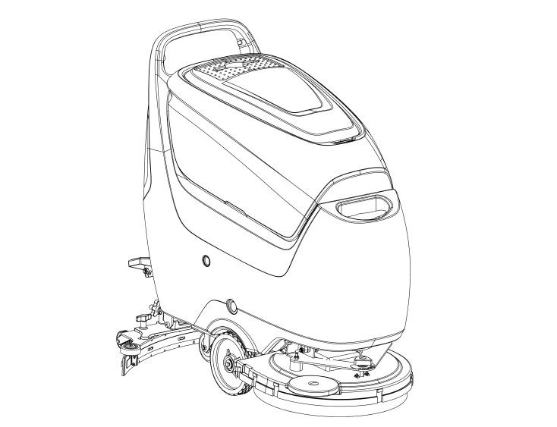

**WARNING**

**Do not operate the floor scrubber before reading and understanding the operator manual.**

**NOTE:**

* **Please check product type and parameters of your scrubber in this manual as well as on the ID-plate.**
* **Keep this operator manual for future reference.**

CONTENTS

INTRODUCTION 1

MANUAL PURPOSE AND CONTENT 1

HOW TO KEEP THE MANUAL 1

DECLARATION OF CONFORMITY 1

ACCESSORIES AND MAINTENANCE 1

CHANGE AND IMPROVEMENT 2

INTENDED USE 2

MACHINE IDENTIFICATION 2

TRANSPORTING AND UNCRATING 2

SAFETY 3

SAFETY SYMBOLS 3

GENERAL SAFETY INSTRUCTIONS 3

MACHINE SETUP 6

MAIN COMPONENTS 6

MAIN COMPONENTS DESCRIPTION 8

TECHNICAL DATA 9

ELECTRICAL WIRING DIAGRAM 10

OPERATION INSTRUCTIONS 10

INSTALLING BATTERIES 10

INSTALLING AND REMOVING DISK BRUSHES/PADS 11

ATTACHING SQUEEGEE ASSEMBLY 11

START AND STOP OF MACHINE 11

DRAINING TANKS 12

AFTER USE 13

AFTER LONG-TERM INACTIVITY 13

INITIAL USE 13

MAINTENANCE 13

REGULAR MAINTENANCE CHECKLIST 14

CHARGING BATTERY 14

CLEANING SQUEEGEE 15

SQUEEGEE BLADE CHECK AND REPLACEMENT 15

CLEANING BRUSH/PAD 16

VACUUM FILTER CLEANING 16

SOLUTION FILTER CLEANING 17

TROUBLESHOOTING 17

FAULT CODE 17

COMMON TROUBLE SHOOTING 18

SCRAPPING AND DISPOSE 19

HAZARDOUS SUBSTANCE AND CONTENT 19

# INTRODUCTION

**NOTE**

**The code of related components in ( ) can be found in the chapter of machine**

**description.**

## MANUAL PURPOSE AND CONTENT

* This manual is to provide the operator with the necessary information for the correct and safe use of the machine, which includes the technical data, safety, operation, storage, maintenance, accessories and dispose of the machine.
* Before performing any operation or maintenance on this machine, the operator and the qualified technicians must read this manual carefully.
* If you have any questions about the explanation of this manual or want more related information, please contact our company.
* The purpose of this manual is to allow operators and qualified technicians to carry out the maintenance of the machine. The operator is not allowed to perform the steps that must be completed by the technicians. All instructions in this manual should be seriously followed, otherwise our company shall not be liable for any losses arising therefrom.

## HOW TO KEEP THE MANUAL

* This manual must be placed near the machine. Properly keep the manual away from water, fire or other dangers.

## DECLARATION OF CONFORMITY

* The declaration of conformity is provided with the machine to prove that the machine complies with relevant criteria and regulations.



#### NOTE

**The certificate of conformity is provided with the documentation of the machine.**

## ACCESSORIES AND MAINTENANCE

* All necessary operation, maintenance and repair procedures must be performed by qualified personnel or the maintenance center designated by our company. Only original spare parts and accessories are allowed to be used on the machine.
* If you need service or want to order spare parts or accessories, please contact our company's after-sales service department or the agent, and provide the model and serial number of the machine.

## CHANGE AND IMPROVEMENT

* Our company is committed to the continuous improvement of the products and reserves the right to notify the improvements and changes of the products that have been sold.

## INTENDED USE

* This floor scrubber can be used in commercial and industrial environments, and it is suitable for cleaning smooth and hard floors (washing and sewage collecting). It must be used in a safe environment by a qualified operator. This scrubber is not suitable for cleaning outdoors floors, carpets or rough floors.

## MACHINE IDENTIFICATION

* The model and serial number of this machine are marked on the identification label. The information on this label is very important, which is required to be provided when you order the accessories for the machine.

## TRANSPORTING AND UNCRATING

* Carefully check machine for signs of damage. Report damages at once to carrier. Record the damages on paper to reserve the right for compensation.

After uncrating, check if the machine is equipped with the following items:

1.Technical documents, including operation manual;

2. Battery connecting cable.

# SAFETY

The following symbols indicate potential dangers. In any case, please read this information carefully and take necessary precautions to avoid possible injury and property loss. It is necessary to have cooperation of the operator to avoid injury, otherwise any precautions are ineffective. Most of the safety accidents that occur in factories are caused by people who fail to obey simple and effective instructions during working and walking. A careful and prudent operator is the best guarantee against accidents and is essential for successful completion of any prevention program.

## MCj04113200000[1]SAFETY SYMBOLS

#### DANGER！

**It indicates the danger that may cause death of the operator.**

MCj04113200000[1]

**WARNING！**

**It indicates a potential hazard that may cause people injury and objects damage.**

MCj04113200000[1]

**CAUTION！**

**It indicates a caution related to important or useful functions.**

**Pay attention to the paragraphs marked by this symbol.**



**NOTE**

**It indicates notes on important matters and useful functions.**



**CONSULTATION**

**It indicates the necessity to refer to the instructions of this manual before performing**

**any procedures.**

## GENERAL SAFETY INSTRUCTIONS

Specific warnings and cautions for potential damages to personnel and machine are notified as follows:

MCj04113200000[1]

#### DANGER！

* Disconnect the battery before performing any maintenance/repair procedures.
* Only trained or authorized personnel is allowed to use this machine. Children or disabled people cannot use this machine.
* Keep the battery far from sparks, flames and incandescent material. During the normal operation explosive gases are released.
* Do not wear jewelry when working near electrical components.
* Do not work on the ground that cannot bear the weight of the machine.
* Do not use the machine near toxic, dangerous, flammable, explosive dust, liquid, or steam.
* The battery will produce explosive hydrogen during the charging process. Please keep the recovery tank open during charging, and ensure that the surrounding area is well ventilated and away from open flames.

MCj04113200000[1]

#### WARNING!

* Please check if the values of voltage and frequency indicated on the serial number sticker match with the power before using the on-board charger.
* Do not move the machine by pulling the charger cord, do not let the cord pass through a closed door,

or wind the cord around objects with sharp edges or angles, and do not let the machine run over the cord. Please keep the charger cord away from hot surfaces.

* Do not charge the battery when the wire or plug is damaged. If the machine is damaged, not working properly, has been placed outdoors or dropped into water, please return the machine to the repair center.
* In order to avoid fire, electric shock or personal injury, please make sure someone is on duty when the machine is energized. Before taking any maintenance or repair, please disconnect the charger from the power supply.
* Do not smoke while charging.
* The machine must be protected from sunlight, rain and bad weather. Please store the machine indoors.
* Do not use the machine as a toy. Be careful when there are children nearby.
* The machine can only be used under the instructions manual, and only the accessories approved by the company can be used.
* Take precautions to avoid the danger that hair, jewelry and loose clothes may be caught by the moving parts of the machine.
* The responsible personnel can leave the machine only after confirming that the machine cannot move itself, otherwise someone must be on duty there.
* Please do not use the machine on a slope exceeds the specified angle.
* Please do not use the machine in particularly dirty areas.
* When using the machine, please be careful not to injure people or objects around.
* Do not collide with the surrounding shelves, especially when the collision may cause the danger of falling objects.
* Keep the machine away from corrosive liquids.
* The storage temperature and working ambient temperature of the machine must be between 0-40°C (32°F~104°F).
* The humidity of the air must be between 30%-95%.
* Do not use the machine as a means of transportation.
* Do not use the machine on a slope higher than 2%.
* For stationary machine, stop the working brush to avoid damage to the ground.
* When the machine catches fire, please use dry powder fire extinguisher instead of liquid one.
* Do not change the safety protection of the machine, be sure to follow the maintenance instructions carefully.
* Keep the working area unobstructed and do not use the machine in blocked aisle. Remove dust, hair and any objects that may obstruct the air circulation from the aisles.
* Do not remove or change the stickers on the machine.
* The vibration generated by the machine when operating in accordance with the instructions is safe. The vibration of the machine should be lower than 2.5m/s² (98/37/EEC-EN 1033/1995).
* This machine cannot be used on roads or public streets.
* Be careful when transporting the machine when the temperature is below 0°C (32°F). The water in tanks and hoses may freeze and seriously damage the machine.
* Please use the brushes and pad provided with the machine and the parts specified in the instruction manual. Other brushes and pads may reduce security.
* In case of machine malfunctions, ensure that these are not due to lack of maintenance. If necessary, request assistance from the authorized personnel or from an authorized service center.
* If the accessories really need to be replaced, please obtain original accessories from an authorized dealer or agent.
* In order to ensure the safe and correct use of the machine, please ask authorized personnel or maintenance center to perform regular maintenance according to the manual.
* Please read all relevant instructions carefully before performing any maintenance/repair procedures.
* Do not directly rinse the machine with water or corrosive materials.
* This machine must be properly disposed because of the toxic and hazardous materials (batteries, etc.) that must be disposed by a specific center in accordance with relevant regulations (see the chapter for disposal).

# MACHINE SETUP

## MAIN COMPONENTS

1. Control panel
2. Handle
3. Recovery tank lid
4. Recovery tank
5. Hinge
6. Solution tank
7. Brush disk cover
8. Brush disk/ Pad driver
9. Load wheel
10. Solution tank level hose
11. Caster
12. Recovery tank drain hose
13. Squeegee vacuum hose
14. Squeegee adjusting knob
15. Squeegee fixing knob
16. Squeegee blade
17. Squeegee lift/lower foot pedal
18. Squeegee lifting lever
19. Charging socket
20. Float shut-off screen
21. Float shut-off screen holder
22. Solution tank fill-port
23. Solution tank filter
24. Draining electromagnetic valve
25. Filter
26. Solution tank drain tap
27. Solution tank water tap

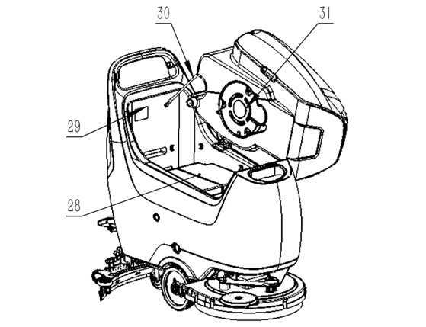

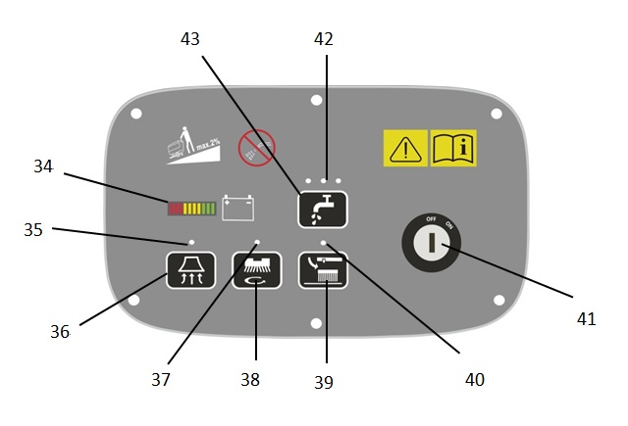

1. Battery
2. Identification plate
3. Tank rope
4. Vacuum pressure plate
5. Balance adjusting knob
6. Brush angle adjusting knob
7. Battery indicator/ fault code display
8. Vacuum motor button indicator
9. Vacuum motor button
10. Brush/pad driver indicator
11. Brush/pad driver button
12. Brush/pad driver removal button
13. Brush/pad driver removal indicator
14. Key switch
15. Solution flow indicator
16. Solution flow button

## MAIN COMPONENTS DESCRIPTION

**Control panel (1)** --This panel is the control part of the machine, see the description of control and switch.

**Handle (2)** -- Hold this handle and operate the machine through it.

**Recovery tank lid (3)** -- This lid seals the recovery tank. When cleaning the recovery tank, it can be taken off and hanged on the fill-port.

**Recovery tank (4)** -- This tank stores sewage sucked up by squeegee.

**Hinge (5) --** This hinge connects solution tank and recovery tank.

**Solution tank (6)** -- This tank stores solution/clean water.

**Brush disk cover (7)** -- This brush cover mounts brush disk, pad driver and the brush motor.

**Brush disk/ Pad driver (8)** -- A brush disk or a pad driver with a polishing pad can be installed on the machine.

**Load wheel (9)** -- This wheel carries the weight of the machine.

**Solution tank level hose (10)** --This hose indicates the level of water in the solution tank.

**Caster (11)** -- This caster turns the machine.

**Recovery tank drain hose (12)** -- This hose drains dirty water from the recovery tank.

**Squeegee vacuum hose (13)** -- This hose transfers sewage from the squeegee to the recovery tank.

**Squeegee adjusting knob (14)** -- This knob adjusts the angle of the squeegee to be well-matched with the ground and the sewage can be well-sucked.

**Squeegee fixing knob (15)** -- This knob connects and fixes the squeegee to the machine.

**Squeegee assembly (16)** --This squeegee collects the dirty water after washing.

**Squeegee lift/lower foot pedal (17)** --This pedal lifts/lowers/presses the brush disk.

**Squeegee lifting lever (18)** -- The lever lifts or lowers the squeegee.

**Charging socket (19) --** This socket is used to charge the battery.

**Float shut-off screen (20)** -- Keep this part clean or the vacuum motor will be clogged.

**Float shut-off screen holder (21)** -- This fixes the floating shut-off screen.

**Solution tank fill-port (22)** -- This port makes filling water/ detergent (low-foam type) easier to the solution tank.

**Solution tank filter (23)** -- This filter prevents the dirt into the solution tank.

**Draining electromagnetic valve (24)** -- This valve controls the flow of water and the output.

**Filter (25)** -- This filter filters the solution liquid before supplying to the brush.

**Solution tank drain tap (26) --** This tap is used for emptying the solution tank.

**Solution tank water tap (27)** -- This tap is used for turning on/off the solution liquid.

**Battery (28)** -- This battery supplies power for the operation of the machine. The optional battery must be 24V.

**Identification plate (29)** -- This ID plate indicates the data of the machine.

**Tank rope (30)** -- This rope helps holding the open recovery tank.

**Vacuum pressure plate (31)** -- This plate fixes the filter sponge and protects the vacuum pump.

**Balance adjusting knob (32) --** This knob is used to adjust the horizontal balance of the brush disk/ pad driver to prevent shaking.

**Brush angle adjusting knob (33) --** This knob is used to adjust the angle of brush disk/ pad driver, which influence the machine speed.

**Battery indicator/ fault code display (34) --** This display indicates the battery charge level and fault codes.

**Vacuum motor indicator (35) --** This indicator light indicates the working state of the vacuum motor.

**Vacuum motor button (36) --** This button is used for turning on/off the vacuum motor.

**Brush/pad driver indicator (37)** -- This indicator light indicates the working status of the brush motor.

**Brush/pad button (38) --** This button is used for turning on/off the brush motor.

**Brush/pad removal button (39) --** Long press this button to automatically release the brush disk/ pad driver.

**Brush/pad removal indicator (40) --** This indicator light indicates the working status of the automatic brush removal switch.

**Key switch (41) --** This switch is used for turning on/off the power of machine.

**Solution flow indicator (42) --** The three indicator lights indicate three different solution flows.

**Solution flow button (43) --** This button is used for adjusting the flow of detergent/water supplied to the brush. Three flows are available.

## TECHNICAL DATA

|  |  |  |
| --- | --- | --- |
| Model | | NB530 |
| Machine Height | mm | 1060 |
| Solution tank capacity | L | 50 |
| Recovery tank capacity | L | 50 |
| Front wheel diameter | mm | 200 |
| Rear wheel diameter | mm | 100 |
| Vacuum motor power | W | 400 |
| Gradeability | % | 2 |
| Sound pressure level | dB (A) | 65.8 |
| Battery (maintenance free AGM) |  | (2*12V) 24V100Ah/3-4h |
| Battery compartment size (L*W*H) | mm | 360*360*240 |
| Vacuum capacity | mmH2O | ＞1055 |
| Scrubbing path width | mm | 530 |
| Squeegee width | mm | 760 |
| Maximum length | mm | 1228 |
| Machine width (without squeegee) | mm | 550 |
| Brush/pad diameter | mm | 530 |
| Net weight (without batteries) | kg | 89 |
| Brush motor rated power | W | 550 |
| Brush rotate speed | rpm | 160 |
| Minimum brush pressure | kg | 20.5 |
| Maximum brush pressure | kg | 27.8 |

## ELECTRICAL WIRING DIAGRAM

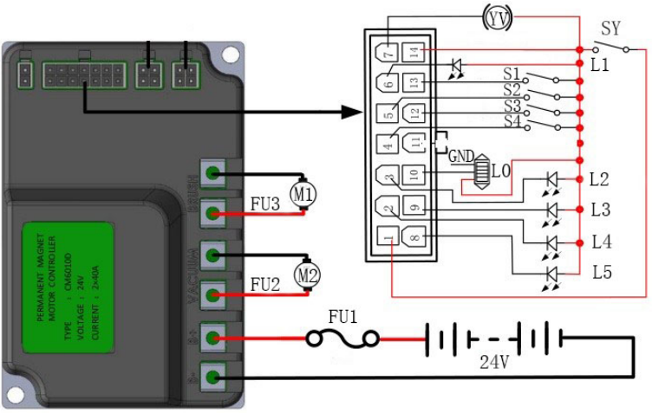

|  |  |  |  |
| --- | --- | --- | --- |
| M1 | Brush Motor | L2 | Vacuum motor indicator |
| M2 | Vacuum Motor | L3 | Water flow 2 |
| FU1 | Fuse 50A | L4 | Water flow 3 |
| FU2 | Current limit 40A | L5 | Water flow 1 |
| FU3 | Current limit 40A | S1 | Brush removing switch |
| YV | Water flow control EM valve | S2 | Brush motor switch |
| SY | Key switch | S3 | Water flow switch |
| L0 | BDI | S4 | Vacuum motor switch |
| L1 | Brush motor indicator |  |  |

# OPERATION INSTRUCTIONS

MCj04113200000[1]

**WARNING**

**If the battery is installed or wired incorrectly, the electrical components of the machine may**

**be seriously damaged. The battery must be installed by qualified personnel. Please check**

**whether the battery is damaged before assembling. Disconnect the battery connector and**

**charger plug. Handle the battery with great care.**

**This machine requires two 12V batteries, please follow the solution water tank drawing for wiring.**

## INSTALLING BATTERIES

1. Open the recovery tank lid (3) to check whether the recovery tank is empty, if not, drain it through the drain hose (12).

2. Remove the recovery tank lid (3), hang it on the solution tank fill-port (22), and then turn the recovery tank (4) to one side.

3. Put the battery into the battery compartment, wire it according to the solution tank drawings, and connect the battery to the machine through the connector.

## INSTALLING AND REMOVING DISK BRUSHES/PADS

The machine can be equipped with brush or pad depending on the different cleaning tasks.

1. Place the brush disk (A) or pad driver (B) under the holder.

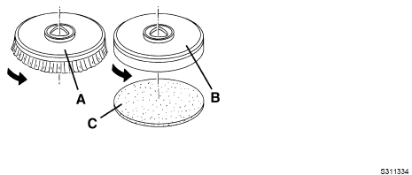

2. Operate the squeegee lower/lift foot pedal (17) to lower the holder for installing the brush/pad driver.

3. Start the machine through turning the key switch to "ON" position.

4. Turn on the brush disk/pad driver switch (38) and vacuum motor switch (36).

5. Gently push the machine forward to install the brush disk/pad driver. If necessary, repeat this operation until the brush disk/pad driver is installed.

6. Depress the foot pedal (17) to lift the holder in order to remove the brush disk/pad driver, and then press and hold the brush removal switch (39) until the indicator light flashes, and the brush disk/pad driver will fall to the ground automatically.

7. If you need to remove the brush manually, just rotate the brush disk/pad driver in the opposite direction to the normal direction.

## ATTACHING SQUEEGEE ASSEMBLY

Install the squeegee assembly (16) and tighten it with the squeegee fixing knob (15), and then assemble the vacuum hose (13) to the squeegee.

## START AND STOP OF MACHINE

**START THE MACHINE**

1. Follow the methods described above for preparation.
2. Turn on the key switch (41) to "I" position. Check the battery charge through the BDI. If the red light of BDI is on, please turn the key switch to "O" position and charge the battery.
3. Hold the handle and move the machine to the working area.
4. Use the lifting lever (18) to lower the squeegee (16).
5. Press the pedal (17) to place the brush disk/pad driver on the ground.
6. Press the brush disk/pad driver button (38) and vacuum motor button (36), the brush disk/pad driver indicator light (37) and vacuum motor indicator light (35) will be on.
7. Adjust the water flow according to the state of the ground to be cleaned, press the solution flow button (43) and adjust the water flow.
8. The angle adjusting knob can adjust the speed of the machine. Increase the tilt angle of the brush disk by turning the knob to the direction with rabbit mark, which makes it easier to push the machine and narrows the scrubbing path width. Decrease the tilt angle of the brush disk by turning the knob to the direction with tortoise mark, which makes it heavier to push the machine and widens the scrubbing path width. Adjustment depends on the cleanliness of the ground.
9. Adjusting the balance knob makes the machine walk straightly.
10. Check the squeegee if it works well, adjust the balance knob if necessary (14).
11. Adjust the squeegee adjusting knob (14) until the rear squeegee blade fully touches the ground, and the front squeegee blade must be in light contact with the ground.
12. Hold the handle and push the machine to start scrubbing.

**STOP THE MACHINE**

13. Press the brush disk/pad driver switch (38) to turn off the drive motor.

14. When the brush drive motor turns off, depress the foot pedal (17) to raise the brush disk/ pad driver.

15. Press the vacuum motor button (36) to turn off the vacuum motor. After a delay of 5 seconds, the vacuum motor is off, for sucking up the remaining sewage on the ground.

16. Lift the squeegee (16) with the lifting lever (18).

17. Turn the key switch (41) to "O" position.

18. Make sure that the machine cannot move independently.If the floor is particularly difficult to clean, it is possible to turn on the brush disk/pad driver extra pressure function by pressing the pedal (17) to position (17c).

#### MCj04113200000[1]CAUTION !

#### To avoid any damage to the floor surface, turn off the brush/pad driver when the machine stops in an area, especially when the extra pressure function is on.

**Working with brush disk/pad driver extra pressure function turned on**

If the floor is particularly difficult to clean, it is possible to turn on the brush disk/pad driver extra pressure function by pressing the pedal (17) to position (17c).

**Charging the battery during work**

There are 10 notches on the BDI display (34) indicating the state of the battery charge. When only the last red notch (81c) is on, the battery is run out of charge. After a few seconds, the brush disk/pad driver will automatically turn off. Move the machine to the charging area for charging as soon as possible.

#### MCj04113200000[1]CAUTION !

**Do not use the machine when the battery charge is low, to avoid damaging the batteries and reducing the battery life.**

## DRAINING TANKS

The float shut-off screen (20) will block the inspiratory path of vacuum motor when the recovery tank (4) is full. A sudden noise increase of the vacuum motor indicates the recovery tank (4) needs to be drained immediately.

#### MCj04113200000[1]CAUTION !

#### If the vacuum path is closed accidentally (for example, when the float ball is activated because of a sudden machine movement), to resume the operation: turn off the vacuum motor by pressing the vacuum motor button(36), then open the recovery tank lid (22) and check if the float ball inside the shut-off screen (20) has gone down to the water level. Then close the recovery tank lid (3) and press the vacuum motor button (36) to turn on the vacuum motor.

When the recovery water tank (4) is full, drain it according to the following procedures.

**DRAINING RECOVERY TANK**

1. Stop the machine.
2. Depress the foot pedal (17) to raise the brush disk/ pad driver.
3. Lift the squeegee (16) by the lifting lever (18).
4. Move the machine to the designated sewage discharge area.
5. Drain the recovery tank (4) through the drain hose (12).

**DRAINING SOLUTION TANK**

1. Then rinse the recovery tank with clean water.Perform step 1 to step 4.
2. Turn on the solution tank water tap (27) and drain the solution tank (6). Then rinse the tank with clean water.

## AFTER USE

After working, complete the following steps before leaving the machine:

1. Remove the brush disk/pad driver according to the procedures shown in the relevant chapter.
2. Drain the solution tank and recovery tank according to the procedures shown in the relevant chapter.
3. Perform the daily maintenance procedures (see the maintenance chapter).
4. Store the machine in a clean and dry place, with the brush disk/ pad driver and the squeegee lifted or removed.

## AFTER LONG-TERM INACTIVITY

If the machine is not going to be used for more than 30 days, proceed as follows:

1. Perform the procedures shown in chapter of After Use.
2. Disconnect the battery and the machine.
3. Charge the battery regularly.

## INITIAL USE

After the first 8 hours of use, check if the fastening and connecting parts of the machine are loose, and check for visible damage and leakage.

# MAINTENANCE

The service life and maximum operational safety of the machine are guaranteed by correct and regular maintenance. The following checklist provides a general maintenance schedule for the machine. The maintenance interval depends on the working condition of the machine, which should be set by the person in charge of maintenance.

MCj04113200000[1]**WARNING !**

**The procedures must be carried out with the machine off and the battery disconnected. Moreover, read carefully the instructions in the Safety chapter before performing any maintenance procedures.**

All regular or extraordinary maintenance procedures must be performed by qualified personnel, or by an authorized service center. This manual describes only the easiest and most common maintenance procedures. For other maintenance procedures shown in the Regular Maintenance Table, refer to the Service Manual that can be consulted at any service center.

## REGULAR MAINTENANCE CHECKLIST

|  |  |  |  |
| --- | --- | --- | --- |
| Check Item | Daily (after use) | Weekly | Semiannually |
| Charge battery |  |  |  |
| Clean squeegee |  |  |  |
| Clean brush/pad |  |  |  |
| Clean solution tank and recovery tank |  |  |  |
| Check seal of tanks |  |  |  |
| Check squeegee and replace it if necessary |  |  |  |
| Clean solution tank filter |  |  |  |
| Clean vacuum motor filter |  |  |  |
| Check if all screws and nuts are tightened |  |  |  |

## CHARGING BATTERY

#### NOTE

**Charge the batteries when the red indicator light (34) turns on, or at the end of every working**

**cycle.**

MCj04113200000[1]

**CAUTION！**

**Keep the battery fully charged to extend the service life of the battery.**

MCj04113200000[1]**CAUTION！**

**Charge the battery as soon as possible when the battery is low, otherwise the battery life will be**

**shortened. Please check the battery at least once a week.**

**CHARGE THE BATTERY**

1. Turn the key switch (41) to "O" position.
2. Check if charger is suitable, the output voltage must be DC 24 V.
3. Connect the charger to the charging socket (19) of the machine.
4. Connect the charger to the power supply and start charging.
5. When the charger shows fully charged, remove the charger from the power supply and the charging socket in turn.

MCj04113200000[1]

**CAUTION！**

**Do not turn on the key switch (41) or operate the machine while charging the battery.**

## CLEANING SQUEEGEE

#### NOTE

**The squeegee must be clean and its blades must be in good conditions in order to get a good drying.**

MCj04113200000[1]

**CAUTION !**

**It is advisable to wear protective gloves when cleaning the squeegee because there may be sharp debris.**

1. Move the machine to a level ground.
2. Turn the key switch (41) to "O" position.
3. Lift the squeegee (16) by the lifting lever (18).
4. Loosen the fixing knob (15), and remove the squeegee (16).
5. Remove the vacuum hose (13) from the squeegee.
6. Clean the squeegee (16). 8. In particular, clean the compartments (A, Fig. 2) and the vacuum hose from dirt and debris. Check the front squeegee blade (C) and the rear squeegee blade (D) for integrity, cuts and tears; otherwise replace them (see the procedures in the following paragraph).
7. Assemble the squeegee in the reverse order of the above.

## SQUEEGEE BLADE CHECK AND REPLACEMENT

1. Clean the squeegee (Fig. 2) as shown in the previous paragraph.

2. Check that the edge (E, Fig. 2) of the front blade (C) and the edge (F) of the rear blade (D), they should be on the same horizontal level over the entire length; otherwise adjust the height of squeegee according to the following procedures:

-- Loosen the buckle (G), release the retainers (M) to adjust the rear blade (D); then lock the buckle.

-- Unscrew the knob (I) and adjust the front blade (C); then tighten the knob.

3. Check front blade (C) and rear blade (D) for integrity, cuts and tears; if necessary replace them as shown below. Check if the front edge (J) of the rear blade is not worn; otherwise, turn it upside down (the upper edge is intact). If the upper edge is worn, then replace the blade according to the following procedures:

-- Loosen the buckle (G), release pressure strip from the retainers (M) and remove the retaining strip (K). Replace the worn blade and assemble the new rear blade in the reverse order of removal.

-- Unscrew the knob (I) and remove the retaining strip (L), then replace the front blade (C). Assemble the front blade in the reverse order of removal. After the blade replacement (or overturning), adjust the height as shown in the previous procedures.

4. Connect the vacuum hose (13) to the squeegee.

5. Assemble the squeegee (16) and tighten the knob (15).

6. If necessary, adjust the balance of the squeegee through adjusting knob (14).

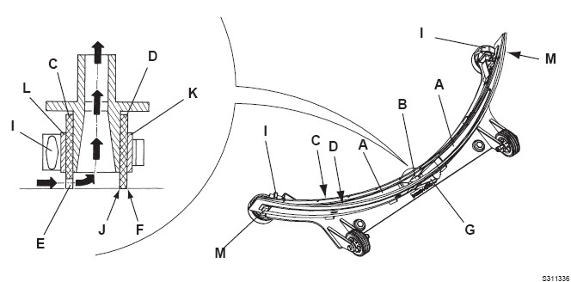

## CLEANING BRUSH/PAD

MCj04113200000[1]**CAUTION！**

**It is advisable to wear protective gloves when cleaning the brush/pad because there may**

**be sharp debris.**

1. Remove the brush disk/ pad driver from the machine according to the methods described above.

2. Clean the brush disk/ pad driver with water and detergent.

3. Check the brush bristles for integrity and wear, and replace the brush if necessary.

4. Check the pad for wear, and replace the pad if necessary.

**Clean the recovery tank and the filter, inspect the sealing of the lid**

1. Move the machine to the designated sewage discharge area.

2. Turn the key switch (41) to "O" position.

3. Remove the recovery tank lid (3) and rinse the lid (3), recovery tank (4) and the screen (20) with clean

water. Drain the sewage through the hose (12).

4. If necessary, loosen the buckle of the screen (20), clean the float ball and other parts and fit them back.

5. Check the sealing of recovery tank lid for integrity. Replace the sealing if necessary.

#### NOTE

#### The seal of the lid creates vacuum in the tank which is necessary for sucking in the recovery water.

## VACUUM FILTER CLEANING

1. Gently turn the recovery tank to one side, if necessary, drain the water in the recovery tank first.

2. Take out the filter cotton assembled on the vacuum pressure plate (31).

3. Check if the vacuum filter is clean, if necessary, clean it with water and compressed air, and then fit it back in place.

4. Turn the recovery tank back to normal working position.

## SOLUTION FILTER CLEANING

1. Close the solution tank water tap (27).

2. Remove the filter cover and the filter screen, clean them with water, and then fit them back.

3. Fix the filter cover.



#### NOTE

**The filter screen (E) must be correctly fitted on the housing (G).**

4. Turn on the solution tank water tap (27).

# TROUBLESHOOTING

## FAULT CODE

|  |  |  |  |  |
| --- | --- | --- | --- | --- |
| State of the BDI | | Fault | Possible Cause | Remedy |
|  | 0 notch is on | Unknown error | 1. The machine is not on. | 1. Check the machine and the wiring cables. |
| 1. BDI is broken. | 1. Replace the PCB. |
| 1. Controller failed. | 1. Replace the controller. |
|  | 1 notch flashes | Battery is low | Battery voltage is too low. | Charge the battery. |
|
|  | 3 notches flash | Controller temperature failure | 1. Controller temperature is too high/low. | 1. Turn off the key switch and cool the controller itself. |
| 1. Controller failed. | 1. Replace the controller. |
|  | 5 notches flash | Open circuit of vacuum motor | Open connection for vacuum motor. | Check the wiring of the vacuum motor with controller. |
|
|  | 6 notches flash | Open circuit of brush motor | Open connection for brush motor. | Check the wiring of the brush motor with controller. |
|
|  | 7 notches flash | Over-current of vacuum motor | 1. Short circuit. | 1. Check if there is short circuit. |
| 1. Vacuum motor failed. | 1. Replace the vacuum motor. |
|  | 8 notches flash | Over-current of brush motor | 1. Short circuit. | 1. Check if there is short circuit. |
| 2.Brush motor failed. | 2. Replace the vacuum motor. |
|  | 9 notches flash | Over-voltage of battery | Battery voltage is too high. | Check if the battery specification is correct. |
|
| Solution flow indicator | 3 notches flash | Open circuit of electromagnet valve | Open connection for electromagnet valve. | Check electromagnet valve. |
|

## COMMON TROUBLE SHOOTING

|  |  |  |
| --- | --- | --- |
| Trouble | Possible Cause | Remedy |
| Insufficient recovery water vacuuming | The recovery tank is full. | Drain the tank. |
| The hose is disconnected from the squeegee. | Connect the hose and the squeegee. |
| The float shut-off screen is clogged. | Clean the float shut-off screen and check the float. |
| The hose or the inspiratory path is closed. | Clean the hose or the inspiratory path. |
| The squeegee is dirty or the blades are worn or damaged. | Clean and check the squeegee. |
| The recovery tank lid is not correctly closed or the sealing is broken. | Close the lid correctly or replace the sealing. |
| Insufficient solution flow to the brush | The solution/clean water filter is dirty and clogged. | Clean the filter. |
| The dirty solution tank makes the drain hose and tap clogged. | Clean the solution tank and the drain tap. |
| The electromagnetic valve is damaged or clogged. | Clean or replace the electromagnetic valve. |
| Marks caused by the squeegee | There are debris under the squeegee blade. | Remove the debris. |
| The squeegee blade is worn, shipped or torn. | Replace the squeegee blade. |
| The squeegee has not been balanced with the adjusting knob. | Adjust the balance of the squeegee. |

# SCRAPPING AND DISPOSE

Have the machine scrapped by a qualified scrapper.

Before scrapping the machine, remove and separate the following materials, which must be properly disposed of according to relevant laws and regulations:

– Battery

– Brush disk/pad driver

– Plastic hoses and components

– Electrical and electronic components (*)

## HAZARDOUS SUBSTANCE AND CONTENT

|  |  |  |  |  |  |  |
| --- | --- | --- | --- | --- | --- | --- |
| Item | Hazardous substance | | | | | |
| Pb | Hg | Cd | Cr (VI) | PBB | PBDE |
| Battery | X | o | o | o | X | X |
| Charger | X | o | X | o | o | o |
| Chassis | X | o | o | o | o | o |
| Electronic accessories | X | o | X | o | X | X |
| Hose | X | o | o | X | X | o |
| Motor | X | o | o | o | X | X |
| Cable | X | o | X | X | o | o |
| Basic parts | o | o | o | X | o | o |
| Controller | X | o | o | o | o | o |
| Treatment/sewage | o | o | o | o | X | X |
| Brush/broom | o | o | o | o | X | X |
| This table compiles in accordance with SJ/T 11364. | | | | | | |
| O: Indicates that the content of the hazardous substance in all homogeneous materials of the part is below the limit requirement specified in GB/T 26572. | | | | | | |
| X: Indicates that the content of the hazardous substance in at least one of the homogeneous materials of the part exceeds the limit requirement of GB/T 26572. | | | | | | |