1.     Loose 4 bolts at both sides

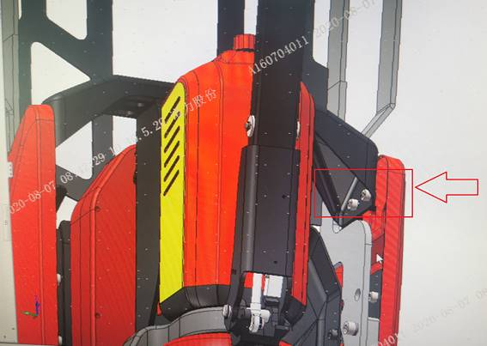

2. Remove the bolts at both sides

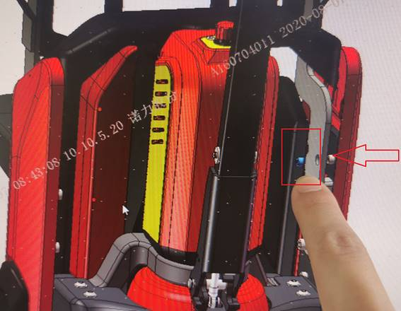

3.Loose 2 bolts, then remove front black cover

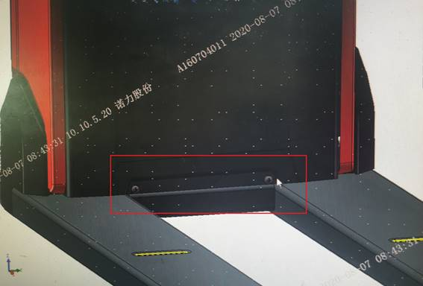

4.There is transition board, then install the bracket and tighten 2 pcs bolts at both sides

