AWPS2356 Brake Deactivation Instruction
1、Please make sure the aerial platform is retracted all the way, the gate and all doorways are closed, and that it is parked on a flat surface.
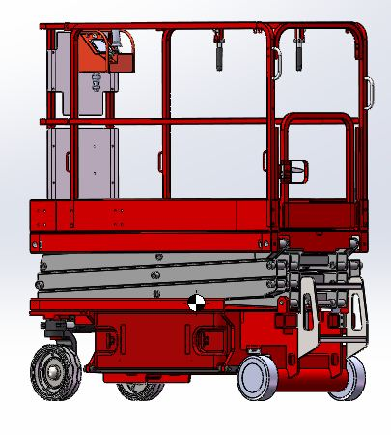

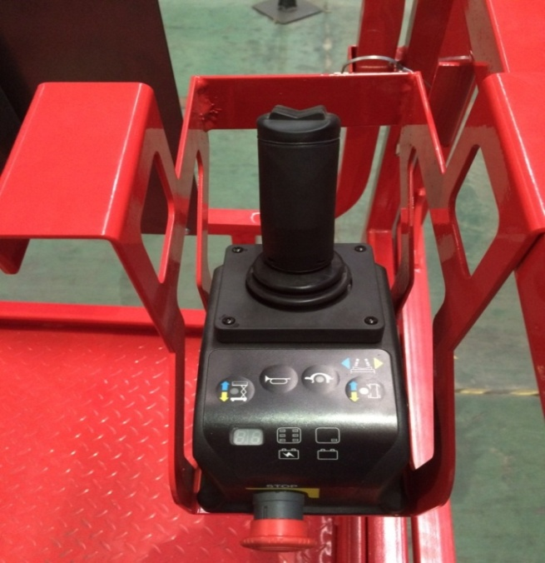
2、Make sure the ignition key is in the off position，and the emergency red switch both on the joystick and also at the ground control panel are both open；
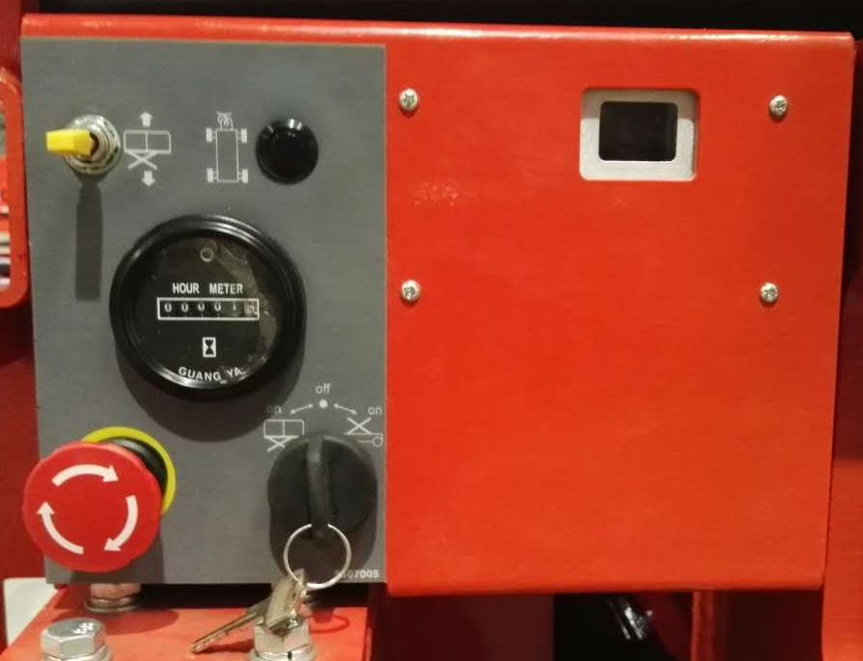

Ground control panel switch
Platform joystick switch

3、First，push the brake release button once，so that the switch is closed，check illustration
Brake release button

平台操作盒急停开关

4、Next, push the lift/lower switch downward and hold it in the downward position，now turn the key towards the right for ground control mode，keep this for about 4 seconds，at this point the vehicle’s buzzer and its horn should beep at the same time，brake is released，let go of the lift/lower switch，buzzer should chime on a regular pattern.
Key switch
Lift/Lower switch

