Version 10/2020
From truck identification number： 30201000506
PSE12BSL/PSE12NSL-BPT-001-EN

SPARE PARTS LIST
Electric stacker PS E12BSL / PS E12NSL

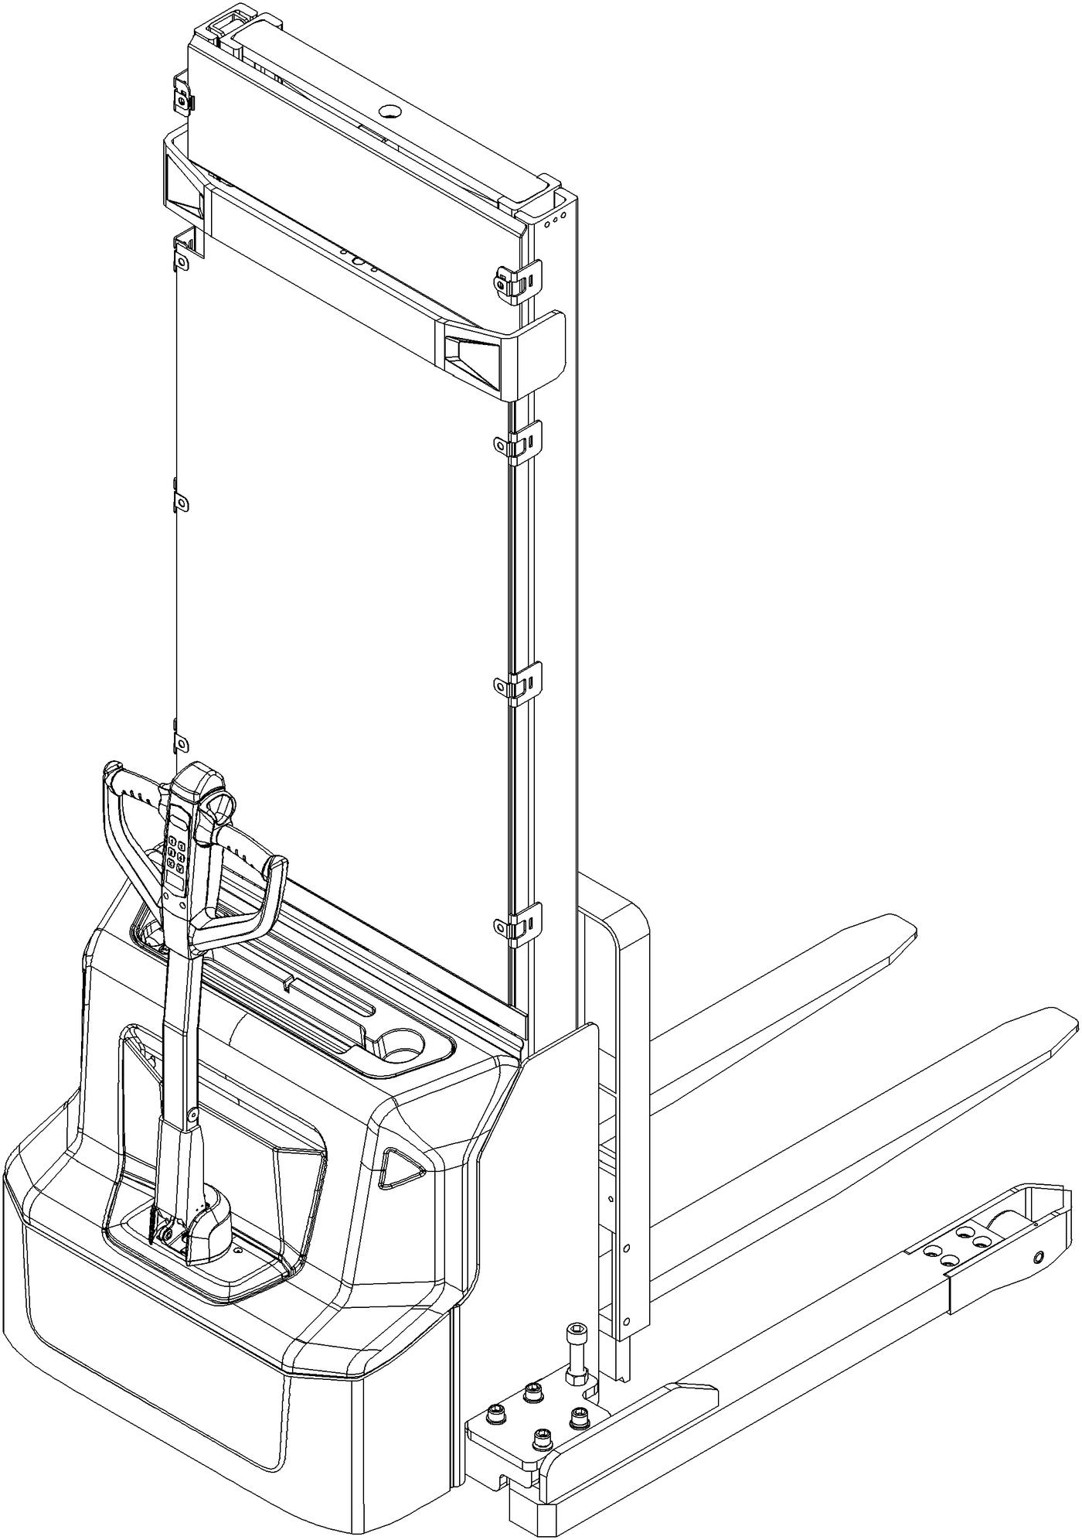
Please order spare parts from an authorized dealer of Noblelift Intelligent Equipment Co., LTD.
In order to avoid wrong shipping, all the orders of parts should be marked with the following items:
- Truck model, manufacturing number and year of manufacture.
- When ordering spare parts for mast, hydraulic parts, steer bridge and motor, the manufacturing number shall be noted.
- The article number for spare parts of Noblelift are shown in the spare parts list. Please also pay attention to the mark of supply status and order quantity, etc. (the number listed in "Mark" column of the spare parts list).
"Mark" column:
The unmarked number indicates the lead time for these parts is short.
Number 1: Supply as package. Indicating that supply the small parts or sealing parts as packages, with its minimum quantity for each package, the lead time for these spare parts is short.
Number 2: Supply with limit. Indicating that these parts are not in stock and will be prepared for production after receiving the order from the customer. The lead time may be long.
Number 3: Phasing out supply. Indicating that due to technical improvements, these parts are replaced by new parts and will not be supplied after current stock run out. Please check the corresponding explanations.
Number 4: Supply as assembly. Indicating that these parts are assembly parts specified by the manufacturing process, which cannot be supplied as single part.
Number 5: Check other lists. This list is the property of Noblelift and can be shared under the confidential agreement only, Noblelift has the right to claim for compensation. Copy is not allowed without the permission of Noblelift. The figures are not limited by the original design structure. Noblelift Intelligent Equipment Co., LTD reserves the right to improve the products to adapt to the continuous progress of technology.

TABLE OF CONTENTS
Chapter 1: Drive system 1
01 Drive unit (536746013501) 1
02 Drive assembly (536746013001) 3
Chapter 2: Hydraulic system 5
01 Hydraulic unit (536746024001) 5
02 Pump unit (536746023501) 7
Chapter 3: Truck structure 9
01 Truck frame (536746021501) 9
02 Forks (536746038001) 11
03 Battery holder (536746012501) 13
04 Battery holder (lithium battery) (536746012502) 15
05 Control panel assembly (532246010001) 17
Chapter 4: Steering system, braking system and wheels 19
01 Tiller (532246011001) 19
02 Tiller head (532246011002) 21
03 Load wheel (536746017001) 23
04 Side wheel (536746016501) 25
05 Manual steering (536746031201) 27
Chapter 5: Mast system 29
01 Two stage mast (standard) (532246044001) 29
01 Two stage mast (standard) (532246044001) continuation 31
01 Two stage mast (standard) (532246044001) continuation 33
02 Mono-mast (532246043001) 35
02 Mono-mast (532246043001) continuation 37
Chapter 6: Electrical parts and wire harness 39
01 Wire harness (532202033001) 39
02 Wire harness (532202033002) 41
03 Electrical control unit (532233010017) 43
04 Charger (532246036501) 45
Chapter 7: Special equipment 47
01 Load backrest (536746040501) 47
Chapter 8: Others 49
01 Labels and decals (EU) (536746047001) 49
02 Labels and decals (USA) (536746047002) 51
Appendix 53
01 Electrical circuit diagram (lead-acid battery) (532246045501) 53
02 Electrical circuit diagram (Lithium battery) (532246045502) 54
03 Hydraulic circuit diagram (532246045503) 55
04 Easy worn parts list 56

Chapter 1: Drive system

01 Drive unit (536746013501)
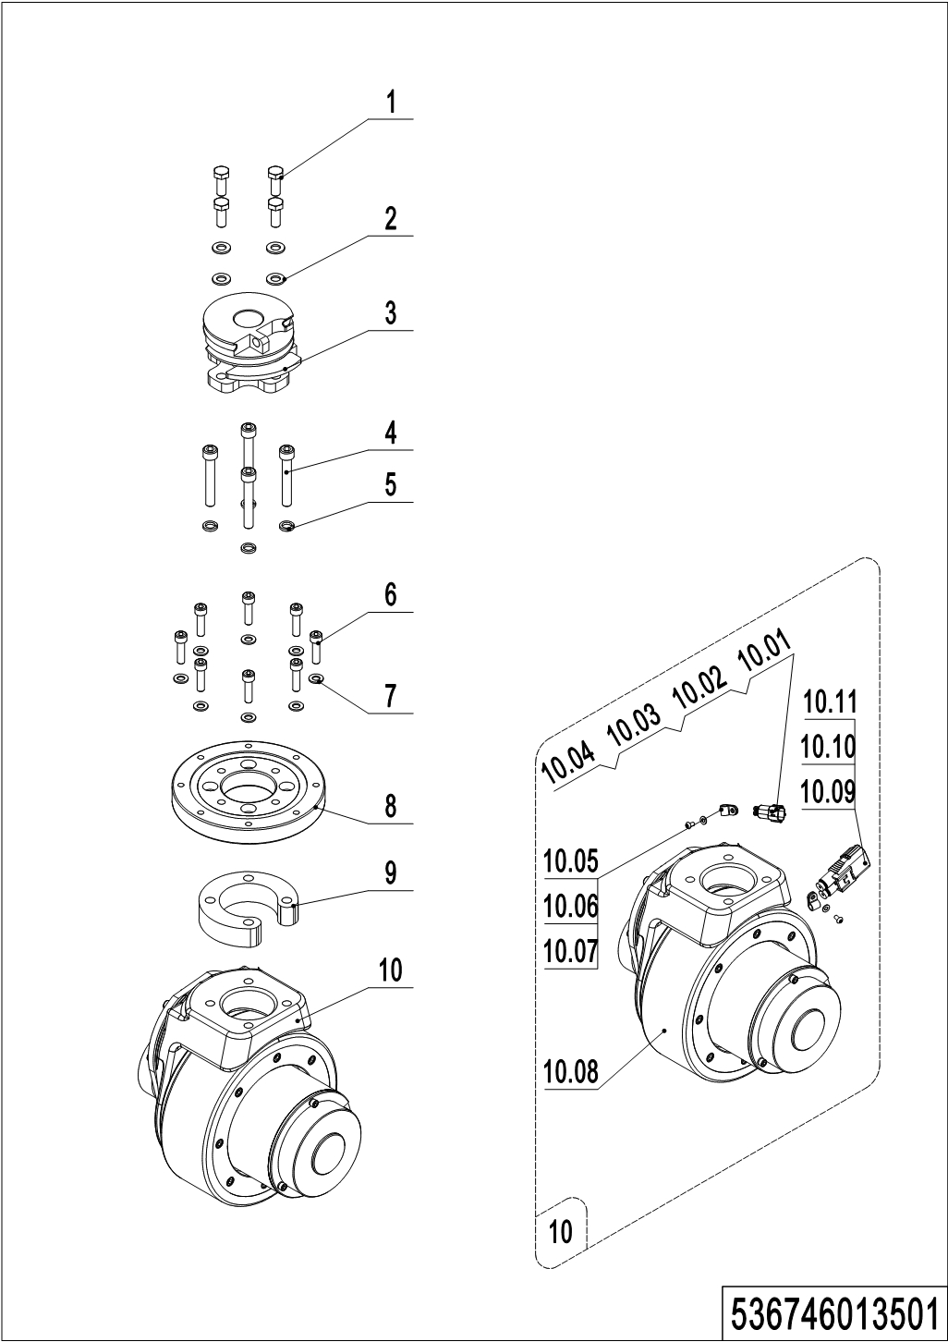
01 Drive unit (536746013501)
No. | Item Code | Mark | Item Description | Qty. | Substitute | Note
1 | 910100300036 | 1 | Bolt | 4
2 | 910400100007 | 1 | Flat Washer | 4
3 | 536731210001 |  | Drive axle welding | 1
4 | 910200200084 | 1 | Screw | 4
5 | 910400500007 | 1 | Spring Washer | 4
6 | 910200200138 | 1 | Screw | 8
7 | 910400100006 | 1 | Flat Washer | 8
8 | 532213520001 |  | Slewing Bearing | 1
9 | 536713520001 |  | Linking plate | 1
10 | 508098510057 |  | Drive Unit | 1 |  | Water proof
10.01 | 920400200004 | 1 | Connector | 1
10.02 | 920400200003 | 1 | Connector | 1
10.03 | 920400200017 | 1 | Connector | 2
10.04 | 920400200018 | 1 | Connector | 2
10.05 | 910200700001 | 1 | Screw | 2
10.06 | 910400100003 | 1 | Flat Washer | 2
10.07 | 921300200001 |  | Cable Clamp | 2
10.08 | ------------ | 5 | Drive assembly | 1 |  | Check 536746013001
10.09 | 920400200169 | 1 | Connector | 1 |  | Water proof
10.10 | 920400200150 | 1 | Connector | 2 |  | Water proof
10.11 | 920400200171 | 1 | Connector | 2

02 Drive assembly (536746013001)
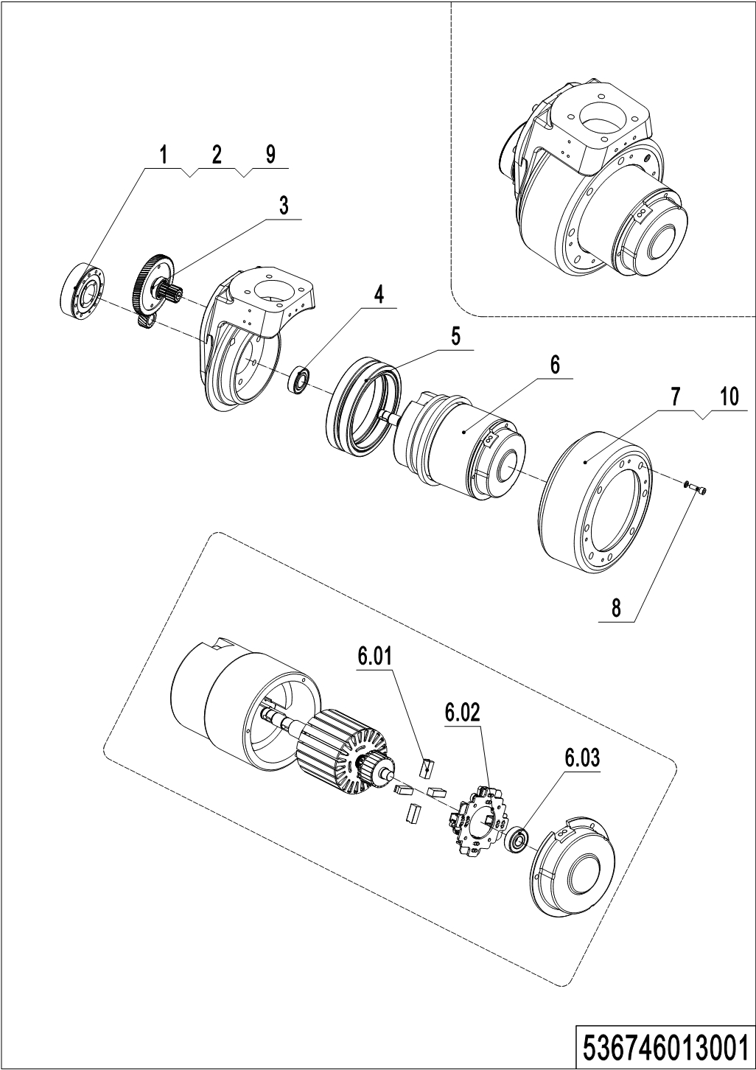
02 Drive assembly (536746013001)
No. | Item Code | Mark | Item Description | Qty. | Substitute | Note
-- | 940900100017 |  | Drive Unit | 1 |  | 8NM, PU wheel
1 | 508098520028 | 2 | Brake (8NM) | 1
2 | 508098520040 | 2 | Rubber Strip | 1
3 | 508098510015 | 2 | Gear Components | 1
4 | 910700200004 |  | Bearing | 1
5 | 508098520011 | 2 | Gear Ring | 1
6 | 508098510016 | 2 | Motor | 1
6.01 | 508098520000 | 2 | Carbon Brush | 4
6.02 | 508098520001 | 2 | Carbon Brush Holder | 1
6.03 | 910700200016 |  | Bearing | 1
7 | 508098520003 |  | Wheel | 1
8 | 910200200167 | 1 | Screw Kits | 8
9 | 910200200019 | 1 | Screw | 3
10 | 508098520032 | 2 | Seal | 1

Chapter 2: Hydraulic system

01 Hydraulic unit (536746024001)
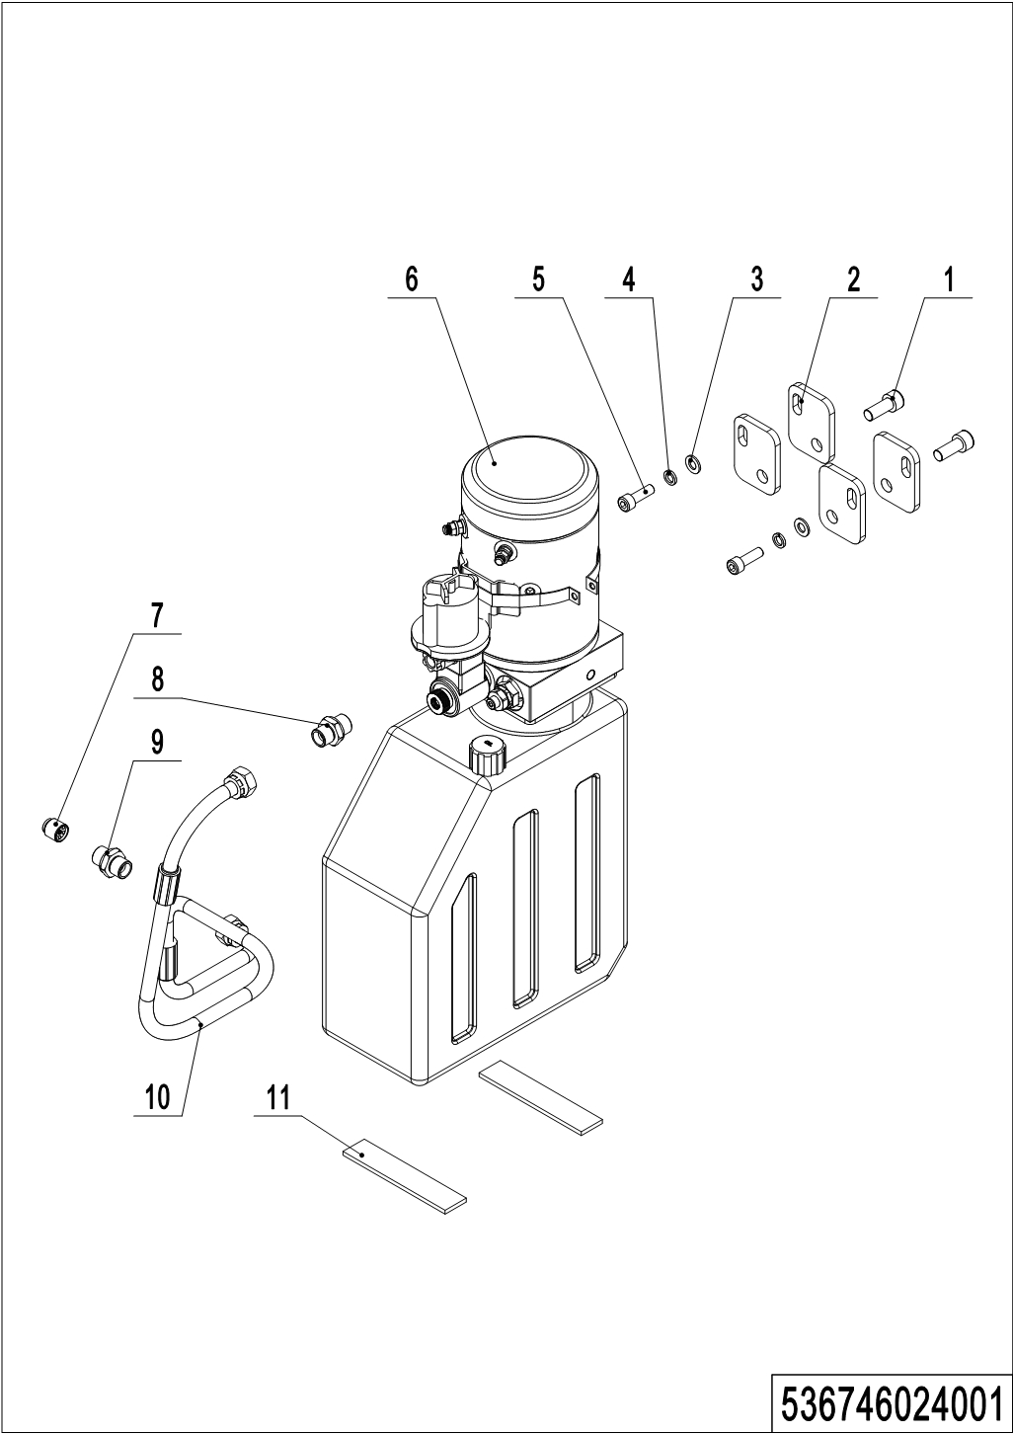
01 Hydraulic unit (536746024001)
No. | Item Code | Mark | Item Description | Qty. | Substitute | Note
1 | 910200200076 | 1 | Screw | 2
2 | 532223520001 |  | Plate | 4
3 | 910400100006 | 1 | Flat Washer | 2
4 | 910400500006 | 1 | Spring Washer | 2
5 | 910200200058 | 1 | Screw | 2
6 | ------------ | 5 | Hydraulic power 24V2.2Kw2.0cc | 1 |  | Check 536746023501
7 | 950600300001 |  | Safety Valve | 1
8 | 950400300007 |  | Joint | 1
9 | 950400400003 |  | Joint | 1
10 | 536724020001 |  | Hose | 1
11 | 532223520010 |  | Buffer gasket | 2

02 Pump unit (536746023501)
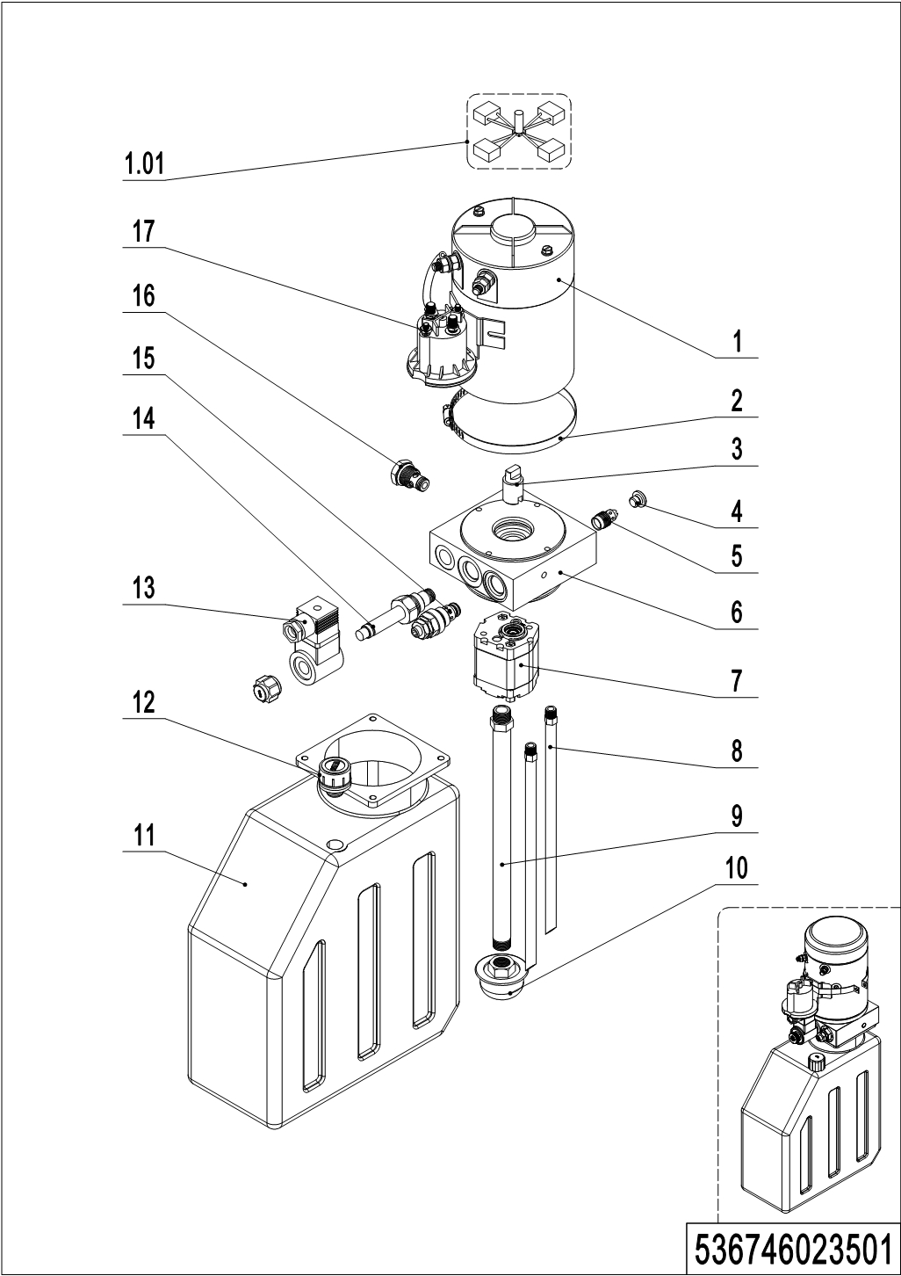
02 Pump unit (536746023501)
No. | Item Code | Mark | Item Description | Qty. | Substitute | Note
-- | 950900100082 |  | Pump Unit | 1
1 | 532298510037 |  | Motor | 1
1.01 | 532298510026 |  | Carbon Brush | 1
2 | 532298510040 |  | Hose Clamp | 1
3 | 532298520007 |  | Coupling | 1
4 | 532298520003 |  | End Cap | 1
5 | 532298510027 |  | Valve | 1
6 | 532298520006 |  | Valve Block | 1
7 | 532298510043 |  | Gear pump | 1
8 | 532298520004 |  | Pipe | 2
9 | 536798520002 |  | Oil suction pipe | 1
10 | 532298510031 |  | Filter | 1
11 | 536798520003 |  | Oil tank | 1
12 | 536798510001 |  | Vent plug G3/8 | 1
13 | 532298510034 |  | Coil | 1
14 | 532298510033 |  | Magnetic Valve | 1
15 | 532298510044 |  | Overflow valve | 1
16 | 532298510028 |  | Check Valve | 1
17 | 532298510036 |  | Switch | 1

Chapter 3: Truck structure

01 Truck frame (536746021501)
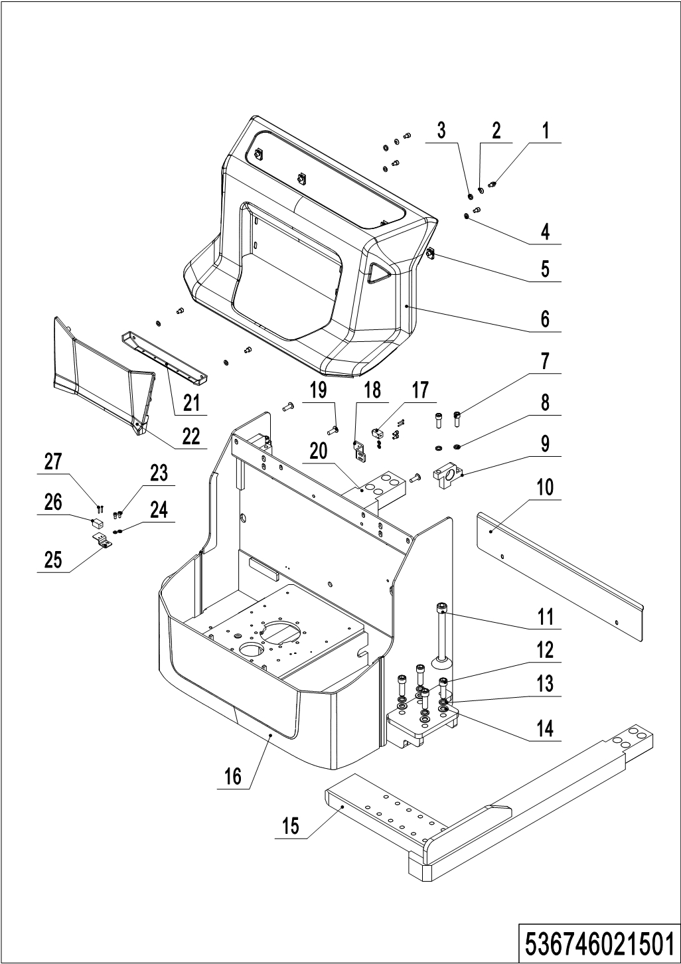
01 Truck frame (536746021501)
No. | Item Code | Mark | Item Description | Qty. | Substitute | Note
1 | 910200200053 | 1 | Screw | 8
2 | 910400600004 | 1 | Spherical Washer | 2
3 | 910400700004 | 1 | Taper faced washer GB850-8 | 2
4 | 910400100006 | 1 | Flat Washer | 6
5 | 940400400003 |  | Cage Nut | 4
6 | 532221520026 |  | Outer cover | 1
7 | 910200200099 | 1 | Screw | 4
8 | 910400500008 | 1 | Spring Washer | 4
9 | 532221520020 |  | Mounting Plate | 2
10 | 536721520001 |  | Baffle | 1
11 | 536721510004 |  | Support Leg Kit | 2
12 | 910200200114 |  | Screw | 8
13 | 910400500010 |  | Spring Washer | 8
14 | 910400100010 |  | Flat Washer | 8
15 | 536721510003 | 2 | Leg | 1
16 | 536721510001 | 2 | Chassis welding | 1
17 | 920200400030 |  | Proximity Switch | 1 |  | Only for mono mast
18 | 532243020012 |  | Mounting Plate | 1 |  | Only for mono mast
19 | 941100100004 | 1 | Screw | 4
20 | 536721510002 | 2 | Leg | 1
21 | 532221520025 |  | Cover | 1
22 | 532221520024 |  | Panel | 1
23 | 910200200033 | 1 | Screw | 2 |  | Two stage mast
23 | 910200200033 | 1 | Screw | 4 |  | Mono mast
24 | 910400100005 | 1 | Flat Washer | 2 |  | Two stage mast
24 | 910400100005 | 1 | Flat Washer | 4 |  | Mono mast
25 | 532221520023 |  | Mounting Plate | 1
26 | 920200400017 |  | Proximity Switch | 1
27 | 910200500015 | 1 | Screw | 2 |  | Two stage mast
27 | 910200500015 | 1 | Screw | 4 |  | Mono mast

02 Forks (536746038001)
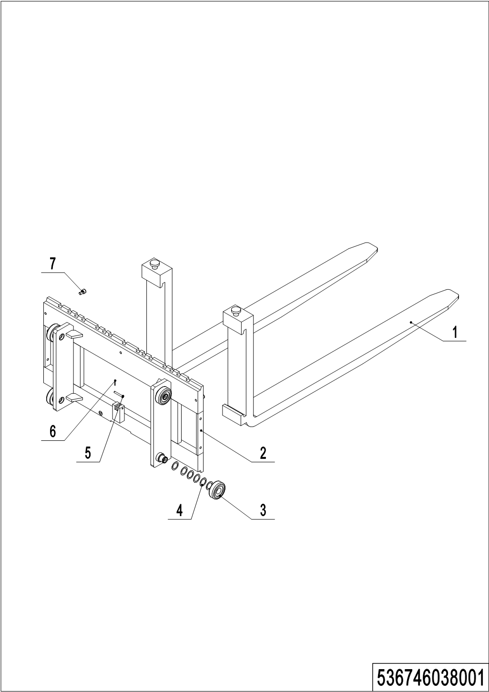
02 Forks (536746038001)
No. | Item Code | Mark | Item Description | Qty. | Substitute | Note
1 | 940100100045 |  | Fork100x40x1150 | 2
2 | 536738010001 |  | Fork | 1 |  | Two-stage mast
2 | 536738010002 |  | Fork |  |  | mono mast
3 | 940200100038 |  | Main Roller | 4
4 | 940600500016 |  | Washer | 24
5 | 941100800006 |  | Pin | 1
6 | 910600600015 |  | Cotter Pin | 1
7 | 910200200074 |  | Screw | 3

03 Battery holder (536746012501)
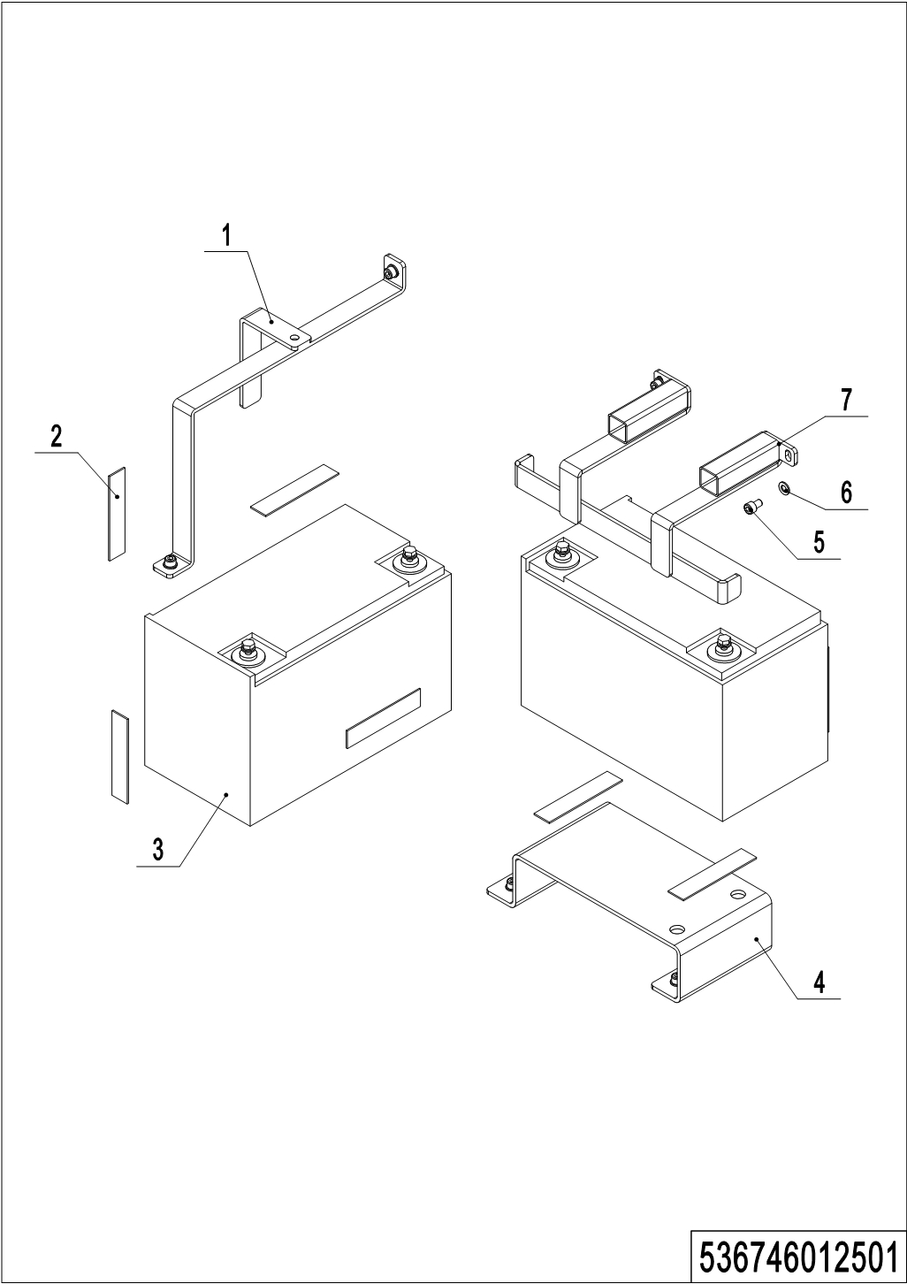
03 Battery holder (536746012501)
No. | Item Code | Mark | Item Description | Qty. | Substitute | Note
1 | 536712510003 |  | Mounting Plate | 1 |  | 85Ah
1 | 536712510001 |  | Mounting Plate | 1 |  | 106Ah
2 | 536712520002 |  | Crash Pad | 9
3 | 920600100080 |  | Battery12V80Ah | 2 |  | LS
3 | 920600100081 |  | Battery12V100Ah | 2 |  | LS
3 | 920600100105 |  | Battery12V85Ah | 2 |  | TN
3 | 920600100107 |  | Battery12V106Ah | 2 |  | TN
4 | 536712520001 |  | Mounting Plate | 1
5 | 910200200053 | 1 | Screw | 8
6 | 910400100006 | 1 | Flat Washer | 8
7 | 532212510001 |  | Mounting Plate | 1 |  | 85Ah
7 | 532212510003 |  | Mounting Plate | 1 |  | 106Ah

04 Battery holder (lithium battery) (536746012502)
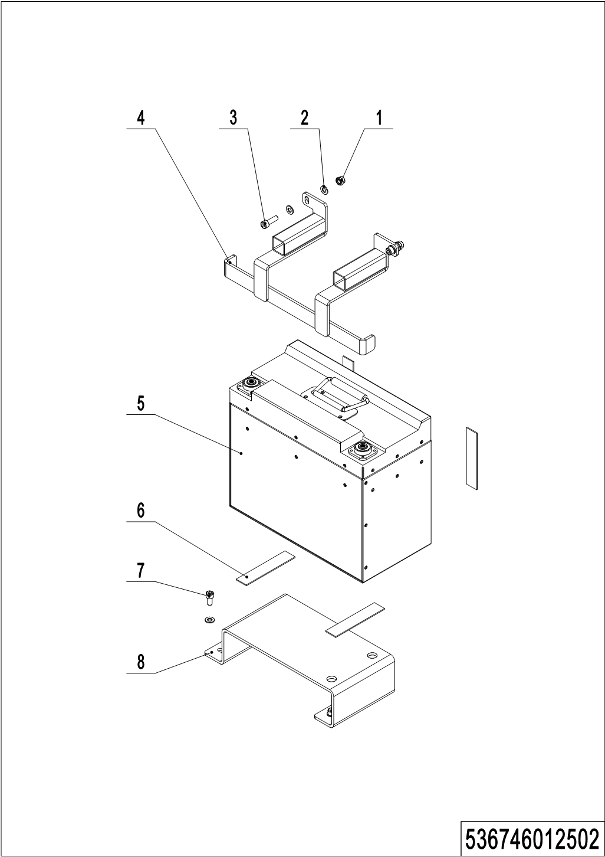
04 Battery holder (lithium battery) (536746012502)
No. | Item Code | Mark | Item Description | Qty. | Substitute | Note
1 | 910300500004 | 1 | Nut | 2
2 | 910400100006 | 1 | Flat Washer | 8
3 | 910200200058 | 1 | Screw | 2
4 | 536712510002 |  | Mounting Plate | 1
5 | 920600100082 |  | Li Battery24V60Ah | 1 |  | HF
5 | 920600100108 |  | Li Battery24V60Ah | 1 |  | FDE
6 | 536712520002 |  | Crash Pad | 5
7 | 910200200053 | 1 | Screw | 4
8 | 536712520001 |  | Mounting Plate | 1

05 Control panel assembly (532246010001)
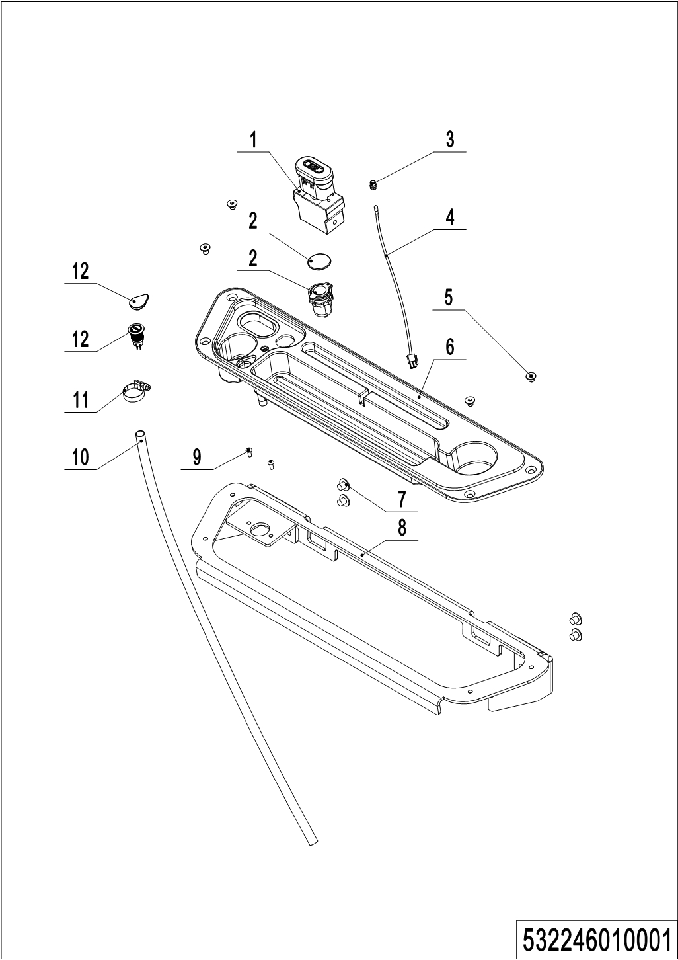
05 Control panel assembly (532246010001)
No. | Item Code | Mark | Item Description | Qty. | Substitute | Note
1 | 920200100001 |  | Emergency Button | 1
2 | 532210020003 |  | Close Plate | 1 |  | Lead-acid battery
2 | 206033010036 |  | USB interface | 1 |  | Lithium battery
3 | 922000100024 |  | Lamp Holder | 1
4 | 532298510006 |  | Indicator Light | 1
5 | 910200400023 | 1 | Screw | 4
6 | 532210020001 |  | Bezel | 1
7 | 941100100005 |  | Screw | 4
8 | 532210010001 |  | Mounting Plate | 1
9 | 910200300012 | 1 | Screw | 2
10 | 532210020008 |  | Pipe | 1
11 | 911000600008 |  | Hose Clamp | 1
12 | 532210020002 |  | Close Plate | 1 |  | Lead-acid battery
12 | 532233010023 |  | Button | 1 |  | Lithium battery

Chapter 4: Steering system, braking system and wheels

01 Tiller (532246011001)
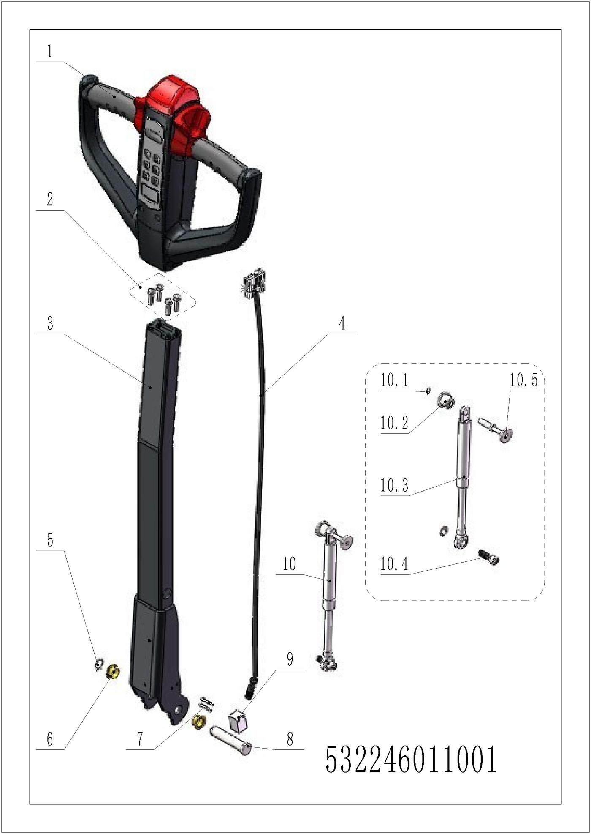
01 Tiller (532246011001)
No. | Item Code | Mark | Item Description | Qty. | Substitute | Note
1 | 922100100021 |  | Tiller | 1
1 | 922100100028 |  | Tiller | 1 |  | IC card
2 | 910200200036 | 1 | Screw | 4
3 | 532211010000 |  | Tiller | 1
4 | 532233010019 |  | Wire Harness | 1
5 | 910401300006 |  | Circlip | 1
6 | 940500200001 |  | Bushing | 2
7 | 941101100001 | 1 | Screw | 2
8 | 508011020004 |  | Pin | 1
9 | 505633510001 |  | Proximity Switch | 1
10 | 532298510039 |  | Air spring kits | 1
10.1 | 910401300001 |  | Circlip | 1
10.2 | 508011020005 |  | Fixing Base | 1
10.3 | 532211020003 |  | Gas Spring | 1
10.4 | 941100100011 | 1 | Screw | 1
10.5 | 508011010002 |  | Pin | 1

02 Tiller head (532246011002)
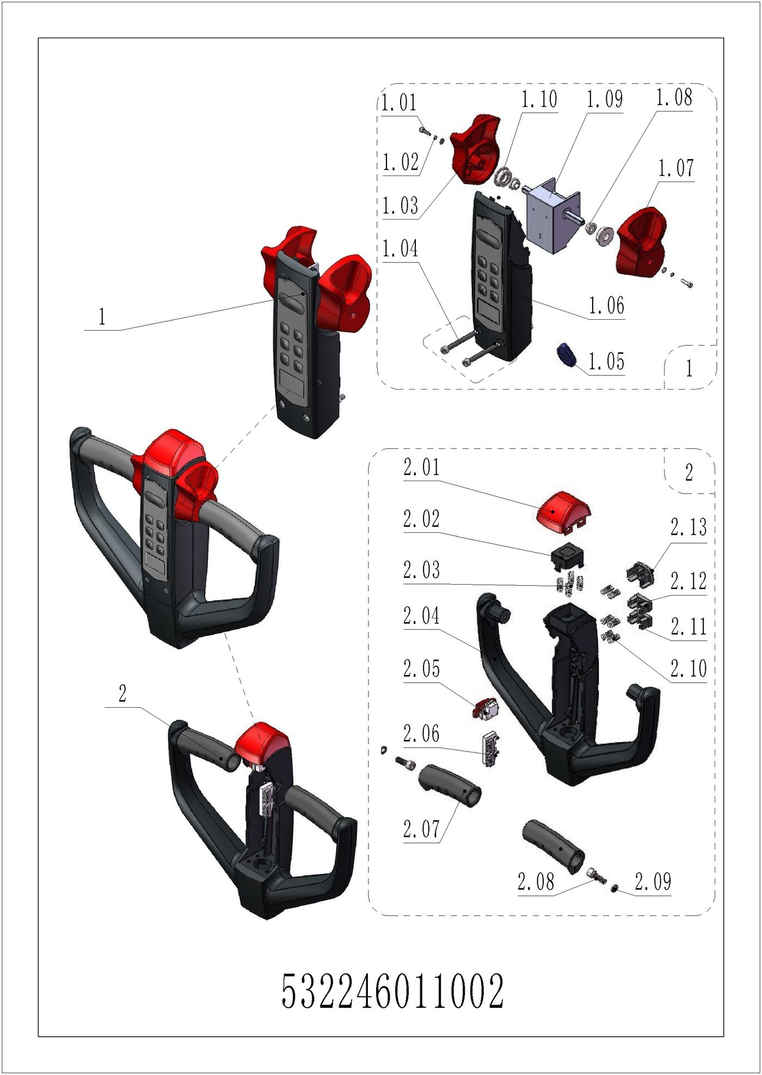
02 Tiller head (532246011002)
No. | Item Code | Mark | Item Description | Qty. | Substitute | Note
1 | 532298510022 |  | Handle Cap Kit | 1
1 | 532298510023 |  | Handle Cap Kit | 1 |  | IC card
1.01 | 910200200003 | 1 | Screw | 2
1.02 | 910400500002 | 1 | Spring Washer | 2
1.03 | 508098520014 |  | Traction lever | 1
1.04 | 910200200159 | 1 | Screw | 2
1.05 | 508098520027 |  | ID Card | 1 |  | With RFID card function
1.06 | 508098510039 |  | Display Screen kit | 1
1.07 | 508098520020 |  | Traction lever | 1
1.08 | 508098520016 |  | Bushing | 2
1.09 | 532298510005 |  | Accelerator | 1
1.09 | 532298510007 |  | Accelerator | 1 |  | IC card
1.10 | 508098520015 |  | Bushing | 2
2 | 508098510031 |  | Handle Cap Kit | 1
2.01 | 508098520018 |  | Cap,Break Switch | 1
2.02 | 508098520019 |  | Bracket | 1
2.03 | 502311020018 |  | Spring | 4
2.04 | 508098520012 |  | Handle Cap | 1
2.05 | 508098510029 |  | Microswitch Kits | 1
2.06 | 508098510030 |  | Microswitch Kits | 1
2.07 | 508098520013 |  | Handle | 2
2.08 | 910200200058 | 1 | Screw | 2
2.09 | 910400500006 | 1 | Spring Washer | 2
2.10 | 502311020022 |  | Spring | 6
2.11 | 508098520031 |  | Button | 1
2.12 | 508098520030 |  | Button | 1
2.13 | 508098520029 |  | Horn Button | 1

03 Load wheel (536746017001)
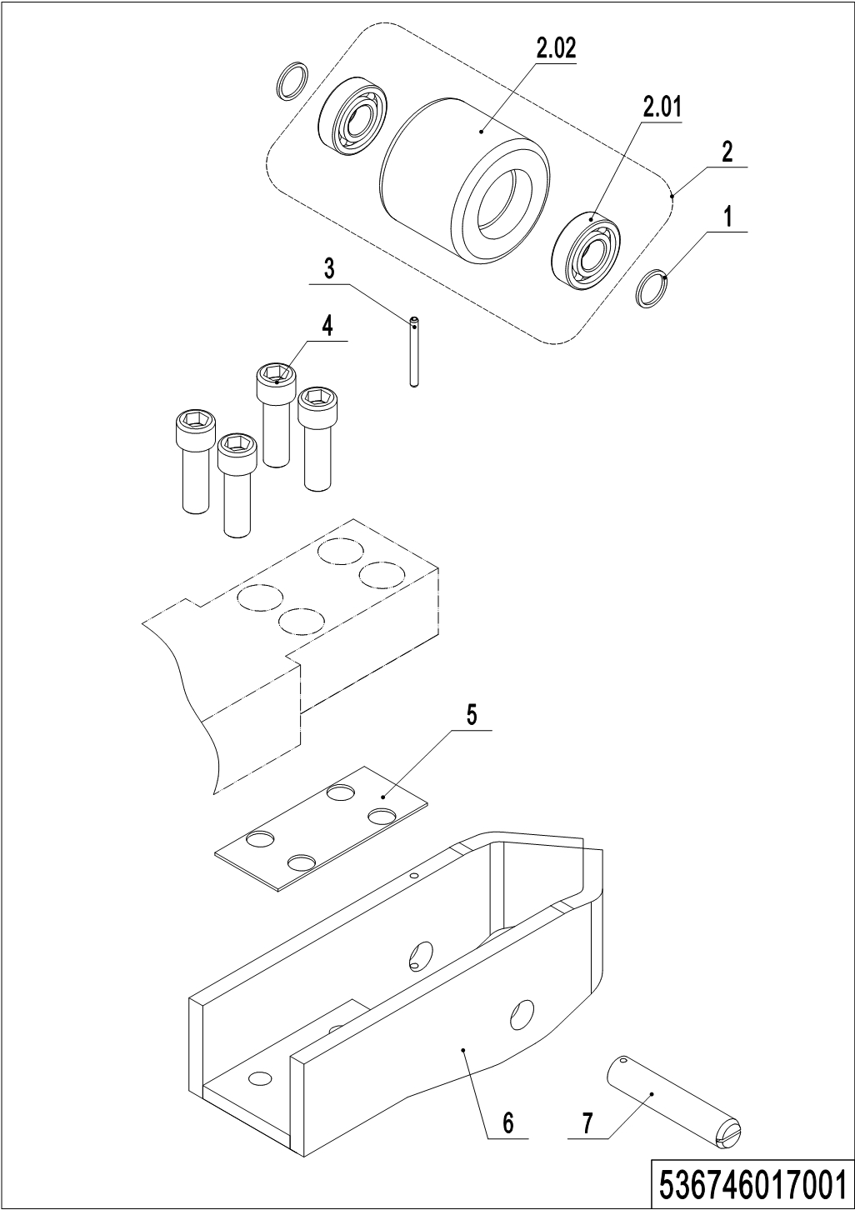
03 Load wheel (536746017001)
No. | Item Code | Mark | Item Description | Qty. | Substitute | Note
1 | 940600500053 |  | Washer | 4
2 | 532998510000 |  | Wheel | 2
2.01 | 910700200019 |  | Bearing | 4
2.02 | 940300300009 |  | WheelΦ84x70 | 2
3 | 910600400030 | 1 | Spring Pin | 2
4 | 910200200123 | 1 | Screw | 8
5 | 536717020001 |  | Pad | 2
6 | 536717010001 |  | Wheel Carrier | 2
7 | 536717020002 |  | Axle | 2

04 Side wheel (536746016501)
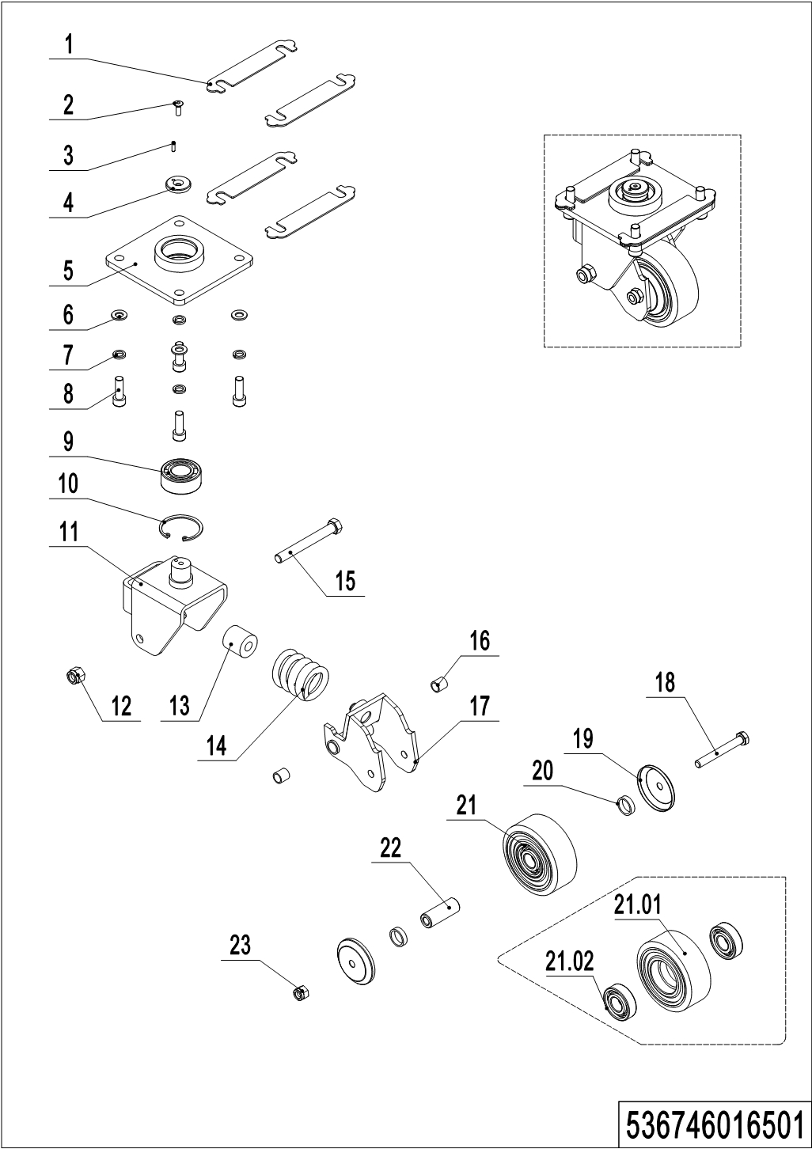
04 Side wheel (536746016501)
No. | Item Code | Mark | Item Description | Qty. | Substitute | Note
-- | 536716510000 |  | Caster Assembly | 2
1 | 536716520001 |  | Adjustment Pad | 8
2 | 941100300001 | 1 | Screw | 2
3 | 910600100004 | 1 | Cylindrical Pin | 2
4 | 505616520007 |  | Retaining Ring | 2
5 | 536716510002 |  | Plate | 2
6 | 910400100007 | 1 | Flat Washer | 8
7 | 910400500007 | 1 | Spring Washer | 8
8 | 910200200077 | 1 | Screw | 8
9 | 910700500002 |  | Bearing | 2
10 | 910401400016 |  | Circlip | 2
11 | 505616510001 |  | Wheel Carrier | 2
12 | 910300500006 | 1 | Nut | 1
13 | 505616520000 |  | Spring | 2
14 | 940400500006 |  | Spring | 2
15 | 941100200002 | 1 | Bolt | 2
16 | 940500100002 |  | Bushing | 4
17 | 536716510001 |  | Whirling Arm | 2
18 | 910100100038 | 1 | Bolt | 2
19 | 505616520011 |  | Dust Cap | 4
20 | 505616520012 |  | Check Ring | 4
21 | 503598510003 |  | Caster Assembly | 2
21.01 | 940300300018 |  | WheelΦ100x40 | 2
21.02 | 910700200019 |  | Bearing | 4
22 | 505616520013 |  | Bushing | 2
23 | 910300500005 | 1 | Nut | 1

05 Manual steering (536746031201)
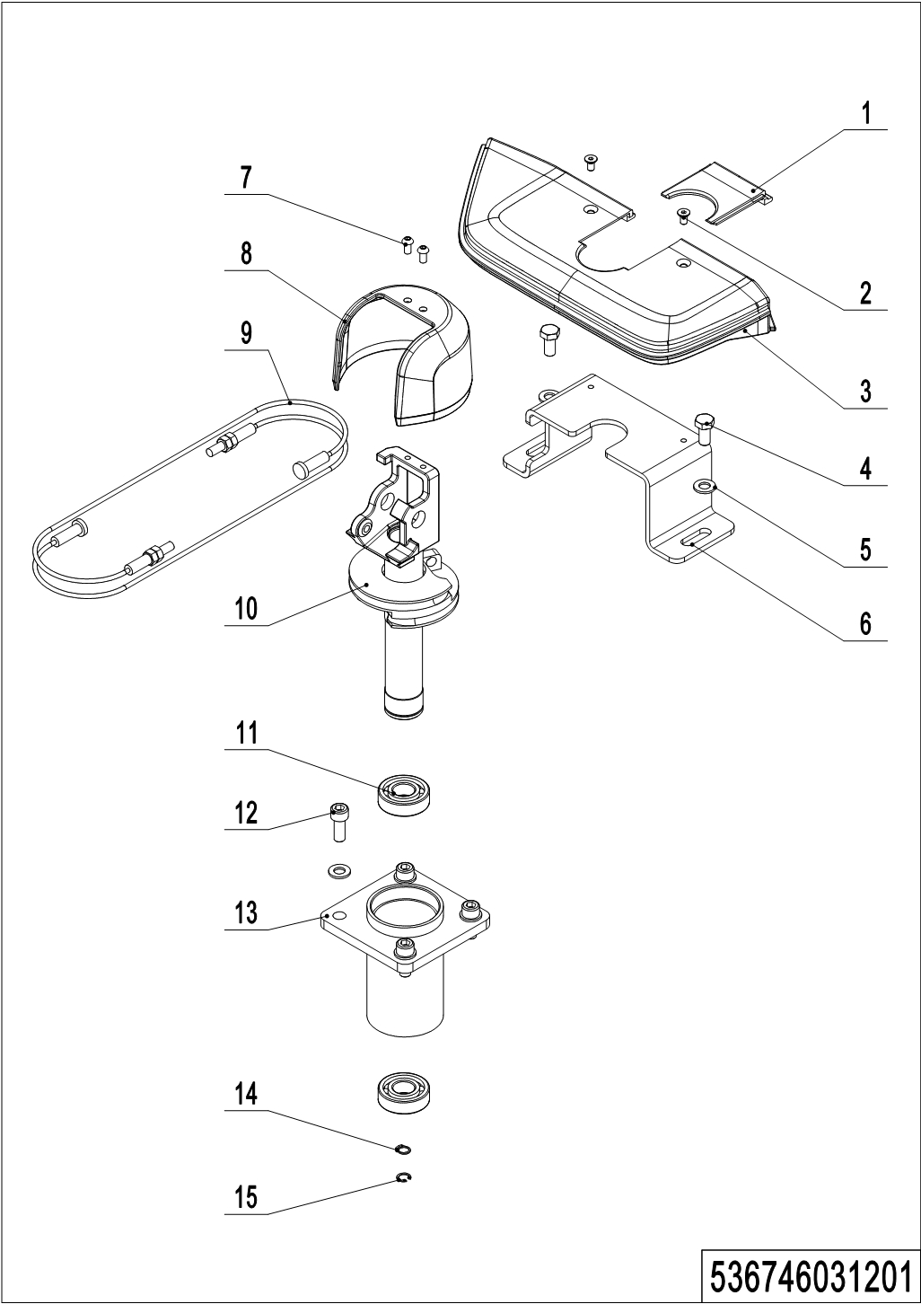
05 Manual steering (536746031201)
No. | Item Code | Mark | Item Description | Qty. | Substitute | Note
1 | 532231220011 |  | Handle Cap | 1
2 | 910200400016 | 1 | Screw | 2
3 | 532231220010 |  | Handle Cap | 1
4 | 910100300035 | 1 | Bolt | 2
5 | 910400100007 | 1 | Flat Washer | 6
6 | 532231220008 |  | Pedestal | 1
7 | 910200300017 | 1 | Screw | 2
8 | 532211020001 |  | Protective Cover | 1
9 | 536731210004 |  | Wirerope | 2
10 | 536731210002 |  | handle Spindle | 1
11 | 910700200007 |  | Bearing | 2
12 | 910200200076 | 1 | Screw | 4
13 | 536731210003 |  | Bracket | 1
14 | 910401300018 | 1 | Circlip | 1
15 | 910401400018 | 1 | Circlip | 1

Chapter 5: Mast system

01 Two stage mast (standard) (532246044001)
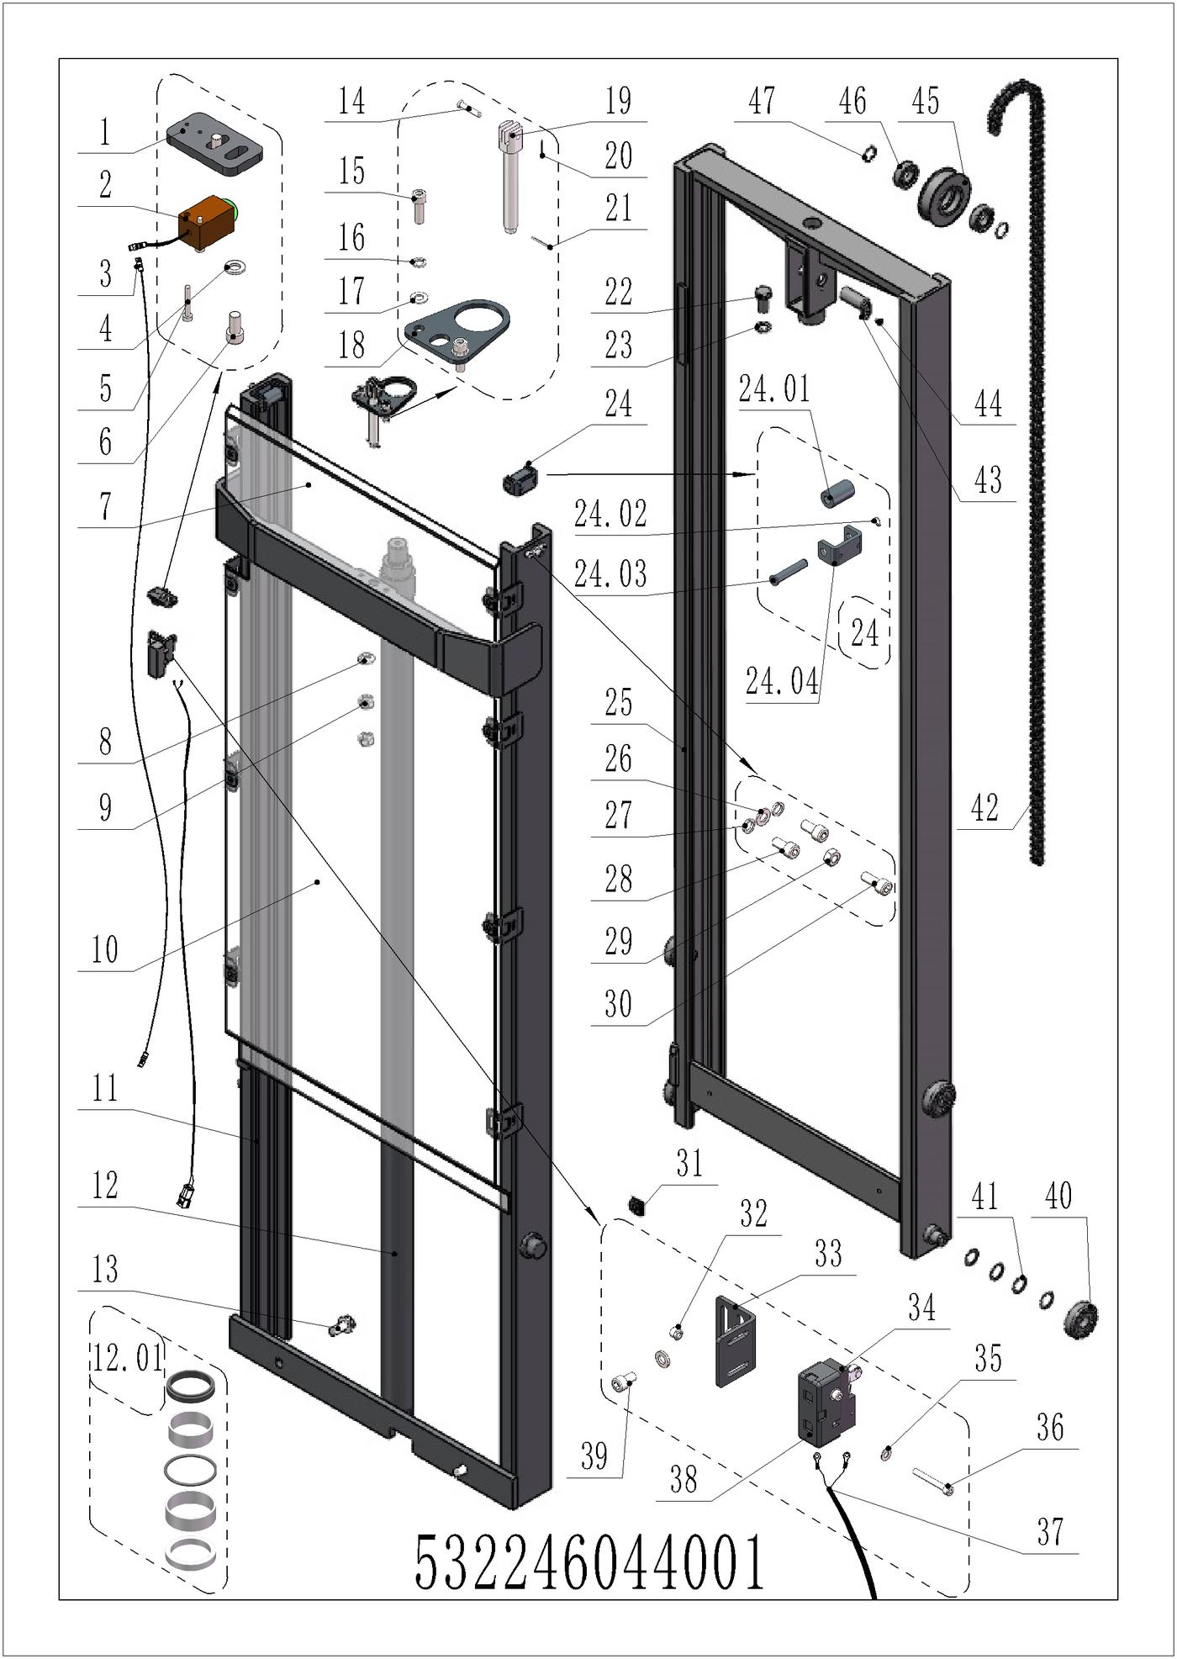
01 Two stage mast (standard) (532246044001)
No. | Item Code | Mark | Item Description | Qty. | Substitute | Note
1 | 532244020029 |  | Mounting Plate | 1
2 | 920200400030 |  | Proximity Switch | 1
3 | 921500100077 |  | Cable | 1
4 | 910400100005 | 1 | Flat Washer | 4
5 | 910200500015 | 1 | Screw | 2
6 | 910200200033 | 1 | Screw | 2
7 | 532244020030 |  | Guard Plate | 1
7 | 532251520005 |  | Iron Gauze | 1
8 | 910400100010 | 1 | Flat Washer | 1
9 | 910300200008 | 1 | Nut | 2
10 | 532244020038 |  | Protective screen 4x715x775 | 1 |  | 2600
10 | 532244020034 |  | Guard Plate | 1 |  | 2900
10 | 532244020033 |  | Guard Plate | 1 |  | 3200
10 | 532244020031 |  | Guard Plate | 1 |  | 3600
10 | 532251520004 |  | Iron Gauze | 1 |  | 2600
10 | 532251520003 |  | Iron Gauze | 1 |  | 2900
10 | 532251520002 |  | Iron Gauze | 1 |  | 3200
10 | 532251520001 |  | Iron Gauze | 1 |  | 3600
11 | 532244010017 | 2 | Outer mast welding (2600) | 1 |  | 2600
11 | 532244010002 | 2 | Outer Mast(2900) | 1 |  | 2900
11 | 532244010012 | 2 | Outer Mast(3200) | 1 |  | 3200
11 | 532244010005 | 2 | Outer Mast(3600) | 1 |  | 3600
12 | 532244010016 |  | Cylinder Φ50xΦ40x1290 | 1 |  | 2600
12 | 532244010001 |  | Cylinder | 1 |  | 2900
12 | 532244010009 |  | Cylinder | 1 |  | 3200
12 | 532244010004 |  | Cylinder | 1 |  | 3600
12.01 | 532298510002 |  | Seal Kit | 1
13 | 910100800005 | 1 | Bolt | 2
14 | 941100800010 |  | Pin | 1
15 | 910200200077 | 1 | Screw | 2

01 Two stage mast (standard) (532246044001) continuation

01 Two stage mast (standard) (532246044001) continuation
No. | Item Code | Mark | Item Description | Qty. | Substitute | Note
16 | 910400500007 | 1 | Spring Washer | 2
17 | 910400100007 | 1 | Flat Washer | 2
18 | 532244020027 |  | Fixing Plate | 1
19 | 206044520060 |  | Chain Anchor | 1
20 | 910600600006 | 1 | Cotter Pin | 1
21 | 910600600019 | 1 | Cotter Pin | 1
22 | 910100300049 | 1 | Bolt | 1
23 | 910400500008 | 1 | Spring Washer | 1
24 | 400244010002 |  | Side roller assembly | 2
24.01 | 401744020000 |  | Roller | 2
24.02 | 910401300003 | 1 | Circlip | 2
24.03 | 401744020001 |  | Pin | 2
24.04 | 532021520075 |  | Wheel Mount | 2
25 | 532244010018 | 2 | Inner mast welding (2600) | 1 |  | 2600
25 | 532244010003 | 2 | Inner Mast(2900) | 1 |  | 2900
25 | 532244010013 | 2 | Inner Mast(3200) | 1 |  | 3200
25 | 532244010006 | 2 | Inner Mast(3600) | 1 |  | 3600
26 | 910400100006 | 1 | Flat Washer | 2
27 | 910400500006 | 1 | Spring Washer | 4
28 | 910200200055 | 1 | Screw | 4
29 | 910300100006 | 1 | Nut | 2
30 | 910200200057 | 1 | Screw | 2
31 | 940400300001 |  | Spring Buckle | 8
32 | 910300500001 | 1 | Nut | 2
33 | 532244020012 |  | Mounting Plate | 1
34 | 920200300003 |  | Microswitch | 1
35 | 910400100003 | 1 | Flat Washer | 2
36 | 910200500028 | 1 | Screw | 2
37 | 532233010002 |  | Wire Harness | 1

01 Two stage mast (standard) (532246044001) continuation

01 Two stage mast (standard) (532246044001) continuation
No. | Item Code | Mark | Item Description | Qty. | Substitute | Note
38 | 920200300007 |  | Protective Cover | 1
39 | 910200200032 | 1 | Screw | 2
40 | 940200100038 |  | Main Roller | 4
41 | 940600500016 |  | Washer | 24
42 | 532244010020 |  | Leaf chain LH1044-107 | 1 |  | 2600
42 | 532244010007 |  | Chain | 1 |  | 2900
42 | 532244010014 |  | Chain | 1 |  | 3200
42 | 206044510103 |  | Chain | 1 |  | 3600
43 | 533243510005 |  | Pin | 1
44 | 910200400016 | 1 | Screw | 1
45 | 940200400002 |  | Sprocket | 1
46 | 910700200020 |  | Bearing | 2
47 | 940600500006 |  | Washer | 2

02 Mono-mast (532246043001)
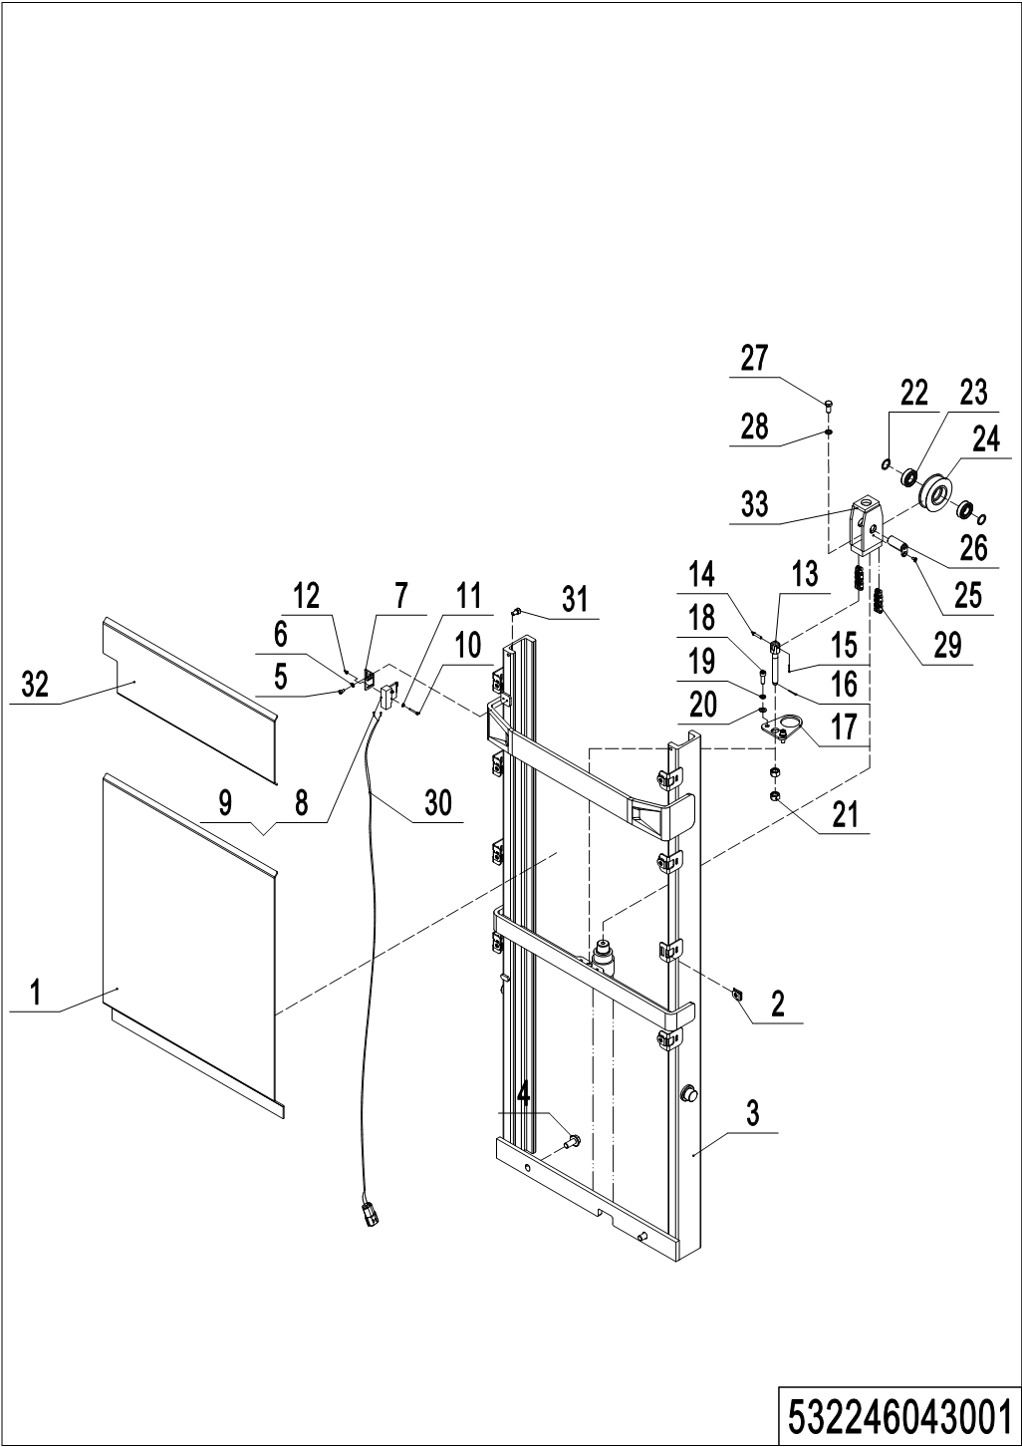
02 Mono-mast (532246043001)
No. | Item Code | Mark | Item Description | Qty. | Substitute | Note
1 | 532243020008 |  | Guard Plate | 1 |  | 1600
1 | 532243020011 |  | Guard Plate | 1 |  | 2000
1 | 532251520006 |  | Iron Gauze | 1 |  | 1600
1 | 532251520007 |  | Iron Gauze | 1 |  | 2000
2 | 940400300001 |  | Spring Buckle | 8
3 | 532243010003 | 2 | Outer Mast(1600) | 1 |  | 1600
3 | 532243010005 | 2 | Outer Mast(2000) | 1 |  | 2000
4 | 910100800005 | 1 | Bolt | 2
5 | 910200200032 | 1 | Screw | 2
6 | 910400100005 | 1 | Flat Washer | 2
7 | 532244020012 |  | Mounting Plate | 1
8 | 920200300003 |  | Microswitch | 1
9 | 920200300007 |  | Protective Cover | 1
10 | 910200500028 | 1 | Screw | 2
11 | 910400100003 | 1 | Flat Washer | 2
12 | 910300500001 | 1 | Nut | 2
13 | 206044520060 |  | Chain Anchor | 1
14 | 941100800010 | 1 | Pin | 1
15 | 910600600015 | 1 | Cotter Pin | 1
16 | 910600600019 | 1 | Cotter Pin | 1
17 | 532243020022 |  | Fixing Plate | 1
18 | 910200200077 | 1 | Screw | 2
19 | 910400500007 | 1 | Spring Washer | 2
20 | 910400100007 | 1 | Flat Washer | 2
21 | 910300200008 | 1 | Nut | 2
22 | 940600500006 |  | Washer | 2
23 | 910700200020 |  | Bearing | 2
24 | 940200400002 |  | Sprocket | 1
25 | 910200400016 | 1 | Screw | 1
26 | 533243510005 |  | Pin | 1

02 Mono-mast (532246043001) continuation
02 Mono-mast (532246043001) continuation
No. | Item Code | Mark | Item Description | Qty. | Substitute | Note
27 | 910100300049 |  | Bolt | 1
28 | 910400500008 |  | Spring Washer | 1
29 | 532344510009 |  | Chain | 1 |  | 1600
29 | 532344510004 |  | Chain | 1 |  | 2000
30 | 532233010002 |  | Wire Harness | 1
31 | 910200200074 |  | Screw | 2
32 | 532243020019 |  | Guard Plate | 1
33 | 532251520008 |  | Iron Gauze | 1

Chapter 6: Electrical parts and wire harness

01 Wire harness (532202033001)
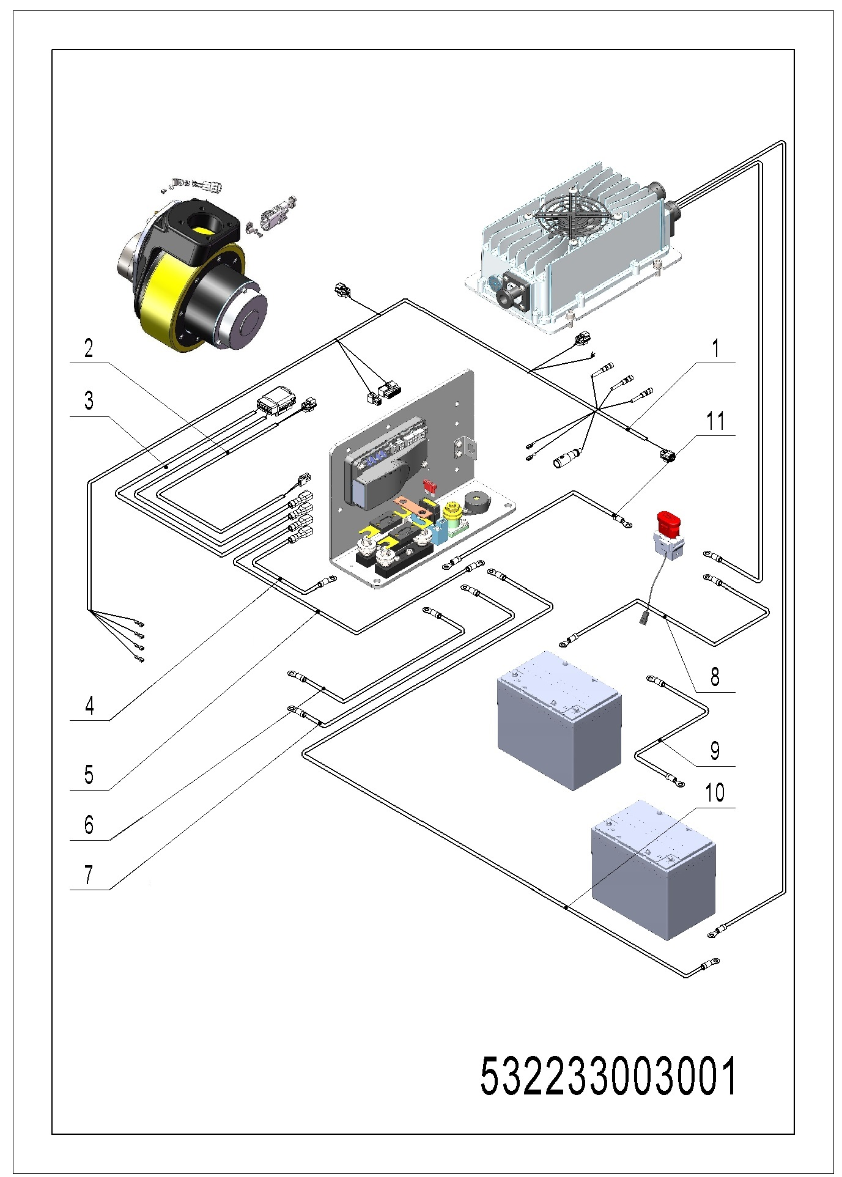
01 Wire harness (532202033001)
No. | Item Code | Mark | Item Description | Qty. | Substitute | Note
1 | 532233010000 |  | Wire Harness | 1
2 | 532233010003 |  | Wire Harness | 1
3 | 532233010004 |  | Wire Harness | 1
4 | 532233010005 |  | Cables | 1
5 | 532233010006 |  | Cables | 1
6 | 532233010007 |  | Cable | 1
7 | 532233010009 |  | Cable | 1
8 | 532233010010 |  | Cable | 1 |  | 85AH battery
8 | 532233010013 |  | Cable | 1 |  | 106AH battery
9 | 532233010011 |  | Cable | 1 |  | 85AH battery
9 | 532233010014 |  | Cable | 1 |  | 106AH battery
10 | 532233010012 |  | Cable | 1 |  | 85AH battery
10 | 532233010015 |  | Cable | 1 |  | 106AH battery
11 | 532233010016 |  | Cable | 1

02 Wire harness (532202033002)
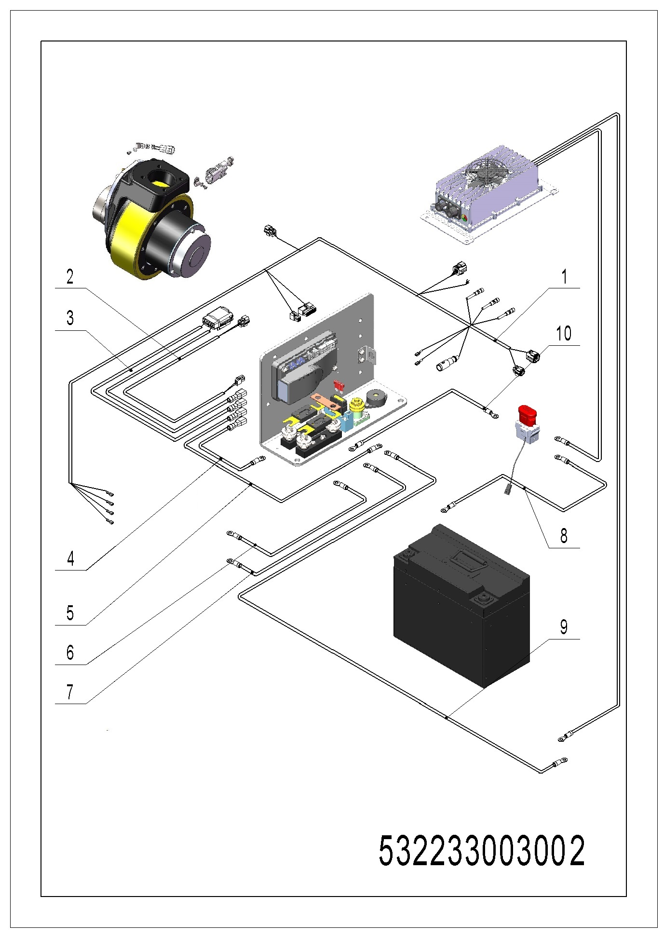
02 Wire harness (532202033002)
No. | Item Code | Mark | Item Description | Qty. | Substitute | Note
1 | 532233010001 |  | Wire Harness | 1
2 | 532233010003 |  | Wire Harness | 1
3 | 532233010004 |  | Wire Harness | 1
4 | 532233010005 |  | Cables | 1
5 | 532233010006 |  | Cables | 1
6 | 532233010007 |  | Cable | 1
7 | 532233010009 |  | Cable | 1
8 | 532233010020 |  | Cable | 1
9 | 532233010021 |  | Cable | 1
10 | 532233010016 |  | Cable | 1

03 Electrical control unit (532233010017)
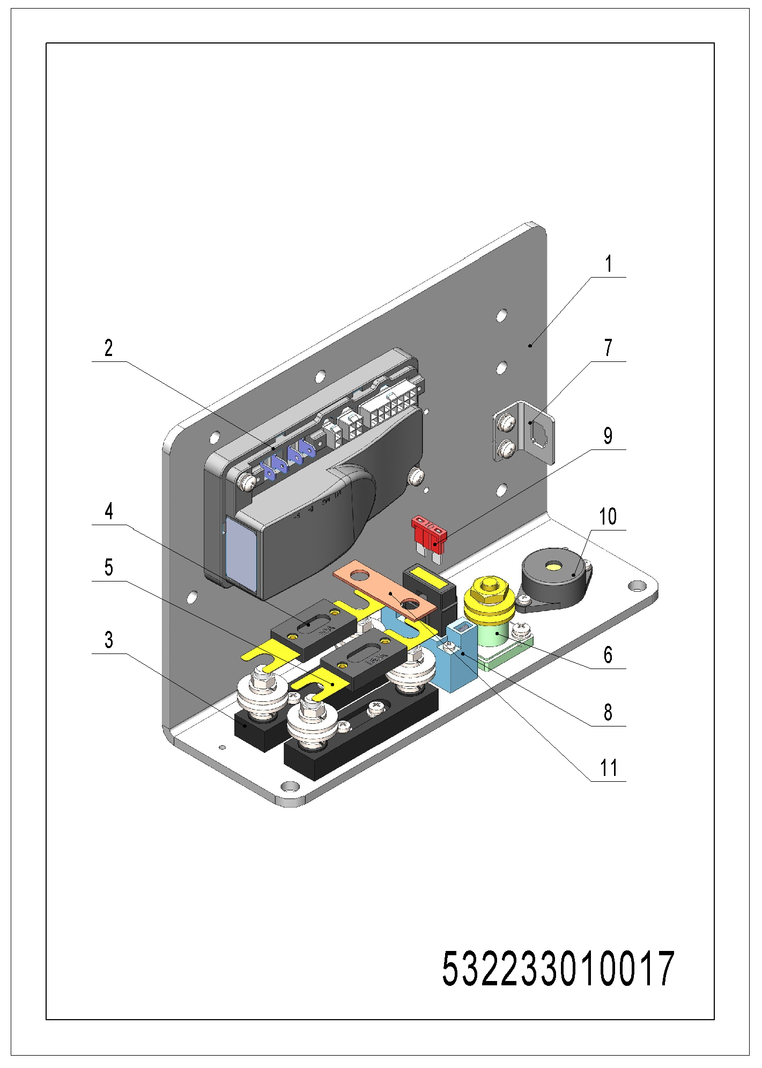
03 Electrical control unit (532233010017)
No. | Item Code | Mark | Item Description | Qty. | Substitute | Note
1 | 505698520008 |  | Screw | 1
2 | 921400100081 |  | Controller | 1
3 | 920100400002 |  | Fuse Holder | 2
4 | 920100100003 |  | Fuse | 1
5 | 920100100007 |  | Fuse | 1
6 | 920100400001 |  | Fuse Holder | 1
7 | 921300300003 |  | Holder | 1
8 | 920100400006 |  | Fuse Holder | 1
9 | 920100200002 |  | Fuse | 1
10 | 920500100007 |  | Horn | 1
11 | 505633020003 |  | Copper Busbar | 1

04 Charger (532246036501)
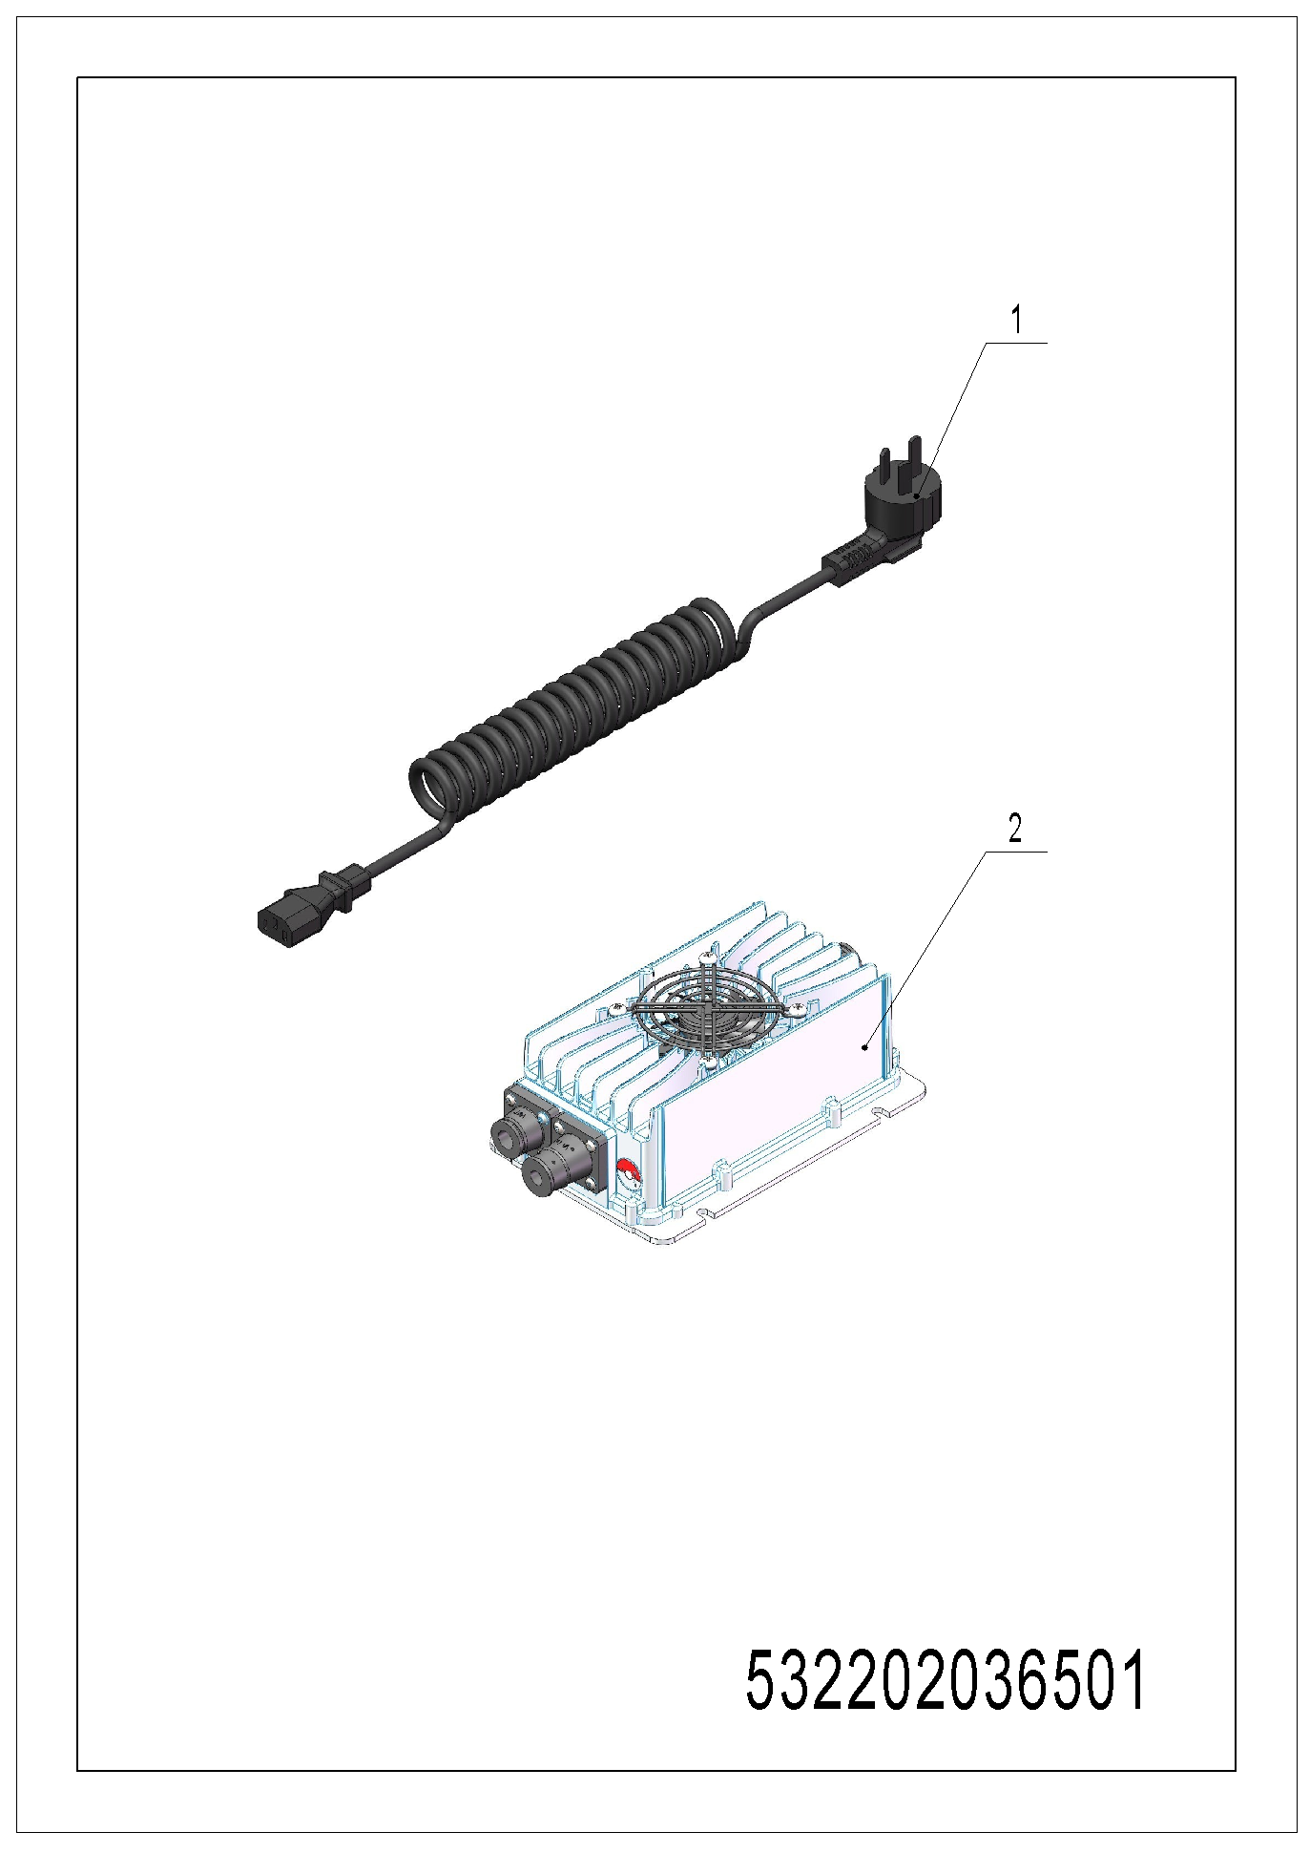
04 Charger (532246036501)
No. | Item Code | Mark | Item Description | Qty. | Substitute | Note
1 | 921500200008 |  | Spring Cable（Asia） | 1 |  | For lead-acid battery
1 | 921500200008 |  | Spring Cable（Asia） | 1 |  | For lithium battery
2 | 921000100051 |  | Charger24V12A | 1 |  | For LS lead-acid battery
2 | 921000100055 |  | Charger24V12V | 1 |  | For TN lead-acid battery
2 | 921000100052 |  | Charger 24V25A | 1 |  | For lithium battery

Chapter 7: Special equipment

01 Load backrest (536746040501)
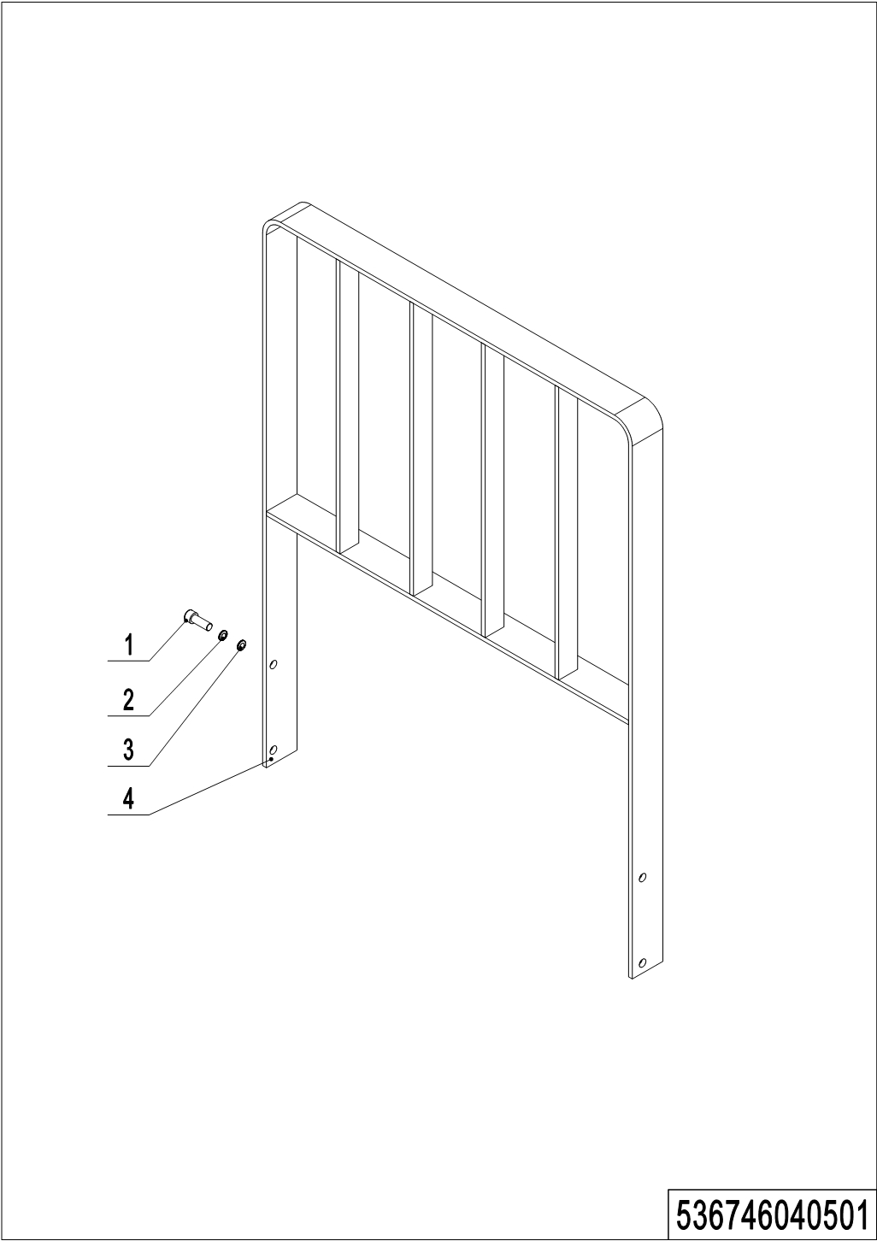
01 Load backrest (536746040501)
No. | Item Code | Mark | Item Description | Qty. | Substitute | Note
1 | 910200200075 | 1 | Screw | 4
2 | 910400500007 | 1 | Spring Washer | 4
3 | 910400100007 | 1 | Flat Washer | 4
4 | 532340510003 |  | Load Backrest | 1

Chapter 8: Others

01 Labels and decals (EU) (536746047001)
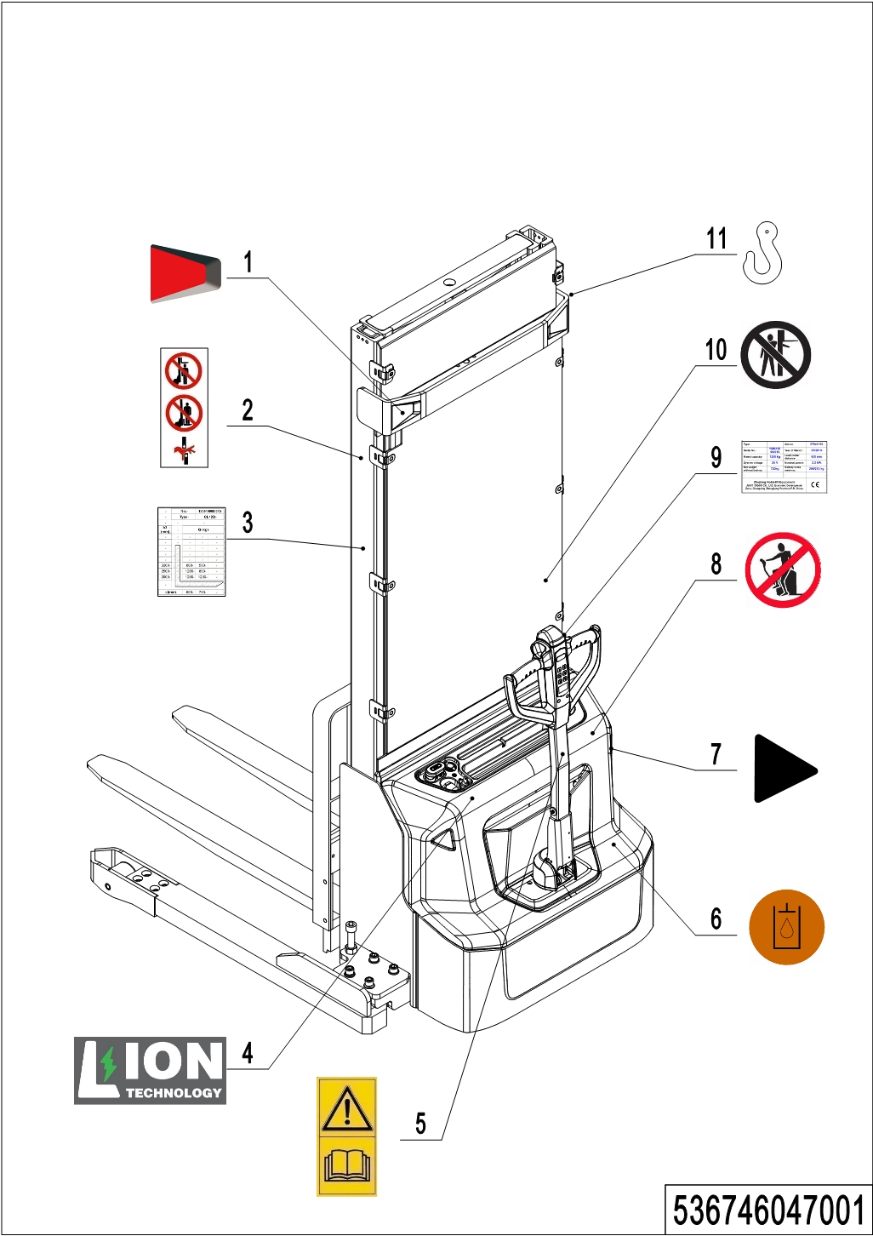
01 Labels and decals (EU) (536746047001)
No. | Item Code | Mark | Item Description | Qty. | Substitute | Note
1 | 532247020007 |  | Warning decal | 1
2 | 941200100004 |  | Label | 2
3 | 532247520001 |  | Load Capacity Diagram | 1
4 | 532247020002 |  | Label | 1 |  | For lithium battery truck
5 | 941200300002 |  | Label | 1
6 | 941200300003 |  | Label | 1 |  | Internal
7 | 532247020000 |  | Label | 2
8 | 941200100003 |  | Label | 1
9 | 532247520017 |  | Label (ID plate with CE mark) PSE12B3600-80Ah | 1
10 | 941200100006 |  | Label | 1
11 | 941200300001 |  | Label | 2

02 Labels and decals (USA) (536746047002)
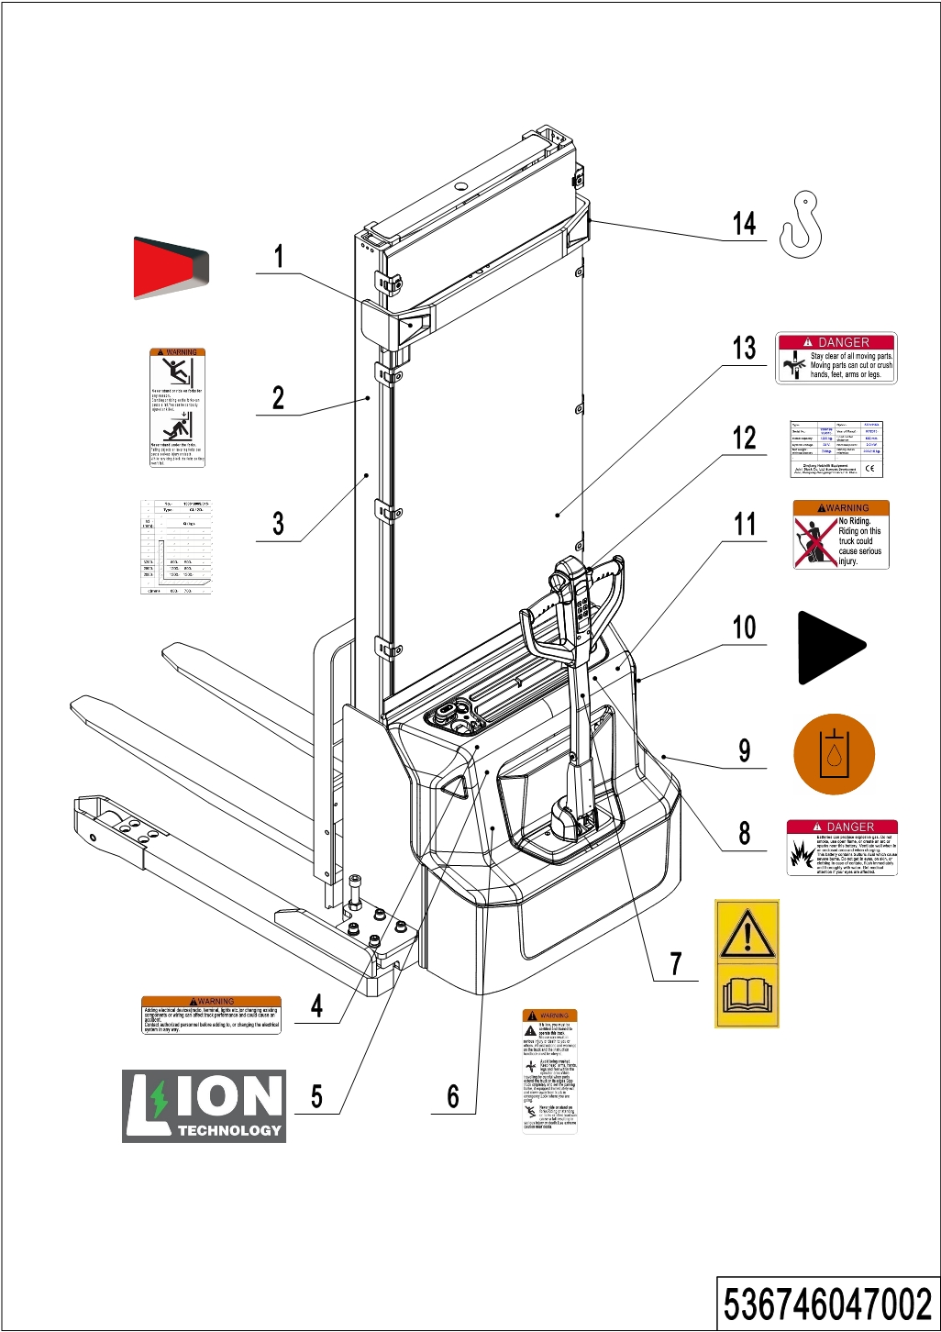
02 Labels and decals (USA) (536746047002)
No. | Item Code | Mark | Item Description | Qty. | Substitute | Note
1 | 532247020007 |  | Warning decal | 1
2 | 941200100016 |  | Label | 2
3 | 532247520001 |  | Load Capacity Diagram | 1
4 | 941200100010 |  | Label | 1
5 | 532247020002 |  | Label | 1 |  | For lithium battery truck
6 | 941200100009 |  | Label | 1
7 | 941200300002 |  | Label | 1
8 | 941200100013 |  | Label | 1
9 | 941200300003 |  | Label | 1 |  | Internal
10 | 532247020000 |  | Label | 2
11 | 941200100011 |  | Label | 1
12 | 532247520017 |  | Label (ID plate with CE mark) PSE12B3600-80Ah | 1
13 | 941200100014 |  | Label | 1
14 | 941200300001 |  | Label | 2

Appendix
01 Electrical circuit diagram (lead-acid battery) (536746045501)
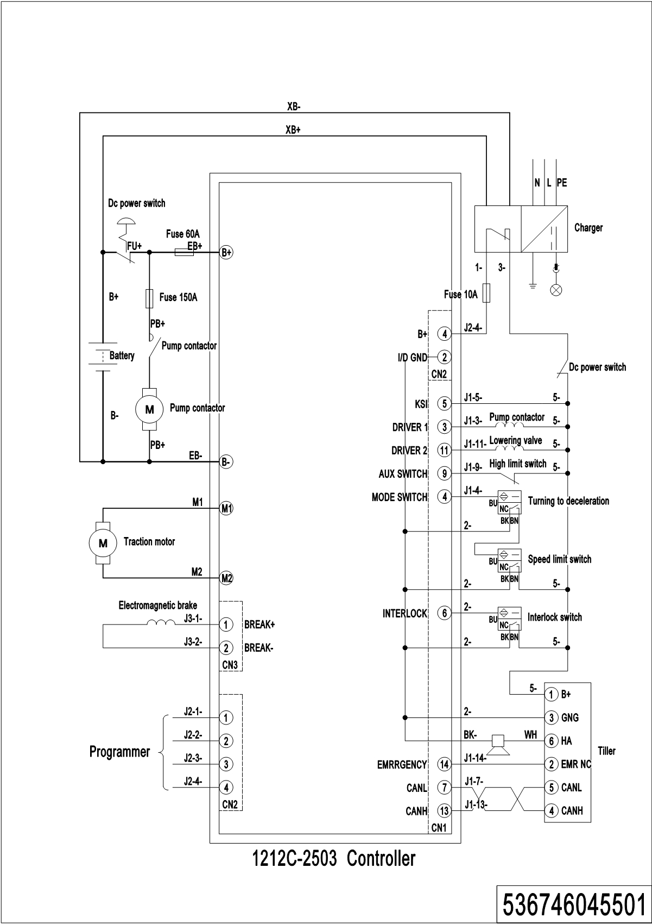
02 Electrical circuit diagram (Lithium battery) (536746045502)
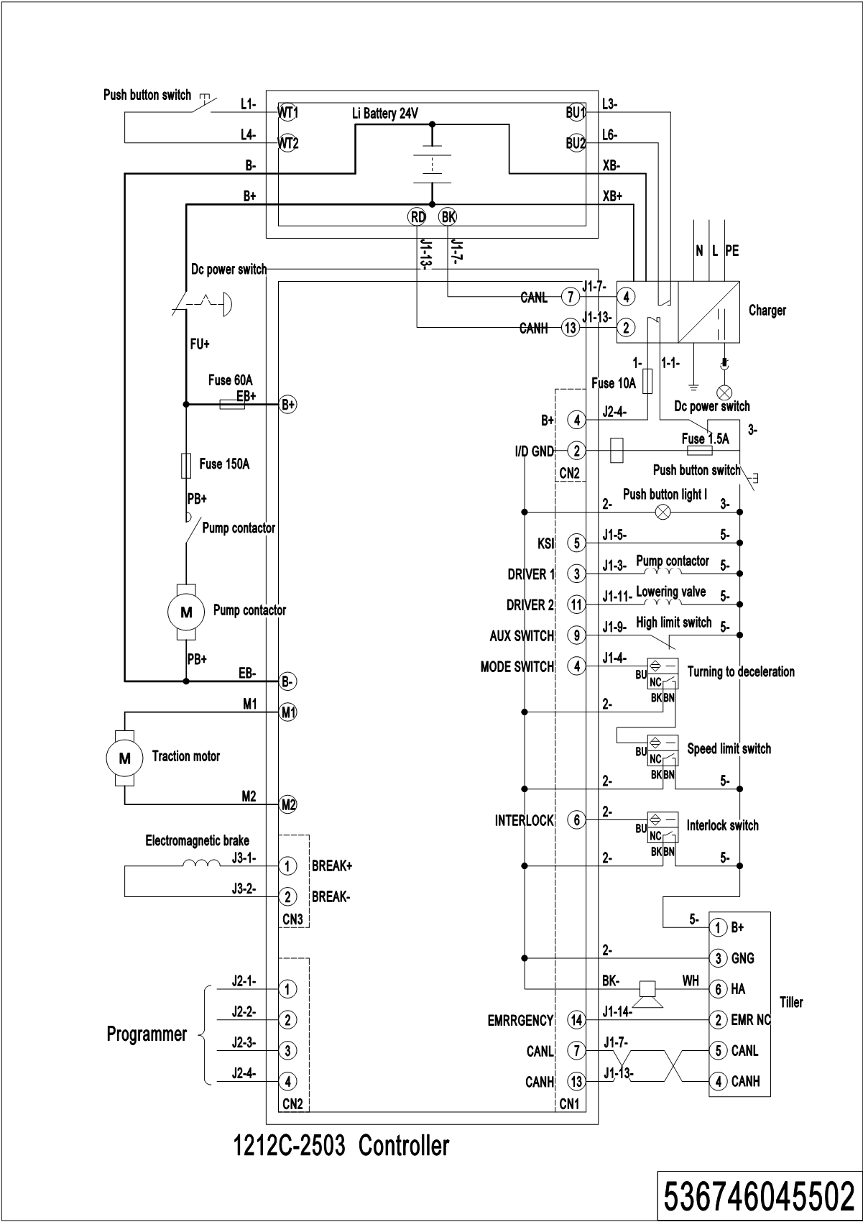
03 Hydraulic circuit diagram (532246045503)
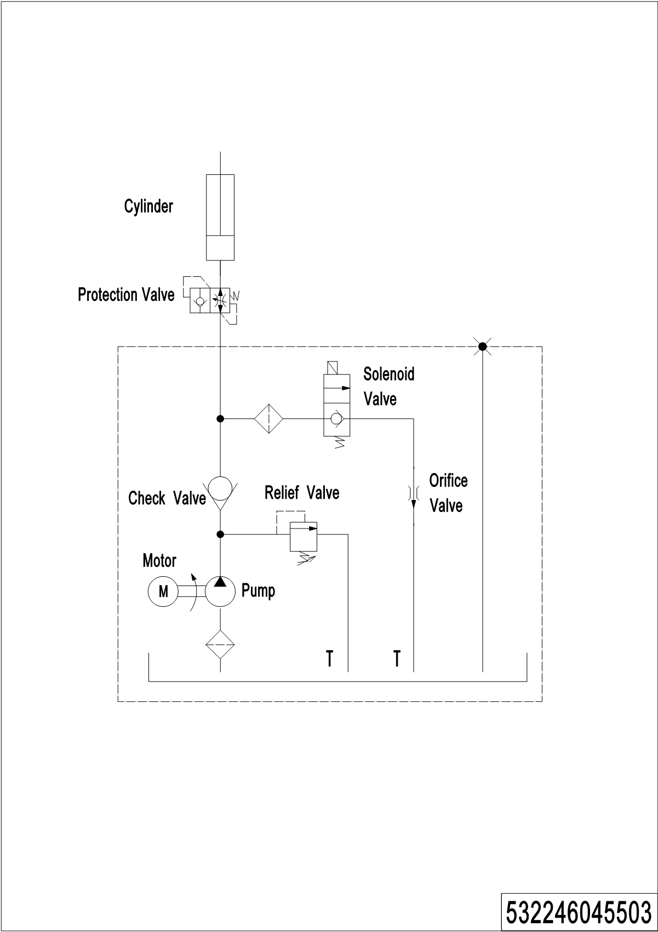
04 Easy worn parts list

No. | Item Code | Mark | Item Description | Qty. | Substitute | Note
1 | 910700200019 |  | Bearing | 4
2 | 940300300009 |  | WheelΦ84x70 | 2
3 | 532998510000 |  | Wheel | 2
4 | 532298510002 |  | Seal Kit | 1
5 | 940300300018 |  | WheelΦ100x40 | 2
6 | 503598510003 |  | Caster Assembly | 2
7 | 532211020003 |  | Gas Spring | 1
8 | 940500200001 |  | Bushing | 2
9 | 910700200020 |  | Bearing | 2
10 | 920100100003 |  | Fuse | 1
11 | 920100100007 |  | Fuse | 1
12 | 920100200002 |  | Fuse | 1

